HOLY EUCHARIST SCHOOL - St ALBANS SOUTH
Term Outline Sheet - 2019
GRADE: 5 TERM: 3
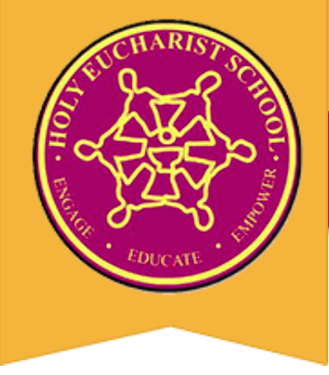

RELIGION

Unit: Our Future Home
Understandings:
- Jesus teaches us how to be humble and loving in our actions.
- The Parable of the Good Samaritan teaches us to treat those around us with dignity (A way of life).
- Small gestures of kindness and love can have a big impact (Fruits of the spirit).
- Individually we contribute to the team. Working together means that I have a responsibility.
- We are all responsible for the welfare of each human in the world -Love thy Neighbor.

ENGLISH

Reading and Viewing
Your child will be:
- Reading a variety of information and narrative text and identifying their features and language.
- Using technical language appropriate to the topic.
- Looking at the author’s perspective and point of view whilst reading.
- Identifying how socio – cultural values, attitudes and beliefs are presented in texts.
- Learning that many complex words are formed using prefixes and suffixes.
- Reading and responding to the novel ‘Boy Overboard by Morris Gleitzman’.

Writing
Your child will be:
- Planning, drafting and publishing an information report and narrative text.
- Proof-reading their own written text.
- Writing for a particular audience.
- Practising taking notes and rephrasing information in their own words.

Speaking and Listening
Your child will be:
- Varying tone, volume and pace of speech for an effective presentation.
- Participating in oral interactions for different purposes e.g. entertaining, informing and influencing others.
- Attentively listening to spoken texts and accurately retelling key information.

MATHEMATICS
Your child will be:
- Describing or estimating the chance of random events using words and fractions, percentages and decimals.
- Posing questions and collecting data to describe and interpret through graphs.
- Identifying and comparing the faces of three-dimensional objects to two-dimensional shapes.
- Identifying the relationship between the number of edges of a shape and the number of corners.
- Describing the connection and difference between area and volume, and mass and capacity.

INTEGRATED STUDES - INQUIRY
Topic: The Earth and Beyond
Learning Area: Science, Geography
Big Question:
- How does scientific understandings and discoveries affect people’s lives?
- How does the Sun influence the Solar System?
- How does Natural Disasters affect the environment and the community?
Understandings:
- Earth is part of a system of planets orbiting around the Sun.
- The sun is the most important part in our Solar System.
- There are different planets and each have different characteristics.
- The planets have different characteristics based on their distance from and their orbit around the sun.
- Sudden geological changes or extreme weather conditions can affect earth’s surface.
- Today’s actions in the environment influence present and future generations.

PHYSICAL EDUCATION
Your child will be:
- Refining their technique for different Athletics events in preparation for the Grade 3-6 Athletics Day.
- Practising specialised movement skills and applying them to a variety of different sports, such as Gymnastics, Hockey, Lacrosse and Skipping.
- Participating in the Middle & Senior Swimming Program to increase their coordination and confidence in the water, as well as learning important water safety skills.

THE ARTS
Visual Arts
Your child will be:
- Reinforcing the skills for painting and preparing a smooth surface on a china plate, as a purposeful decorative mantel piece.
- Using colour, line, tone, texture and balance, as elements of art to enhance visual effects to create an art form based on the theme of the solar system.
- Expressing their ideas to an audience the creating and displaying of an art piece.
Music
Your child will be:
- Identifying loud and soft in musical pieces.
- Creating loud and soft sounds with voice and instrument.
- Developing aural skills.
- Identifying changes in dynamics (loud and soft).
- Creating musical pieces using dynamics (loud and soft).
- Identifying and using music terminology for dynamics: piano, forte, pianissimo, fortissimo, crescendo, diminuendo.
- Identifying and using music symbols for dynamics: piano, forte, pianissimo, fortissimo, crescendo, diminuendo.

LOTE - Language Other Than English
Chinese – Mandarin
Your child will be:
- Continuing to learn numbers in Chinese from 1- 60.
- Translating the expression of time (hours) into pinyin.
- Learning to write Chinese characters.

SCIENCE, TECHNOLOGY, ENGINEERING AND MATHEMATICS (STEM)
Your child will be:
- Designing a user interface for a digital system, generating and considering alternative design ideas using Microbits.
- Investigating different types of data and using a range of software to interpret and visualise data to create information.

PARENT’S SIGNATURE:_______________________________ DATE:______________________

