HOLY EUCHARIST SCHOOL - St ALBANS SOUTH
Term Outline Sheet - 2019
GRADE: 1 TERM: 3
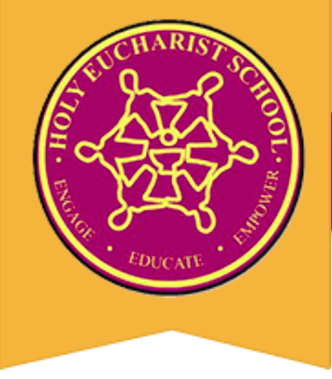

RELIGION

Unit: Images of God
Understandings:
- The Bible is a sacred book that has been handed down through the years.
- The Bible is a collection of different stories about God and God’s people.
- The Old Testament tells us stories about God’s people and His relationship with them.
- The New Testament tells us stories about God’s Son, Jesus Christ, and his relationships with others.
- The stories within the Bible give us different images of God.

ENGLISH

Reading and Viewing
Your child will be:
- Reading and exploring the structure of fairy tales.
- Participating in small group activities to develop reading skills.
- Developing their skills to decode written texts.
- Participating in comprehension activities around texts.
- Participating in Interactive Read Alouds to build vocabulary.

Writing
Your child will be:
- Planning and writing narratives using appropriate text structure and language features.
- Supported in editing their own work for correct sentence structure and grammar.
- Encouraged to attempt to spell unfamiliar words using different strategies.
- Encouraged to use correct letter formation when writing.

Speaking and Listening
Your child will be:
- Encouraged to listen to the speaker.
- Prompted to answer questions in full sentences.
- Practising reading aloud using fluency and correct phrasing.
- Given opportunities to share things of interest to the class.
- Presenting their narratives to the class using expression.

MATHEMATICS
Your child will be:
- Reading, writing and counting numbers to different points.
- Adding and subtracting numbers using the counting on and counting backwards strategy.
- Identifying and describing common 3D shapes.
- Interpreting data by classifying objects or people and creating tally charts and picture graphs.
- Selecting simple questions and gathering appropriate responses for data collection.
- Describing the chance of something occurring using appropriate vocabulary.
- Describing duration using months, weeks, days and hours.

INTEGRATED STUDES - INQUIRY
Topic: Always Take the Weather With You
Learning Area: SCIENCE AND GEOGRAPHY
Big Question: How does the weather affect us?
Understandings:
- Observable changes occur in the sky, the landscape and within seasons.
- The climate affects the way we live and the sky tells us about the weather.
- Each season has its own features and characteristics.
- Different cultural groups describe the seasons and the weather in different ways.

PHYSICAL EDUCATION
Your child will be:
- Performing fundamental movement sequences in their Gymnastics unit, using skills such as balancing on one leg (left and right leg), jumping and demonstrating a safe landing stance.
- Developing their hand-eye coordination skills by playing simplified versions of Hockey and Lacrosse.
- Learning a variety of Athletics events and tabloid sports in preparation for the Junior Sports Day in early Term 4.

THE ARTS
Visual Arts
Your child will be:
- Interpreting sunset in mixed media using ombre colours.
- Experimenting and developing skills, using materials and processes.
- Create a collaborative wall hanging for each of the Grade 1 classes, utilising the paper chains to create a particular art form.
Music
Your child will be:
- Identifying loud and soft in musical pieces.
- Creating loud and soft sounds with voice and instrument.
- Developing aural skills.
- Identifying changes in dynamics (loud and soft).
- Creating simple musical pieces using dynamics (loud and soft).
- Identifying and using music terminology for dynamics: piano, forte, pianissimo, fortissimo.
- Identifying and using music symbols for dynamics: piano, forte, pianissimo, fortissimo

LOTE - Language Other Than English
Chinese – Mandarin
Your child will be:
- Recognising and learning how to read names of family members in Chinese.
- Using Chinese characters (or Pinyin) to write the numbers from 11—20 in Chinese.
- Matching the Pinyin and Chinese words of family members to the English meaning.

SCIENCE, TECHNOLOGY, ENGINEERING AND MATHEMATICS (STEM)
Your child will be:
- Following, describing and representing a sequence of steps and decisions.
- Solving simple problems through coding.

PARENT’S SIGNATURE:_______________________________ DATE:______________________

