HOLY EUCHARIST SCHOOL - St ALBANS SOUTH
Term Outline Sheet - 2019
GRADE: 2 TERM: 3
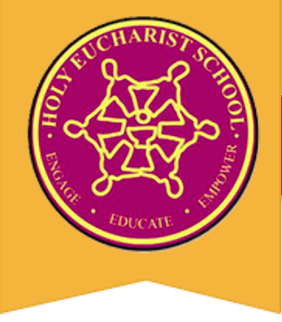

RELIGION

Unit: We are the Caretakers of the Earth
Understandings:
- Creation is a sign of God’s love and goodness.
- Humans and everything on the earth are interconnected.
- We have a responsibility to respect the world and care for the environment, animals and people.
- Different cultures have different stories that relate to the creation of the world and everything in it.

Unit: Saints: Spirited People
Understandings:
- Saints and ordinary people reflect God’s love and goodness.
- The Saints are people who use their gifts to live as God wants them to.
- Christians can learn how to live through the stories of saints lives.

ENGLISH

Reading and Viewing
Your child will be:
- Making connections between the text and the students' own experiences, other texts and the world.
- Making predictions and using clues from the text to support their predictions.
- Investigating and comparing Aboriginal stories and identifying the common features of the language used.

Writing
Your child will be:
- Planning, drafting, editing and creating a short imaginative text.
- Changing or adding details to their writing to improve the quality.
- Identifying and improving spelling within their writing.
- Practicing to write legibly using correctly formed upper- and lower-case letters.

Speaking and Listening
Your child will be:
- Exploring the differences between the language used when giving a presentation and when talking to friends.
- Discussing their own and others’ opinions about characters, events and settings from a variety of texts.
- Rehearsing and delivering short presentations on familiar and new topics, speaking clearly and varying tone, volume and pace appropriately, and using supportive props.

MATHEMATICS
Your child will be:
- Naming and ordering the four seasons.
- Measuring and comparing the length, area and capacity of objects using informal units of measurement.
- Comparing the masses of objects using balance scales.
- Identifying, describing and representing patterns using skip counting and number lines.
- Representing multiplication using groups, repeated addition and arrays.

INTEGRATED STUDES - INQUIRY
Topic: Four Seasons in a Day
Learning Area: Science and Geography
Big Question: How do changes in the weather affect living things and our everyday lives?
Understandings:
- Seasons are a way of recognising changes in the environment.
- The weather affects the way we live, our lifestyles, and our emotions.
- Different places around the world have different weather patterns or seasons.
- Weather has an impact on the physical attributes of a landscape.

PHYSICAL EDUCATION
Your child will be:
- Learning a variety of different Gymnastics skills such as pencil jumps, log rolls and a forward roll.
- Developing their hand-eye coordination skills by playing simplified versions of Hockey and Lacrosse.
- Developing their confidence in a variety of Athletics events and tabloid sports in preparation for the Junior Sports Day in early Term 4.

THE ARTS
Visual Arts
Your child will be:
- Creating swirling waters in the oceans by using different materials, techniques and strategies.
- Experimenting with marbling patterns by using specific materials and processes to create a specific art form.
- Interpreting unique designs from print making, highlighting lines, shapes, contrast and form in their artwork for public viewing and art appreciation.
Music
Your child will be:
- Identifying loud and soft in musical pieces.
- Creating loud and soft sounds with voice and instrument.
- Developing aural skills.
- Identifying changes in dynamics (loud and soft).
- Creating simple musical pieces using dynamics (loud and soft).
- Identifying and using music terminology for dynamics: piano, forte, pianissimo, fortissimo, crescendo, diminuendo.
- Identifying and using music symbols for dynamics: piano, forte, pianissimo, fortissimo, crescendo, diminuendo.

LOTE - Language Other Than English
Chinese – Mandarin
Your child will be:
- Recognising and learning some body parts in Chinese.
- Using Chinese characters (or Pinyin) to write the Chinese numbers from 11—30.
- Tracing and writing the Chinese characters for the parts of the body.

SCIENCE, TECHNOLOGY, ENGINEERING AND MATHEMATICS (STEM)
Your child will be:
- Using Beebots to explore directions such as forwards, backwards, left and right.
- Following, describing and representing a sequence of steps and decisions.
- Solving simple problems.

PARENT’S SIGNATURE:_______________________________ DATE:______________________

