*Community News #2*

Thank you to all the parents who attended our *Meet and Greet Morning or Afternoon Tea* last Friday 28th February, at the Community Hub. It was VERY nice seeing parents coming together to get to know each other. It was also a great opportunity for our Principal Mr. Jeffrey Parker and Mr. Michael Bonnici our Duty Principal / Learning and Teaching Leader, to meet with the parents to say hello and have a chat.

During our Testing Days this week (Thursday 5th February & Friday 6th February) parents are welcome to come into the Community Hub while waiting for their children to complete their tests. There will be coffee, tea and biscuits available. Everyone is welcome.

*Community Hub is located main entrance via Oleander Drive: Near canteen and hall.*

*Mrs. Jo. Dragovic*

***Family School Partnership ( FSP) Leader/ Wellbeing***

***Jagoda.Dragovic @hestalbanssth.catholic.edu.au***



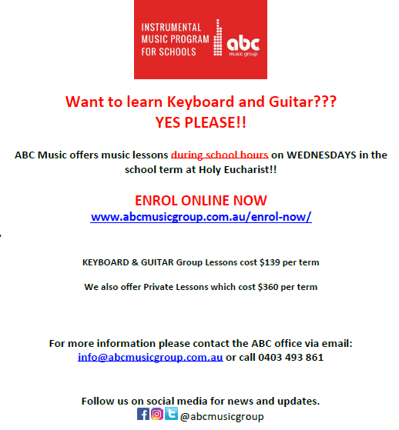





VISUAL ARTS CLASS

Tuesday @ 1:00 – 3:00 pm

( It’s for Free so come and join us )

Join us for a Free

Zumba Classes

Let’s get Fit & have Fun

Holy Eucharist PS - Hall

Wednesdays 9:30 am

(starting 12th of February)

Let’s meet in front of the canteen @ 9:15 am





**CAMP AUSTRALIA**

**BEFORE and AFTER SCHOOL CARE**

Before Care operates from Holy Eucharist School between 7.00am – 8.30am. After Care operates from 3.15pm -6.00pm. Students in Prep, Grade 1 and Grade 2 will be picked up and dropped off at bell times by a Camp Australia Staff Member. Please ensure that your child/ren is registered before they attend the program.

For new enrolments, parents or guardians need to contact Camp Australia directly on telephone number 1300 105 343.

Email: [oshc@campaustralia.com.au](mailto:oshc@campaustralia.com.au)

Website: [campaustralia.com.au](http://campaustralia.com.au/)

**Ms Karen Chircop-Bonello**

After School Care Coordinator

[***holyeuch@oshccampaustralia.com.au***](mailto:holyeuch@oshccampaustralia.com.au)





