www.hestalbanssth.catholic.edu.au
Visual Arts Term 2
Please feel free to email me to ask any questions relating to your art
Mrs Hickey’s email is:
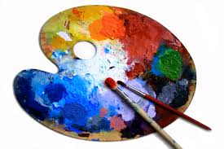
shobha.hickey@hestalbanssth.catholic.edu.au
GRADE 3 & 4

Week 2

This week you are going to study different types of lines. Please refer to the chart below:

Definition: As an element of visual art, line is the use of various marks, outlines, and implied lines during artwork and design. A line has a width, direction, curve, and length. Lines are sometimes called "strokes", especially when referring to lines in digital artwork.

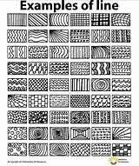
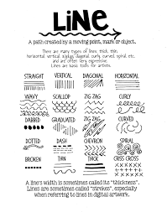
- Create a piece of art work using these lines above.

- Watch the video and see if you can make some op art spheres of your own.
https://www.youtube.com/watch?v=EqNZGTHO1Dw

- Do this as an extra fun activity if you like.
https://www.youtube.com/watch?v=k9PsxaUCjok
Turn the word SING into a cartoon using LINE – Fun activity

Email your samples of work by taking a photo of just your work and sending it to my email.

