HOLY EUCHARIST CATHOLIC PRIMARY SCHOOL
1a Oleander Drive, St Albans South VIC 3021
www.hestalbanssth.catholic.edu.au

Visual Arts Term 2
Grade 5 & 6
Please feel free to email me to ask any questions relating to your art activities.
Mrs Hickey

Mrs Hickey’s email is:
shobha.hickey@hestalbanssth.catholic.edu.au

Week 1
Art Competition
This week you will create a piece of art on the theme ‘Home is where the art is’. Your artwork can be 2D or 3D. It can be a drawing, painting, sculpture, construction or something else.

Step 1: Brainstorm ideas for ‘Home is where the art is’. Think about things that make you feel happy. Making art is important for us to grow, learn and share. See the examples below to get an idea. There is no right or wrong.
Step 2: Do a draft/rough drawing of your ideas for an artwork.
Step 3: Create your artwork anyway you want using different techniques taught in the class. Think about the colours, patterns and textures you might use.
Step 4: If you want to enter the Zart Art competition, talk to your parents to take a photo of your artwork and email the photo to zartart@zartart.com.au with your:
- Name
- Email Address
- Phone Number
- Year Level
- Category section (Category 1: Primary Foundation to Level 3 Category 2: Primary Level 4 to Level 6)
- School Name

HOME is where the ART is…

for your chance to win $250* of Art & Craft Materials…

PLUS $450* of Art & Craft Materials for your school

Total $700* value per prize!

6 Prizes up for grabs! TOTAL Prize pool value $4200

Step 5: Email your photo of your artwork to Miss Hickey.
shobha.hickey@hestalbanssth.catholic.edu.au

See https://www.zartart.com.au/zartstatic/page/home-art-competition
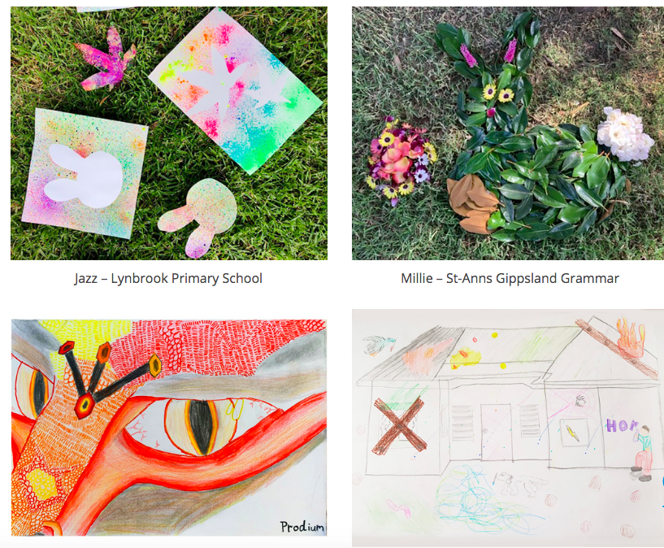
REMEMBER TO BE CREATIVE. I’M LOOKING FORWARD TO SEEING THE WONDERFUL ARTWORKS YOU CREATE.

