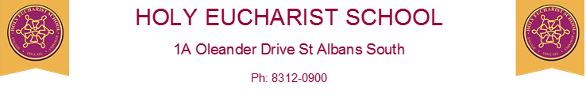
www.hestalbanssth.catholic.edu.au

Visual Arts Term 2
Grades 1 and 2
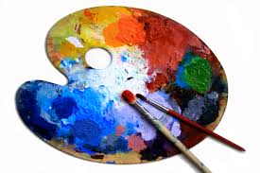
Please feel free to email me to ask any questions relating to your art activities.
Mrs Hickey’s email is:
shobha.hickey@hestalbanssth.catholic.edu.au
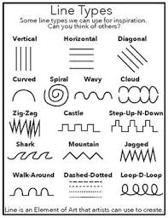
Week 2
This week we plan to work on line, one of the elements of art. You will learn all about different types of lineS. Look at these lines

1.USE THESE LINES TO MAKE A PIECE OF ARTWORK.

2.YOU WILL USE PAPER TO CREATE A MODEL OF A BUNNY RABBIT WITH STRIPS OF WHITE PAPER, PINK AND BLACK PENCILS OR MARKERS AND A GLUE STICK.
WATCH THESE
https://www.easypeasyandfun.com/easy-paper-bunny-craft/
https://www.youtube.com/watch?v=1mb0WpZz2mk

3. WHAT LINES CAN YOU SEE? Write in your book
WHAT SHAPES YOU CAN SEE?
