www.hestalbanssth.catholic.edu.au
Visual Arts Term 2
Please feel free to email me to ask any questions relating to your art
Mrs Hickey’s email is:
shobha.hickey@hestalbanssth.catholic.edu.au
GRADES 5 and 6

Week 2

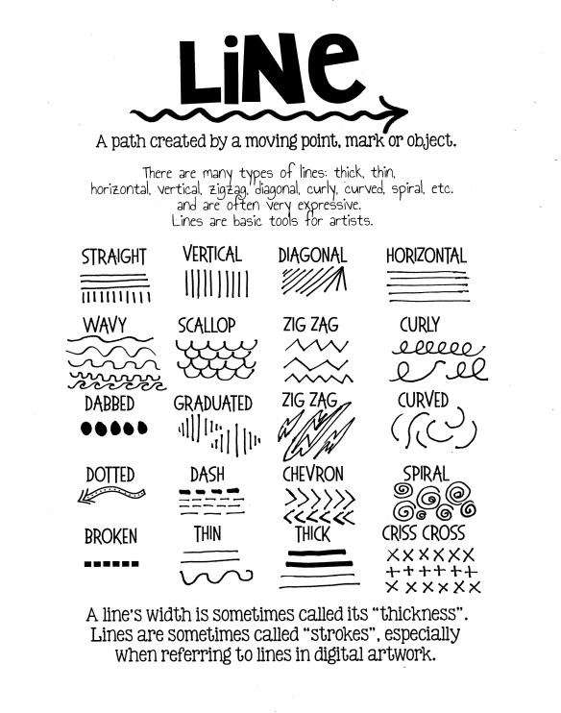
This week you are going to explore art work that involves line work. Please refer to the line charts.

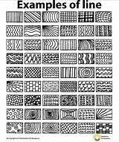

Step 1:
Look at the examples of lines to learn the different types and names.

Step 2:
Watch this video on making tumbling spheres. Try to do some of your own on paper.
https://www.youtube.com/watch?v=EqNZGTHO1Dw

Step 3:
Watch this video to learn more. https://www.youtube.com/watch?v=HIiLZJKV4Ds

Step 3:
Google and research Victor Vaserely and learn more about his artwork. You’ll find this amazing!

Please sent your samples by taking photos of just your works and sending them to my email.

HAVE FUN !!!!!!

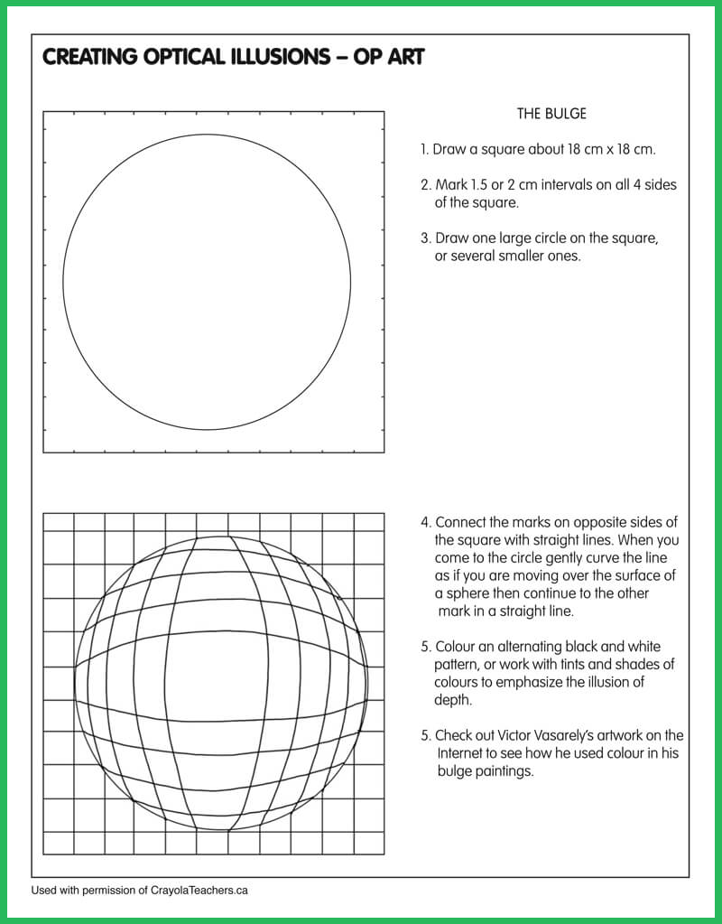
This is an extra task if you have time to do it.

