www.hestalbanssth.catholic.edu.au
Visual Arts Term 2
Prep
Please feel free to email me to ask any questions relating to your art
Mrs Hickey’s email is:
shobha.hickey@hestalbanssth.catholic.edu.au

Week 2
We will be learning about how to use line is an artwork.

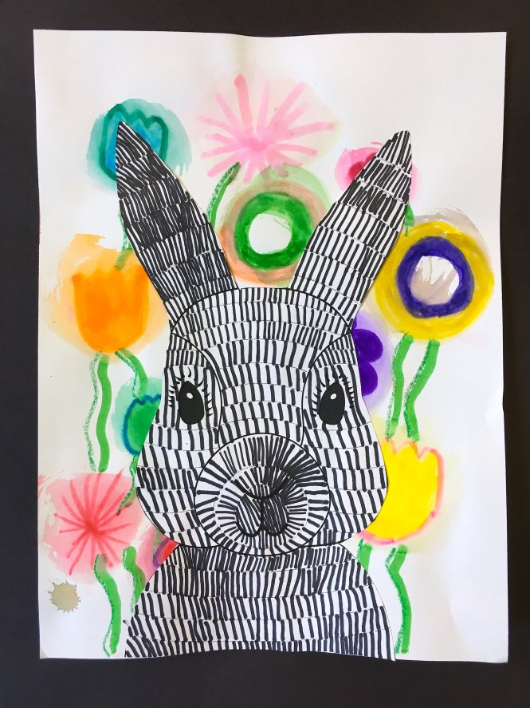

STEP 1 – LOOK AT THE LINES OR MARKS ON THE CUTE BUNNY

STEP 2 - TRACE OR DRAW A BUNNY AND PUT MARKS ON HIS BODY WITH THESE LINES.

VERTICAL IIIIIIIIIII HORIZONTAL _____ DIAGONAL /////////////
))))))))))((((((((((( CURVY OOOOOOOO CIRCLES 00000000 OVALS

STEP 3 – DECORATE AROUND (BACKGROUND) THE BUNNY WITH FLOWERS, GRASS OR EVEN EASTER EGGS.

https://www.youtube.com/watch?v=JL4ULWg7Wb0
How to draw a rabbit with the letter R
HAVE FUN

