Term 2, Day 2, 16th April
Good Morning Grade 5
Welcome back to Term 2

Hope you have found a clear, quiet space to do your work.

All Grade 5 students have been sent a Learning from Home activity document via email or picked up an Activity Pack from the teacher.

If you are having trouble accessing it, understanding the set tasks or if you are missing any login information for any online learning website please email your classroom teacher.

Your schedule for today Term 2 Day 2 will be as follows:

9am-10am: Question Time
This first hour will be a chance for you to ask questions about how home learning will work.This will start at 9am so please be ready by then!

A link will be sent out in the morning for you to join the google meet through google classroom so please make sure that you are checking google classroom in the morning and not emailing your teachers right away!

Please make sure when you are asking your questions that they are thought through and not silly! We will do our best to answer all questions but it is also important that we are respectful to each other and are quiet when other people are speaking.

10am-11am: Writing Activity
Read the writing prompt:
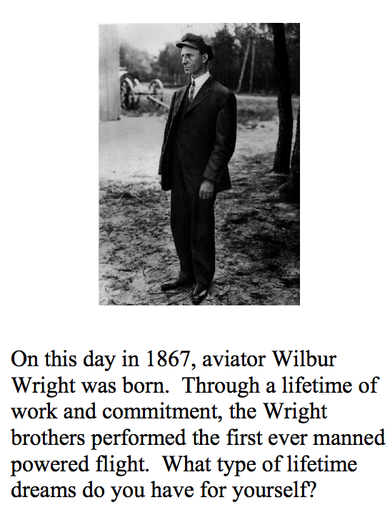
(CAN COMPLETE TASK ON CONTRACTIONS SHEET)
What types of dreams do you have for yourself? Write about a lifetime dream or goal that you have for yourself (5-6 lines)

2nd writing activity
First, watch this cool song telling us what contractions are: https://www.youtube.com/watch?v=5xE-vw2ctqo
Contractions:A contraction is a shortened form of two words written as one word in which an apostrophe takes the place of the missing letter or letters.For example instead of saying is not we get rid of the o and add an apostrophe to make isn’t

ACTIVITY: Look on google classroom and click on the “contractions” link assignment posted by Mr.Nicholl

If you finish both tasks early complete any studyladder activities you have not finished

12:00-1:00 MATHS
Use addition strategies to solve each puzzle adding numbers to the power
line total.Neatly draw and write your solutions in an exercise book or on a piece of paper including the power line total. Receive a code at the end of phase 1 to advance to phase 2 puzzles.
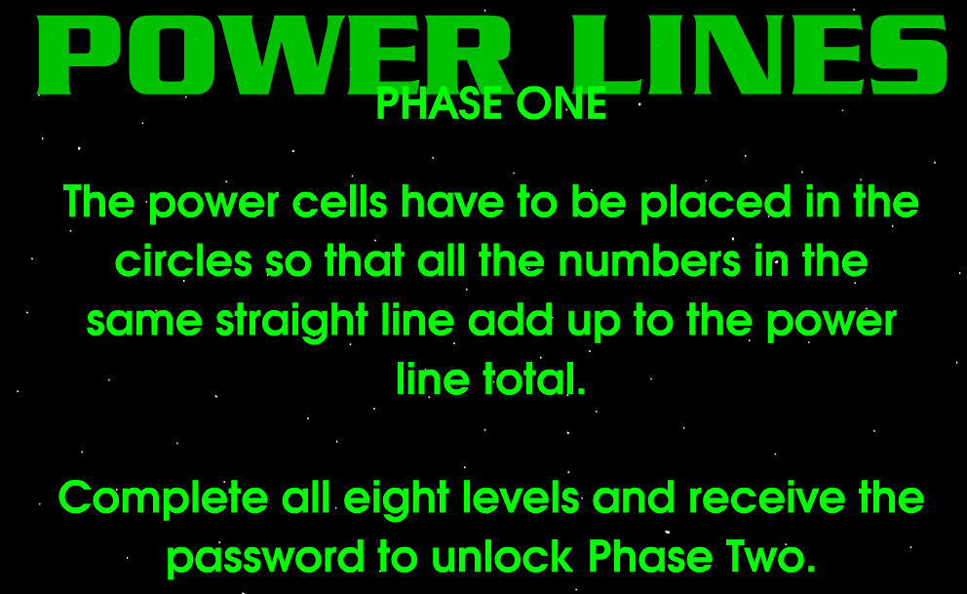
Make sure that your are writing out your completed power lines as you go on a piece of paper
Example:
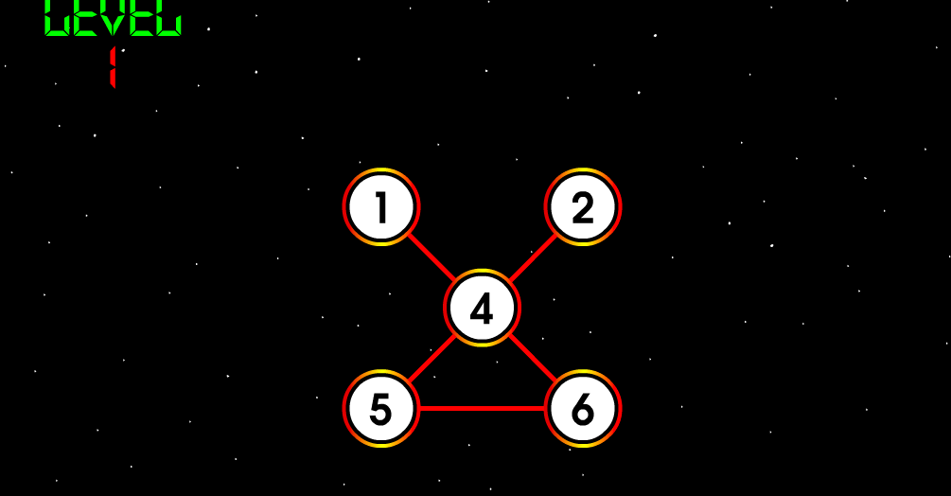

Phase 1:https://www.primarygames.co.uk/pg2/powerlines/powerlines1.html
Phase two: https://www.gamesflow.com/jeux.php?id=247048

1:00-2:00pmInquiry- Law & Order
Using popplet( https://popplet.com/) Create a mind map telling me everything you know about government. If you are not familiar with how to use Popplett watch the following video and it will help you understand how to use it: https://www.youtube.com/watch?v=VaBka3raHSU
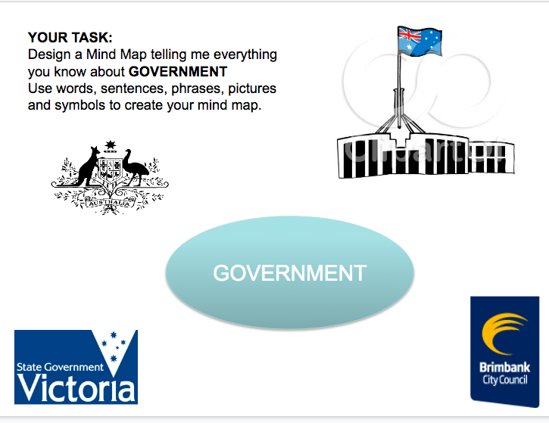

1:30-2:15pm- BREAK

2:15-3:15pm- RE
First,watch the Easter story: https://www.youtube.com/watch?v=HL8R158Ujp4&t=54s

After watching the Easter story complete a kahoot quiz about the resurrection story.Give it your best go!
Link for Kahoot: https://kahoot.it/ The pin is: 03194860
You do not need to wait for other people to join the kahoot, you can just start the quiz right away!

After you finish kahoot, send an email to your teacher about:
Why was it important for Jesus to die on the cross?

You must include at least 2 reasons minimum. Use the internet to help you find two reasons if you need so.

Best of luck
Your Grade 5 Teachers,

Mr P, Mr Nicholl & Miss Christie

