Grade 5 Home Learning Schedule
Week 2, Monday 27th of April, 2020
Thoughts for the day…

PARENT MORNING Monday 27TH April 9:00am
An invitation to all Grade 5 Parents to join our GOOGLE MEET @ 9am
Check Google classroom home page banner for login link.
If parents have any questions they would like to ask the Grade 5 teachers, this is an opportunity to do so. If you would like to just listen in during the meeting time, you are also welcome.

GOOGLE MEET RULES:
- Please keep your microphone off unless you wish to speak or ask a question.
- Wait patiently until it is your turn to speak.
- If you wish to speak to friends, log in early or do this at the end of our meeting.
THANK YOU.

COMMENTS: Please DO NOT make unnecessary comments on our posts. Only use the comments for questions you have about your learning. Thank you.

BEFORE I START MY DAY:
-Have I marked the roll? Make sure you mark your attendance for the day before you start your work!
-Have I picked up my homework pack? Make sure that if you did not pick it up last Friday that you can
-Make sure I take a break! Some students are working so hard and are forgetting to take breaks, please just remember that from 11-12pm and 2pm- 2:30pm are your times to recharge!
9:30am-10:15am | 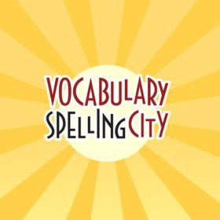  LITERACY- SPELLING FOCUS: -ee words  Log onto www.spellingcity.com and complete the latest unit of work assigned to you by your teacher  After completing the activities on spelling city complete the spelling matters Unit 5 “ee sheet” that you would’ve received in your new homework pack  If you have not picked up your homework pack from school the sheet below will be posted on google classroom and you will have to complete it in an exercise book.  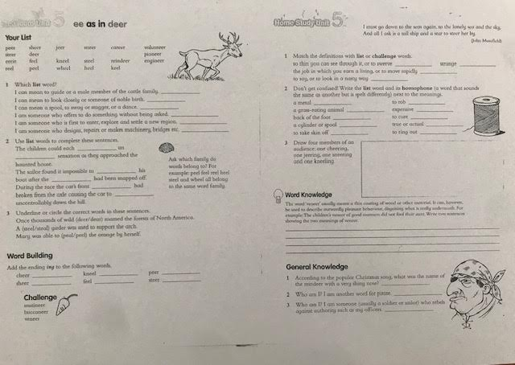
10:15am-11am | WRITING: SIZZLING STARTERS  You are to write an exciting, interesting amazing sentence starter using the following prompts:  1. Almost getting caught  2. Lunchtime fun  3. Learning to ride a bike  4. Playing with a pet  5. A holiday that...  Write these sentences on the sizzling starters document you have been assigned. After you have written your sentence highlight the following language features in it: nouns, adverbs, adjectives, adverbs, connectives  Use this website to help highlight the language features in your sentence:  Parts-of-speech.Info - POS tagging online
11am-12pm | LUNCH BREAK
GOOGLE MEET @ 12pm - Check Google classroom home page banner for login link.
12pm-1pm | MATHS- Addition post test  Today we will be seeing how well you have learnt your addition strategies  You have been set a post assessment task on https://www.essentialassessment.com.au/student/.To access the test follow the following steps:  - Log into your account on https://www.essentialassessment.com.au/student/ account  - Click the bubble ‘number and place value”  - Click the bubble ‘addition”  - Click the bubble “post test”  If you have not had the chance to do the pretest for addition you can complete it during this time!!!!! Also, if you do not know or have forgotten your log-in details please email your teacher and they will send them to you.  For students who have already finished that you can continue to do your my numeracy tasks about chance on essential assessments and also play this chance game as well: https://www.free-training-tutorial.com/probability/machine/machine.html
1pm-2pm | RELIGION – ORGANISATIONS THAT SHOW GENEROSITY  Continue with your RE project  Choose one of the following organisations that you would like to research.  Red Cross  St. Vincent De Paul’s  Salvation Army  World Vision  Caritas Australia  Sacred Heart Mission  Catholic Mission  UNICEF  Save the Children  Don Bosco  Whitelion  Smith Family  Make A Wish Foundation  Starlight  Shane Warne Foundation.  Fred Hollows Foundation  DOXA  Continue working on your Google Slides Presentation individually or with a partner.  Research an organisation that interests you.  TASK:  Design a Google Slides presentation on one organisation that show generosity.  Use suitable pictures to support your presentation. Be creative.  Include all of the following important information.  - NAME OF THE ORGANISATION  - SYMBOL  - EXPLAIN THE 3 MOST IMPORTANT THINGS THAT THEY DO FOR OTHERS, HOW DO THEY SHOW GENEROSITY / KINDNESS?  - WHERE ARE THEY? CONTACT INFORMATION Website address, phone, address.  - WHERE DO THEY HELP OTHERS? IN AUSTRALIA? OVERSEAS?  - Explain what parts of their work interest you or inspire you?  - Other interesting facts you learnt ABOUT THIS ORGANISATION while researching.
2pm-2:30pm | SNACK BREAK
2:30pm-3:15pm | 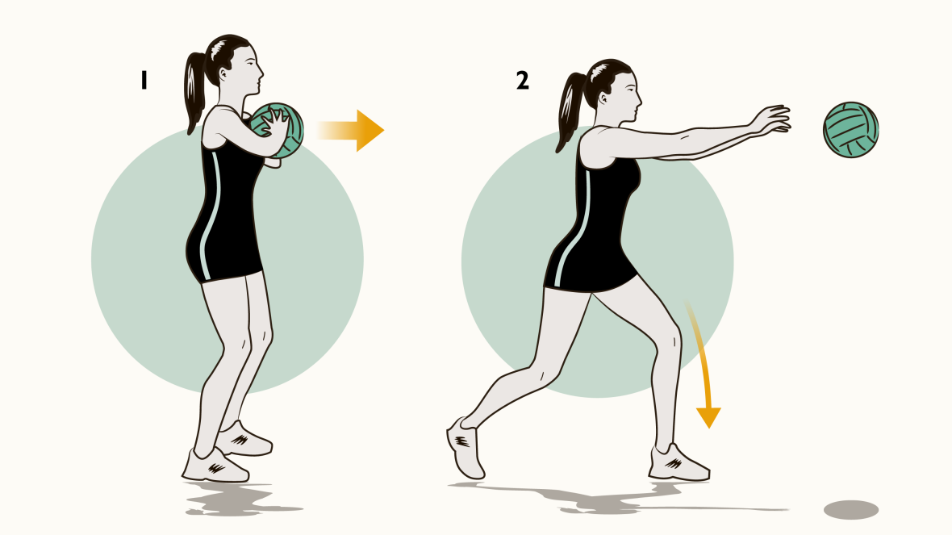  PE- Mr.Herrera: Netball activities  Complete the following activities for PE  Netball Warm-up:  The 7 basic Locomotion movements for sport.  https://www.youtube.com/watch?v=rCg-MkVkxyU  These exercises can be done in the park or on the spot.  10 Mins Activity 1:  WILF: I am looking for students to pass the ball in different ways demonstrating the correct technique.  WATCH THE FOLLOWING VIDEO:  https://www.youtube.com/watch?v=QTlOYtX6d88  Activity 2:  10 mins: 6 individual Throwing & Catching challenges activities:  WATCH THE FOLLOWING VIDEO:  https://www.youtube.com/watch?v=T3kvqbiohC8  Warm down  Go through some gentle breathing exercises and warm down stretches.  https://www.youtube.com/watch?v=M-d11QiWdm8  Health Works!  Youth Fitness 101 -  Cool Down  Have a good day!  Your Grade 5 teachers (Mr P, Mr Nicholl & Miss Christie)

