Grade 5 Home Learning Schedule
Week 2, Monday 20th of April, 2020
Thoughts for the day...

GOOGLE MEET @ 9am - Check Google classroom home page banner for login link

GOOGLE MEET RULES:
- Please keep your microphone off unless you wish to speak or ask a question.
- Wait patiently until it is your turn to speak.
- If you wish to speak to friends, log in early or do this at the end of our meeting.
THANK YOU.

COMMENTS: Please DO NOT make unnecessary comments on our posts. Only use the comments for questions you have about your learning. Thank you.
9:30am-10:15am | LITERACY- SPELLING – Unit 4 - une as in tune words  WILT: I am learning the meaning of new words and how to use these in context.  Log into your Spelling City account and complete the assigned activities. Lost your password – email your teacher!!!!  Complete the Spelling Matters Unit 4 from your home pack.  Use a dictionary and internet sites to help you complete all activities successfully.  NO HOME PACK:  Write 5 words you did not know into sentences.  Make a find a word using 10 of your spelling words.  Write the 10 words in alphabetical order.
10:15am-11am | PERSUASIVE WRITING  REMOTE LEARNING OR GOING TO SCHOOL?  WHICH ONE DO YOU PREFER?  See below my post for your own copy to work on: REMOTE LEARNING.  This task will be continued tomorrow.  Read the stimulus sheet carefully and follow the instructions carefully.
11am-12pm | LUNCH BREAK
GOOGLE MEET @ 12pm - Check Google classroom home page banner for login link
12pm-1pm | NEW WAVE MENTAL MATHS – Complete the next unit questions from your student pack . Use an online Kids Maths dictionary to help you solve problems. http://amathsdictionaryforkids.com/dictionary.html  MATHS- Addition Algorithms  Watch the Video below – you may have to watch this more than once.  https://www.youtube.com/watch?v=mAvuom42NyY  Today we will be doing slightly different lessons in class groups. If you picked up your plastic pocket with the Targeting Maths sheets- you can do it on the sheet. Everyone else can access the Maths sheets through Google classroom classwork.  5P- You will be completing the Addition algorithms worksheet from Targeting Maths pg. 7. This is also in Grade 5 2020 Classroom  You can also catch up to the other Grade 5’s by doing their work too.  5CC & 5AN- You will solve these Addition problems in your book. Set them out neatly using vertical addition. Show all carrying clearly.  - 456 + 358 =  - 983 + 869 =  - 34 + 27 + 59 + 45 =  - 56 + 45 + 49 + 85 =  - While shopping, I spent $456 on clothes and $289 on shoes.  How much money did I spend all together?  - John’s bank balance was $567. He was paid $460. What was the bank balance after he was paid?  - Farmer Joe had 35 chickens, 29 cows, 56 sheep and 23 horses. How many animals did he have altogether?
1pm-2pm | 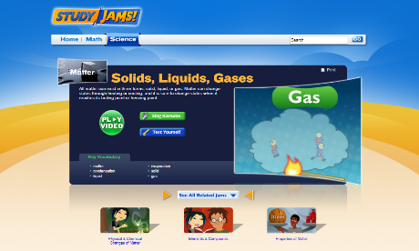  Inquiry- MATTER:- SOLID, LIQUID & GASES  http://studyjams.scholastic.com/studyjams/jams/science/matter/solids-liquids-gases.htm  Complete the activities  1. Play the video  2. Listen to the Song – sing along and have fun – teaching you about matter.  3. Test Yourself.
2pm-2:30pm | SNACK BREAK
2:30pm-3:15pm | PHYSICAL EDUCATION / WELLBEING  KARATE  Activity:  Try out the Japanese martial art of karate by joining in with this online tutorial. https://www.youtube.com/watch?v=hWB0Xehv23A  When you have finished, do some research to find out 3 facts about this particular style of karate, called “Shotokan” and name some other styles of karate.  Well done on completing another day of online learning- you’re doing such a great job! Wishing you all a restful night, see you tomorrow :)  Your Grade 5 teachers (Mr P, Mr Nicholl & Miss Christie)

