Grade 5 Home Learning Schedule
Week 2, Tuesday 21st of April, 2020
Thoughts for the day…

GOOGLE MEET @ 9am - Check Google classroom home page banner for login link

GOOGLE MEET RULES:
- Please keep your microphone off unless you wish to speak or ask a question.
- Wait patiently until it is your turn to speak.
- If you wish to speak to friends, log in early or do this at the end of our meeting.
THANK YOU.

COMMENTS: Please DO NOT make unnecessary comments on our posts. Only use the comments for questions you have about your learning. Thank you.

UPDATE: There are students that have not been able to follow these rules and have been MUTED from commenting on ‘my classroom’ until further notice.Thank you to the majority of you who have been following the rules!

BEFORE I START MY DAY: Have I marked the roll? Make sure you mark your attendance for the day before you start your work!

9:30am-10:15am | 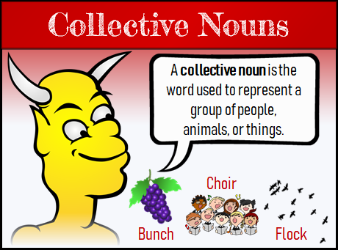  LITERACY- SPELLING AND GRAMMAR: Collective/common nouns  WILT: I am learning the meaning of new words and how to use these in context.  Collective Nouns: A collective noun is a noun such as 'family' or ' team' that refers to a group of people or things.  E.g: a pack of dogs  a herd of cows  a swarm of flies  NOTE: When animals are grouped they given a specific collective noun to describe them  Watch the following video that helps describe collective nouns: https://www.youtube.com/watch?v=zijGfIzT5Ss  Common Noun: A common noun is used to name general things, places, ideas, events, or people.  Complete the worksheet : Collective noun worksheet  IF YOU DO NOT HAVE THE HARD COPY OF THE SHEET FROM YOUR HOMEWORK PACK YOU WILL HAVE TO COMPLETE IT ON EITHER A GOOGLE DOCUMENT OR WRITE IT IN AN EXERCISE BOOK!  (Check your assignments on google classroom for Collective noun worksheet)  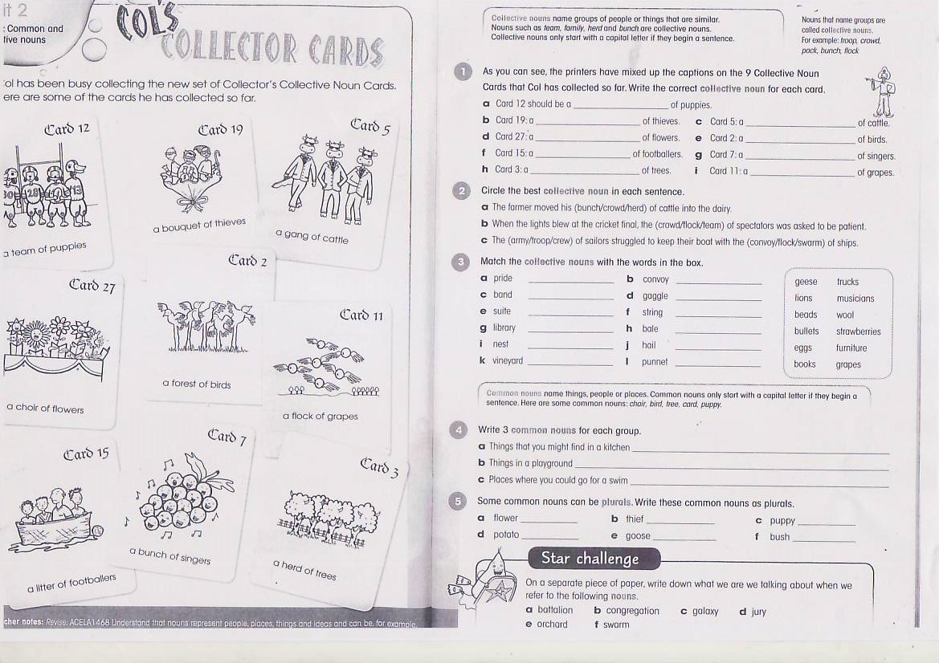
10:15am-11am | CONTINUE PERSUASIVE WRITING PIECE  REMOTE LEARNING OR GOING TO SCHOOL?  WHICH ONE DO YOU PREFER?  See below my post for your own copy to work on: REMOTE LEARNING.  This task will be continued tomorrow.  Read the stimulus sheet carefully and follow the instructions carefully.  Ask yourself the following questions when reading your piece to help you complete your task:  Are my reasons convincing?  Have I used enough evidence to support my reasons?  Have I completed my plan and my good copy?  Have I read over all my work?  Have I used the language features of a persuasive piece effectively? (Rhetorical questions, verbs ext)  ONLY SUBMIT YOUR WORK WHEN YOU HAVE COMPLETED BOTH THE PLAN AND THE GOOD COPY TO A HIGH STANDARD
11am-12pm | LUNCH BREAK
GOOGLE MEET @ 12pm - Check Google classroom home page banner for login link
12pm-1pm | 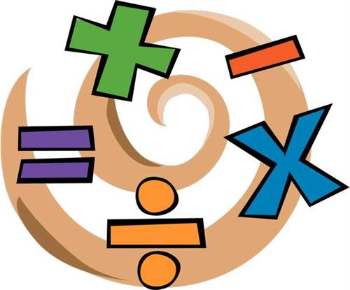  NEW WAVE MENTAL MATHS – Complete the next unit questions from your student pack . Use an online Kids Maths dictionary to help you solve problems. http://amathsdictionaryforkids.com/dictionary.html  MATHS- Addition Algorithms test  Today we will be seeing how well you know your addition strategies  You have been set an assignment listed as ADDITION THINK PAD on google classroom.  Your task is to answer the addition problem on the addition think pad in as many different ways as you can. If you are having trouble completing the task on the document you can complete it on a piece of paper or in a book if you’d like.  After completing that task here is a kahoot for you to complete to consolidate your learning. Simply click the link and it will take you to the quiz:  https://kahoot.it/challenge/07075551?challenge-id=a0130c37-dd5e-45fb-9cfc-7df76ec7d1de_1587357200104  (If the quiz doesn’t work you may need to put the code in first, the code is: 07075551)
1pm-2pm | Inquiry- MATTER:- SOLID, LIQUID & GASES  Click on the website and participate in the game about solids, liquids and masses:  www.abcya.com/states_of_matter.htm  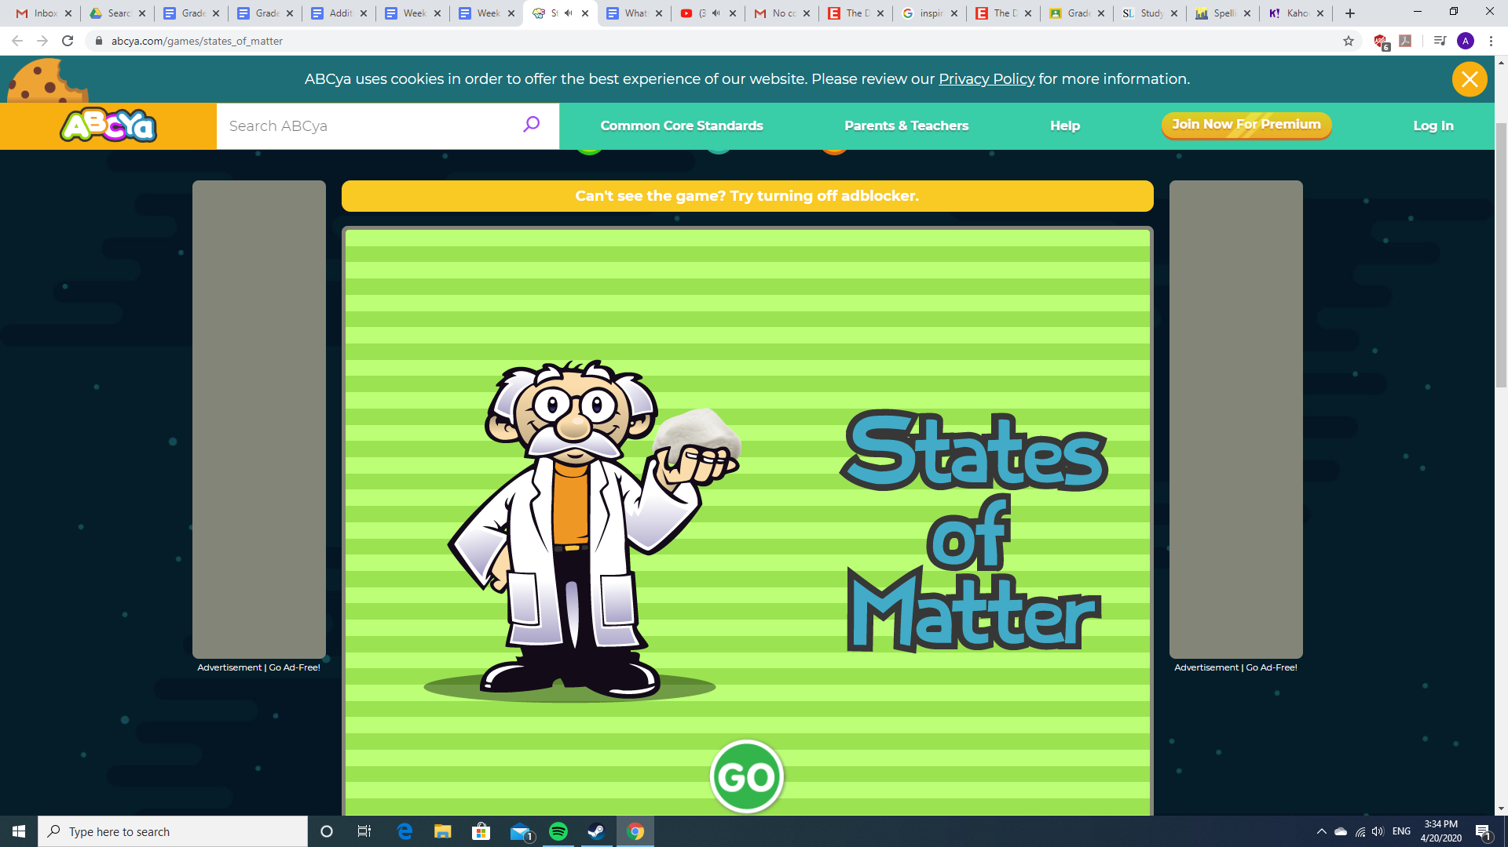  After completing the game move onto your next assignment which will be labelled: What's the matter?  On this worksheet you will be required to write a short definition of what a liquid, solid and a gas are. You will also be required to show examples of each whether by writing them down or using images. Below is an example of what you would do for solids (but more examples would be required when you complete it)  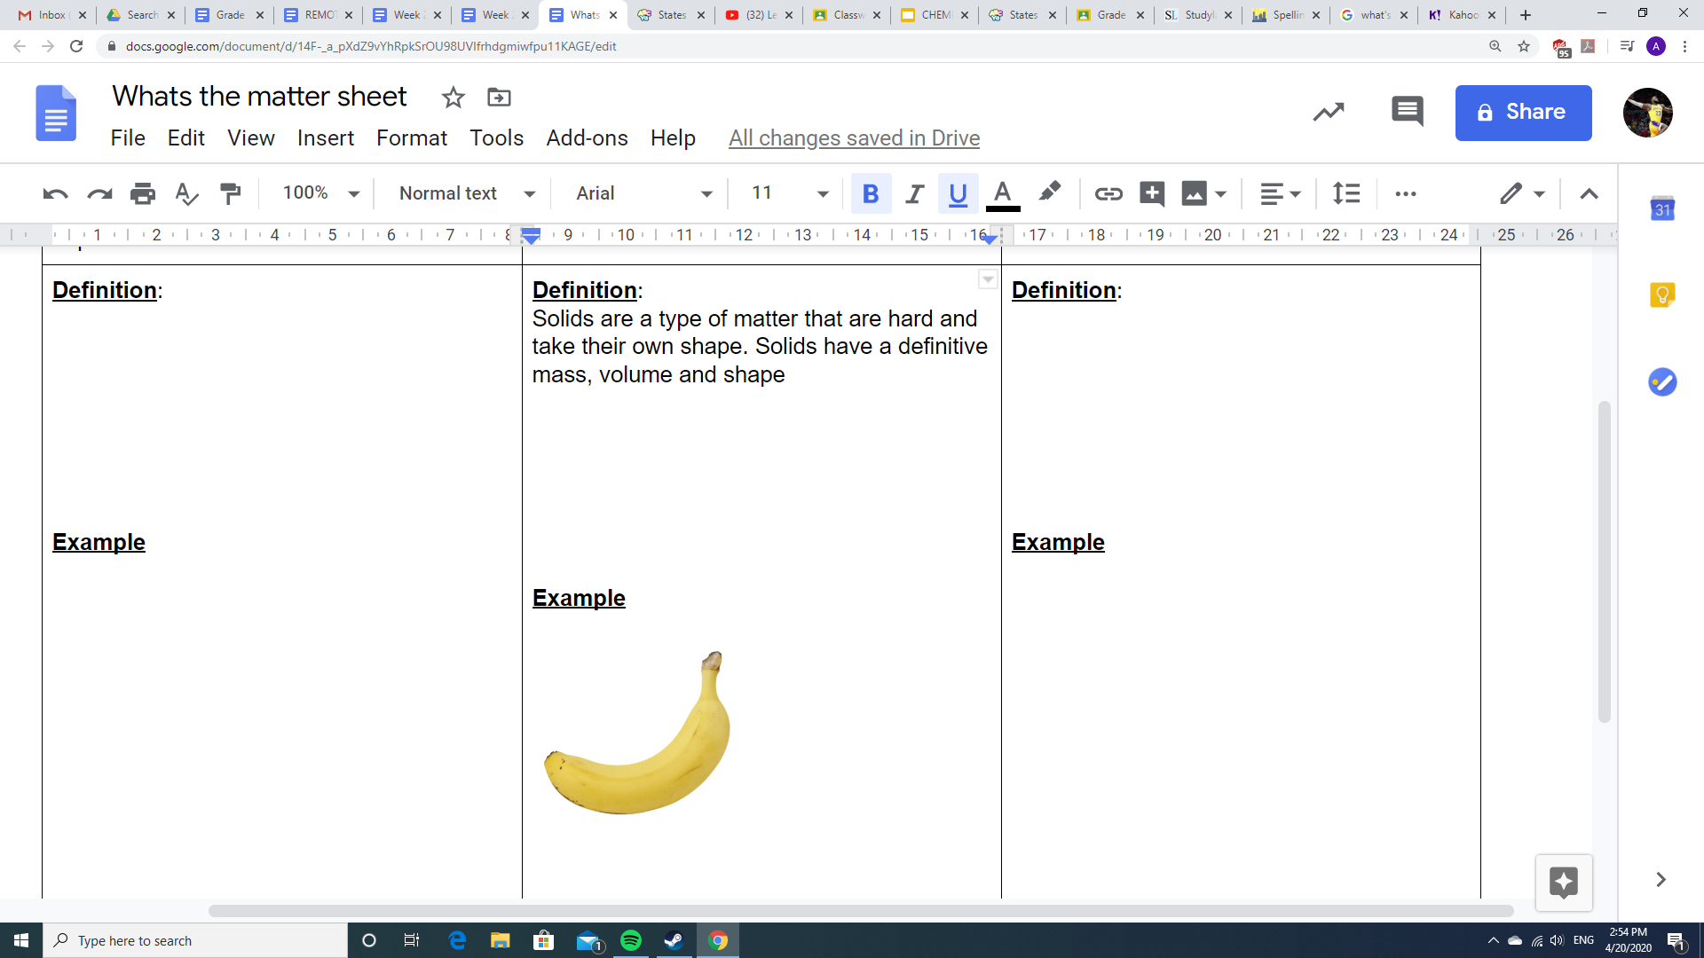  If you are having trouble completing the task on the document you can complete it on a piece of paper or in a book if you’d like.
2pm-2:30pm | SNACK BREAK
2:30pm-3:15pm | Art- Mrs Hickey Week 1  Please complete the Week 1 work given to you by Ms.Hickey. The link on how to complete the activity is below as follows:  https://docs.google.com/document/d/1M4Ej-2o4mvfTw53IQ_Io65PMpR_Cn4tp1ydffTVFfsY/edit  If you finish this activity finish off tasks from:  -Studyladder  -Spelling city  -Essential assessment  Your Grade 5 teachers (Mr P, Mr Nicholl & Miss Christie)

