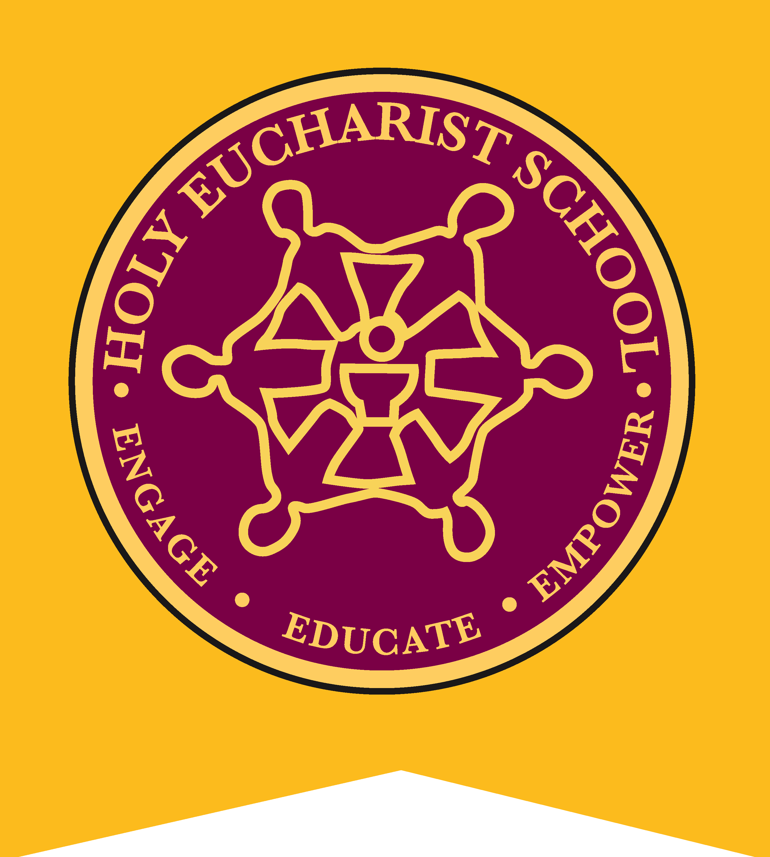
HOLY EUCHARIST CATHOLIC PRIMARY SCHOOL
1a Oleander Drive, St Albans South VIC 3021
www.hestalbanssth.catholic.edu.au
Friday 10th April 2020
NO SCHOOL TUESDAY 14TH APRIL
Dear Parents,
Term two will begin on Wednesday 15th April 2020.
As stated by the Premier, Daniel Andrews, “if any children can learn from home then they must.”
The Catholic Education Commission of Victoria have also advised:
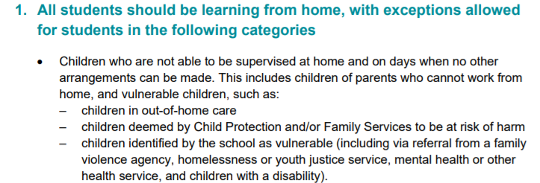
Holy Eucharist School is only open from Wednesday for:
- The children whose parents are Essential Service Workers, on the days when they are not able to supervise their children and no other arrangements can be made.
- For any children deemed at risk including children in out-of-home-care
ALL OTHER STUDENTS ARE TO STAY AT HOME
- IF ANY PARENT WISHES TO INQUIRE ABOUT HOME LEARNING PACKS PLEASE CONTACT THE SCHOOL OFFICE ON 8312 0900.
- FROM TUESDAY 14TH APRIL THE SCHOOL OFFICE WILL BE CLOSED. IF YOU HAVE ANY QUESTIONS OR CONCERNS PLEASE CONTACT THE SCHOOL ON 8312 0900.

Please continue to check school website regularly for the latest updates.

Mr Jeffrey Parker
Principal

