MUSIC WEEK 3

- These are hand signs for different notes. Can you do them? Start on the red DO

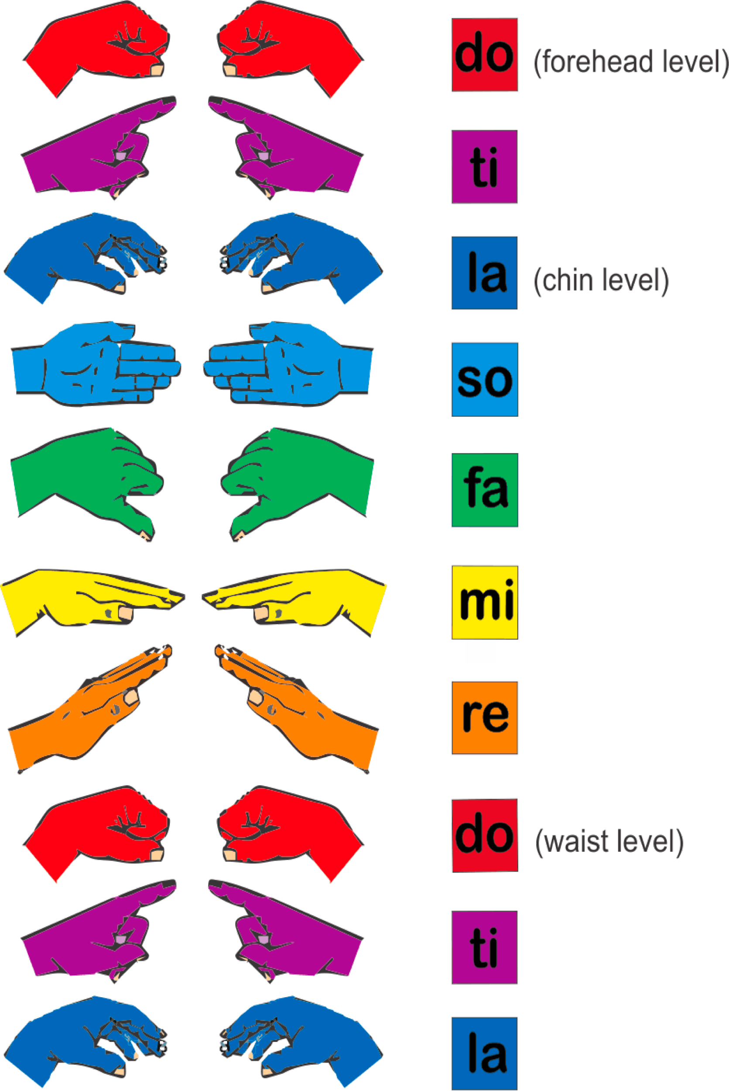
- These hand signs match these notes. Practise them this week. Find a piano app on Mum or Dad’s phone and see if you can play these notes and say the names.

