HOLY EUCHARIST CATHOLIC PRIMARY SCHOOL
1a Oleander Drive, St Albans South VIC 3021
www.hestalbanssth.catholic.edu.au

Music Term 2
Grade 1 & 2
Any questions or problems, just email me and I’ll answer back!
Stay safe and healthy!
Mr. O’Bree

Mr. O’Bree’s email is:
Damian.OBree@hestalbanssth.catholic.edu.au

You will need a piano or keyboard OR if you don't have one, get a piano app for your ipad.
You can download it on Mum or Dad’s phone or an ipad or tablet.

Week 1
Game:
Find the most interesting sound using anything around the house. Record it and try to email it to Mr. O’Bree, but DON’T tell us what it is. Let’s see who can guess it right!
I will let you listen to one next week. We will do a fun activity like this every week!

- Have a look at this song called Chopsticks.

- What notes do you see? (ta, ti ti, ta-a?)

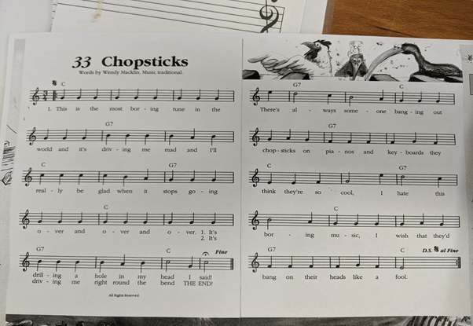

- This music is in groups of 3! Can you count how many groups of 3 there are?
- I want you to say the words in the rhythm that we would say it, like we do in Music class. (You can go as fast or as slow as you like )

- Say the words in the rhythm but say the first word in each group louder or stronger.
(THIS is the MOST boring TUNE in the WORLD….)

- Clap the rhythm as you say the words.

- This song has 2 parts. We will call those parts A and B.

- Click on the link and listen to A:
https://drive.google.com/open?id=1k9q9L3JebTyzmNU7fRiSAcdL6E4Bja_k

- Sing along with my recording.

- Let’s learn to play Part A. It starts on a G. Watch my video. Remember, you can go as slow as you like!
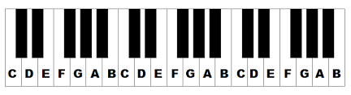
https://drive.google.com/open?id=1wVxRfCTtVGRAou4rOizQZeNPrOMmIyzW

- Keep practising that this week. Go as slow or as fast as you like!

- Here is a song we are going to sing at Mass when we are back at school. Click on the link.Try to sing along.
https://www.youtube.com/watch?v=9clU0ONvWJE
May God Be In Your Heart

May God be in your mind
May God be in your heart
May God be always looking over your shoulders

May God be in my mind
May God be in my heart
May God be always looking over my shoulders

God is in my mind,
in my thoughts all the time
God in my words,
God is my life

God is in my heart,
in the love that I share
God in all I do,
God is my prayer

God looks over me,
God looks after you
God is in me,

SEE YOU NEXT WEEK!

