HOLY EUCHARIST CATHOLIC PRIMARY SCHOOL
1a Oleander Drive, St Albans South VIC 3021
www.hestalbanssth.catholic.edu.au

Music Term 2
Grade 3 & 4
Any questions or problems, just email me and I’ll answer back!
Stay safe and healthy!
Mr. O’Bree

Mr. O’Bree’s email is:
Damian.OBree@hestalbanssth.catholic.edu.au

For our lessons this term, you will need a piano or keyboard OR if you don’t have one, download a piano app from the Apple Store or Google Play. I use Perfect Piano, but any piano app will do.
You can download it on Mum or Dad’s phone or an ipad or tablet.

Week 1
Game: Find the most interesting sound using anything around the house. Record it and try to email it to Mr. O’Bree, but DON’T tell me what it is. I will put someone’s up next week so everyone can guess.
We will do a fun activity like this every week!

- Have a look at this song called Chopsticks. The tune is very famous, but you may not have heard the words. If you play piano, you’ll know it. What notes do you see? (ta, ti ti, ta-a?)

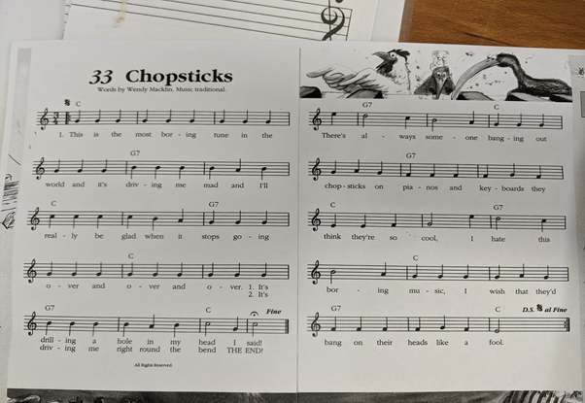

- How many beats in each bar? 3 or 4? (The bar is each section of the music, separated by a line). I want you to say the words in the rhythm that we would say it, like we do in Music class. (There is no tempo to this, so you can go as fast or as slow as you like )

- Say the words in the rhythm but say the first word louder or stronger. The first beat of a bar is the ACCENTED beat.

- Clap the rhythm as you say the words. Don’t forget the ta-a!

- This song has 2 parts. We will call those parts A and B.

- Click on the link and listen to A:
https://drive.google.com/open?id=1k9q9L3JebTyzmNU7fRiSAcdL6E4Bja_k

- Click on the link and listen to B:
https://drive.google.com/open?id=1rpfZ4cGVpYaDj4SRO35GGvAX55lG_ggh
- What was different about the 2 parts?

- Now click on the link and listen to it altogether:
https://drive.google.com/open?id=17r1DQZ3zrsaKtw1j32YdJV6LOJu0fE_J

- This term, we are going to learn about musical patterns and how to build a song with those patterns. Some songs have just 2 patterns, some have more than 2. This song has 2 patterns, so we call this song an A B pattern.

- Sing along with my recording.

- Let’s learn to play Part A. It starts on a G. Watch my video. Remember, you can go as slow as you like!
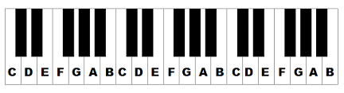
https://drive.google.com/open?id=1wVxRfCTtVGRAou4rOizQZeNPrOMmIyzW

- Keep practising that. If you get really good, get a little faster or sing along. Only try Part A this week. We’ll do Part B next week.

- Here is a song we are going to sing at Mass when we are back at school. This song also has an A B pattern, a verse and a chorus
- Try to sing along.
https://www.youtube.com/watch?v=9clU0ONvWJE
May God Be In Your Heart

May God be in your mind
May God be in your heart
May God be always looking over your shoulders

May God be in my mind
May God be in my heart
May God be always looking over my shoulders

God is in my mind,
in my thoughts all the time
God in my words,
God is my life

God is in my heart,
in the love that I share
God in all I do,
God is my prayer

God looks over me,
God looks after you
God is in me,

SEE YOU NEXT WEEK!

