HOLY EUCHARIST CATHOLIC PRIMARY SCHOOL
1a Oleander Drive, St Albans South VIC 3021
www.hestalbanssth.catholic.edu.au

Music Term 2
Grade 1 & 2
Any questions or problems, just email me and I’ll answer back!
Stay safe and healthy!
Mr. O’Bree
Mr. O’Bree’s email is:
Damian.OBree@hestalbanssth.catholic.edu.au
You will need a piano or keyboard OR if you don't have one, get a piano app for your ipad.
You can download it on Mum or Dad’s phone or an ipad or tablet.

Week 3

Game:
This week, I want you to find something around the house that makes a ringing sound!
Record it and try to email it to Mr. O’Bree, but DON’T tell us what it is. Let’s see who can guess it right!

- Let’s look again at our music for Chopsticks. You can print it out if you find it hard to read.
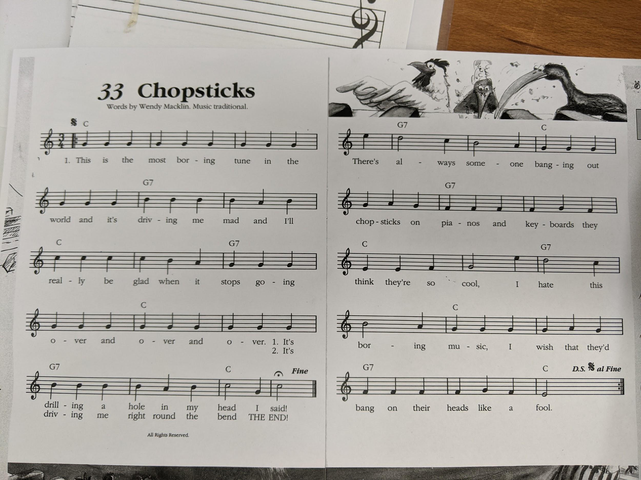

- Let’s say the words of Part A in the rhythm again and clap the rhythm as you say the words, but say the first word in each group louder or stronger. Remember, the music counts in 3’s - 1,2,3 1,2,3 1,2,3.
(THIS is the MOST boring TUNE in the WORLD….)
- Let’s listen to Part A again:
https://drive.google.com/open?id=1k9q9L3JebTyzmNU7fRiSAcdL6E4Bja_k
- Sing along with my recording.
- Let’s practise Part A again. It starts on a G. Watch my video. Remember, you can go as slow as you like!
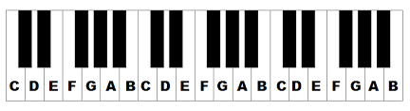 https://drive.google.com/open?id=1wVxRfCTtVGRAou4rOizQZeNPrOMmIyzW

- 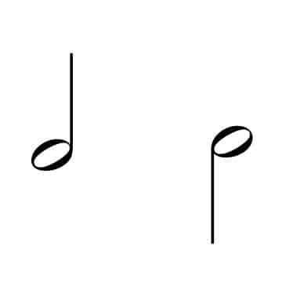This is a ta-a. It can have a stick going up or down. Can you see any in the song Chopsticks? How many are there?
- A ta-ais 2 beats. Put your hands together like a prayer and say ‘ta’. While holding them together, move your hands forward like you are diving in a pool and say ‘a’. Now do it together ‘Ta - a’

- TRY and clap the second page (Part B) of Chopsticks, and say ta 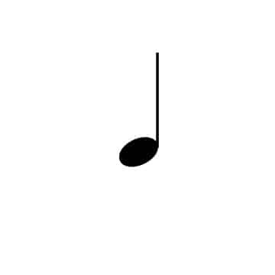and ta-awhile you are clapping.

- Remember, you can go as slow as you like. :)

If you practise that, we might try to learn how to sing and play Part B of Chopsticks.
- Let’s sing our song again for Mass
https://www.youtube.com/watch?v=9clU0ONvWJE
May God Be In Your Heart
May God be in your mind
May God be in your heart
May God be always looking over your shoulders

May God be in my mind
May God be in my heart
May God be always looking over my shoulders
God is in my mind,
in my thoughts all the time
God in my words,
God is my life

God is in my heart,
in the love that I share
God in all I do,
God is my prayer

God looks over me,
God looks after you
God is in me,

SEE YOU NEXT WEEK!

