HOLY EUCHARIST CATHOLIC PRIMARY SCHOOL
1a Oleander Drive, St Albans South VIC 3021
www.hestalbanssth.catholic.edu.au

Music Term 2
Grade 3 & 4
Any questions or problems, just email me and I’ll answer back!
Stay safe and healthy!
Mr. O’Bree

Mr. O’Bree’s email is:
Damian.OBree@hestalbanssth.catholic.edu.au

For our lessons this term, you will need a piano or keyboard OR if you don’t have one, download a piano app from the Apple Store or Google Play. I use Perfect Piano, but any piano app will do.
You can download it on Mum or Dad’s phone or an ipad or tablet.

Week 3
- Have a look again at Chopsticks.
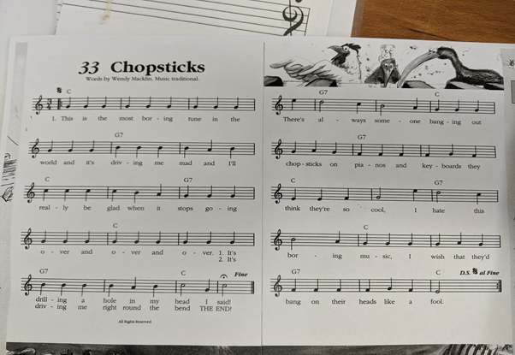

- Take a look at this picture
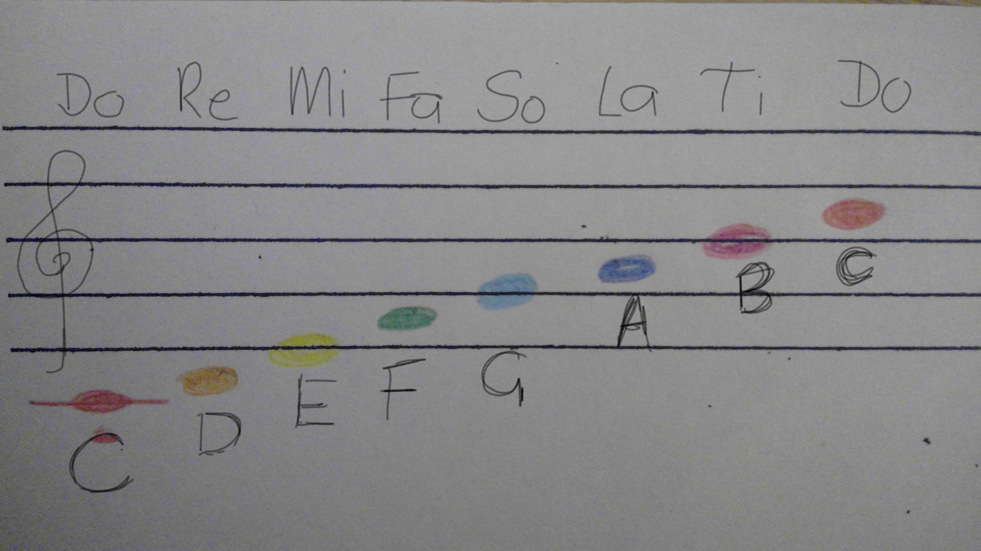
- These are the notes on the stave. You can see the letter names and some other names at the top. These names are called Solfa names. They help us to remember the note.

- What note does Part A of Chopsticks start on? What solfa name does it start on?

- Here are the solfa hand signs.You might remember them from last year. Start on the red DO at your waist and go to the high DO at your forehead.

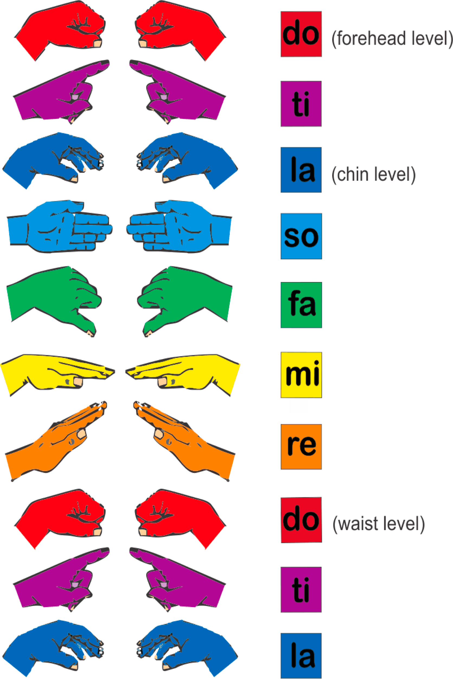
These are those notes on a keyboard. Do is C.
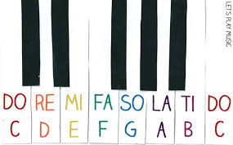

- Can you try and sing Part A of Chopsticks, but this time, instead of saying the words, use solfa words?

- Now try to play Part A while singing the solfa words at the same time. 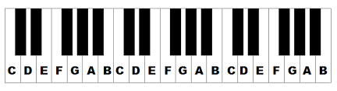
https://drive.google.com/open?id=1wVxRfCTtVGRAou4rOizQZeNPrOMmIyzW
- Keep practising singing, playing and using Solfa for Part A for this week. You don’t have to worry about Part B for this week. We’ll do more on that one next week.
- Let’s keep singing our song for Mass.
https://www.youtube.com/watch?v=9clU0ONvWJE
May God Be In Your Heart

May God be in your mind
May God be in your heart
May God be always looking over your shoulders

May God be in my mind
May God be in my heart
May God be always looking over my shoulders

God is in my mind,
in my thoughts all the time
God in my words,
God is my life

God is in my heart,
in the love that I share
God in all I do,
God is my prayer

God looks over me,
God looks after you
God is in me,

SEE YOU NEXT WEEK!

