Prep Music!
Term 2 Week 2

Hey Preps! I hope you are having a nice day!

Listen to this:
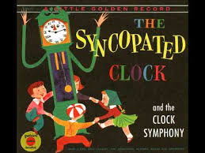
https://www.youtube.com/watch?v=CrpdQngwk2g

It’s called ‘The Syncopated Clock’
By Leroy Anderson

The music changes 3 times!

Can you do a different action when the music sounds different? Clapping? Stomping? Patting? Snapping?

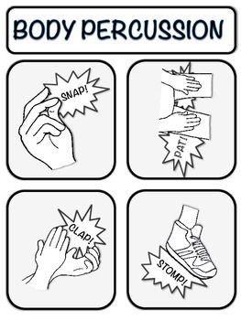

Now listen to a new song which has 2 different parts! You can do 2 different actions!

‘Baby Beluga’
https://www.youtube.com/watch?v=ZjTnENSYAcM

You can sing our other songs at home too!
Sing ‘A Sailor Went to Sea’ with your family.

Play ‘Who Stole The Cookie’ with your family.

Have a good week Preps!

Bye Bye!

Mr. O’Bree

