Prep Music!
Term 2 Week 3

Hey Preps! I hope you are having a nice day!

Listen to this our music again:
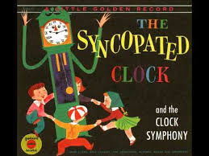
https://www.youtube.com/watch?v=CrpdQngwk2g

It’s called ‘The Syncopated Clock’
By Leroy Anderson

Can you find 3 things around the house to play when the music changes?

- Something that makes a tick tock sound
- Something to wave around the air (a scarf, tea towel)
- Something that makes a jingling or ringing sound (bells, keys)

Now listen to a new song which has 2 different parts! You can do 2 different actions!

‘Baby Beluga’https://www.youtube.com/watch?v=ZjTnENSYAcM

You can sing our other songs at home too!

Sing ‘A Sailor Went to Sea’ with your family.

Play ‘Who Stole The Cookie’ with your family.

