Prep Music!
Term 2 Week 2

Hey Preps! I hope you are having a nice day!

Make a music pattern using the pictures!

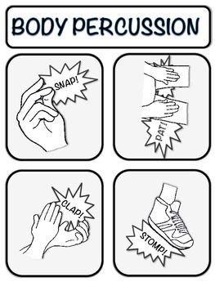

Draw a pattern using the pictures:

Sing ‘A Sailor Went to Sea’ with your family.
Play ‘Who Stole The Cookie’ with your family.

