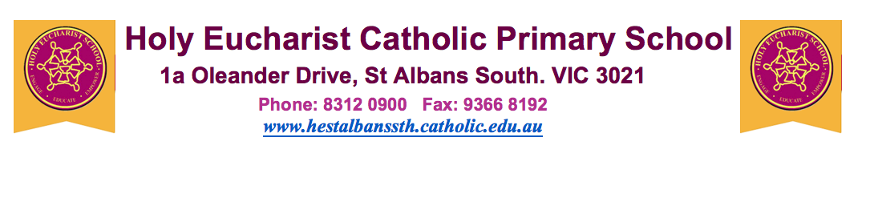

11th April 2020

Remote Schooling arrangements from the start of Term 2

Dear Parents, Guardians and Carers,

As you will be aware, the Victorian State Government has announced that all Victorian Schools will be implementing the Remote Schooling program effective 15 April 2020. This means that from the start of Term 2, most students will be learning from home.

This decision has been made to increase physical distancing across the population and prevent the transmission of coronavirus (COVID-19). Therefore, all students who can learn from home must learn from home.

All students at Holy Eucharist will commence Remote Schooling on 15 April 2020 at home except for:
- children of parents who cannot work from home;
- children who are not able to be supervised at home and no other arrangements can be made; and
- vulnerable children.

Remote Schooling tasks have been assigned to students by their teachers. Information about Remote Schooling and learning materials have been distributed to our parents/guardians in preparation for the Remote Schooling program. Additional learning materials will be provided throughout Term 2.

I wish to reassure you that the safety and wellbeing of our school community will remain our highest priority with physical distancing provisions being made for the safety of students and staff.

Please note that if you choose to send your child to school, your child will be supervised whilst undertaking the Remote Schooling program which has been designed by our school. As such, your child will be undertaking the same program as those children learning at home.

In addition, I wish to advise you that your child’s teacher will not necessarily be supervising your child on-site, but will continue to support your child through the Remote Schooling program as previously advised to you.

School staff will be available throughout the Remote Schooling program and you are asked to make contact directly with your child’s teacher if there are any concerns about your child’s wellbeing or learning program.

During this difficult time, we must all take care to support one another. Our thoughts and prayers are with those who may be unwell, and those who are working to keep our community safe.

If you require further information please feel free to contact me at Jeffrey.Parker@hestalbanssth.catholic.edu.au

Yours sincerely
Jeffrey Parker
(Principal)

