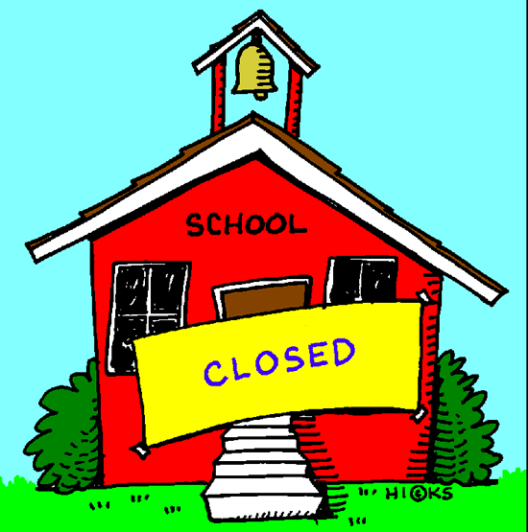
Term 2 Day 1
Good Morning Grade 5
Welcome back to Term 2
Hope you had a wonderful Easter.

Hope you have found a clear, quiet space to do your work.

All Grade 5 students have been sent a Learning from Home activity document via email or picked up an Activity Pack from the teacher.

If you are having trouble accessing it, understanding the set tasks or if you are missing any login information for any online learning website please email your classroom teacher.

Your schedule for today Term 2 Day 1 will be as follows:

9am-10am: Reading Activity
StudyLadder
Many students have not completed all assigned tasks. Some activities need more practise.
Complete as many activities as possible assigned on www.studyladder.com which include:
-Narrative My Visit to the Grand Bazaar – Read the story then answer the 10 questions. Enjoy what you read.
-Prefix origins
-Suffix origins
-Editing text-Spelling errors
-Grammar
- NAPLAN PRACTISE QUESTIONS.

SUFFIXES ( Use a dictionary to help you. )
A suffix is a few letters put at the end of a word to change its meaning.
Adding ‘able’ or ‘ible’ to the end of a word generally means that the subject is capable of or suitable for something. (Sometimes the ending of the base word is changed slightly before ‘able/ible’ is added.)
Take this sentence for eg. Holly’s new rain coat was reversible. It means the raincoat was capable of being reversed.
TASK:-
For each of these words, determine what the subject is capable of or suitable for and then use the word in a sentence. For eg: Edible Suitable for eating The decorations on the cake were made of icing and therefore were edible.

• breakable • disposable • believable • accessible • extendible • flexible Extension:

Make a list of at least 10 more words you can think of or find that end with the suffix ‘able/ible’.

10am-11am: Writing Activity

Watch BTN Episode 9 2020
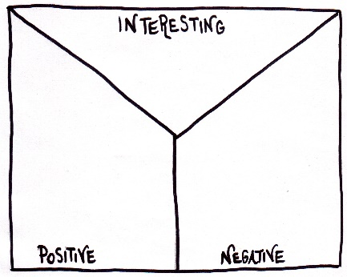
https://www.abc.net.au/btn/classroom/20200331-ep9-btn/12101064

Write some notes while watching the BTN Women’s History Month story.
Reflect and organise the notes into three categories in your book. You may want to watch the story again or look at the transcript on the BTN website to assist you with this activity. What information was...?
- Positive
- Negative
- Interesting

11-11:30am: BREAK

11:30-12:30pm: Many students have not completed the activities below. You will need to catch up.

NEW WAVE MENTAL MATHS – Complete Unit 3 Monday or Tuesday questions. Use an online Kids Maths dictionary to help you solve problems. http://amathsdictionaryforkids.com/dictionary.html

Learn about CHANCE / PROBABILITY.
WATCH THIS:
BAMZOOKI PROBABILITY
https://www.topmarks.co.uk/Flash.aspx?a=activity23
PLAY THIS: PROBABILITY FAIR https://mrnussbaum.com/probability-fair-online-game

STUDENTS WHO HAVE FINISHED THE ABOVE:-
ESSENTIAL MATHS
Many students have not completed the Pre Tests – Some Students have been assigned more difficult tests.
It is important that students complete assigned Pre Tests in order to be assigned My Learning Tasks.
https://www.essentialassessment.com.au/student/
Use your Username & Password to log into the website
- Complete the Addition and Chance pre assessments or retests.
- Complete the activities assigned to you in My Learning.

12:30pm-1:30pm-
Inquiry- Law & Order
If you have not completed this activity please complete.
3 LEVELS OF GOVERNMENT
https://www.peo.gov.au/sub-site/three-levels-of-government-game/index.html
-Play this game to learn about the responsibilities of each level of Government.

Those finished do this.
PASS THE BILL
Learn about how a Bill is passed by playing the interactive game:
http://kidsview.peo.gov.au/Pass-the-bill.html

-Write about the different steps in Passing a bill sequenced in the correct order.

1:30-2:15pm- BREAK

2:15-3:15pm-
WELL BEING
Write an email to your teacher ( 2 great sentences ) reflecting on your home learning experiences, to let your teacher know if you are connected to the home learning activities or if you are having any difficulties with any of the assigned tasks. Include one of the sentences below in your email describing your home learning.
Which of the following describes your learning at home experience so far? (Let us know.)
- I have completed all the assigned activities.
- I have completed some of the assigned activities.
- I have only just started my home learning activities.
- I have completed none of the activities.

Best of luck
Your Grade 5 Teachers,

Mr P, Mr Nicholl & Miss Christie

