HOLY EUCHARIST CATHOLIC PRIMARY SCHOOL
1a Oleander Drive, St Albans South VIC 3021
www.hestalbanssth.catholic.edu.au

Mandarin Term 2

Grade 1

Feel free to ask me any question relating to your Mandarin lessons!
Please stay safe!
Mrs. Huynh

Mrs. Huynh’s email is:
linda. huynh@hestalbanssth.catholic.edu.au

Week 1&2
Mandarin lessons start in week 2.
1. Look at the numbers chart below try to count the numbers 1-10
Numbers chart
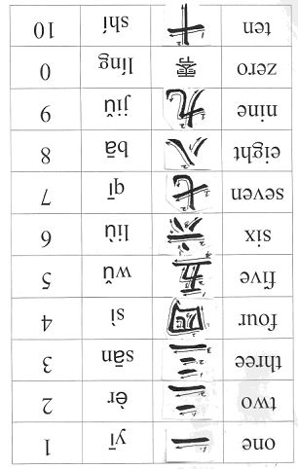
Activity 1 – Use one hand to count the Chinese numbers 1—10
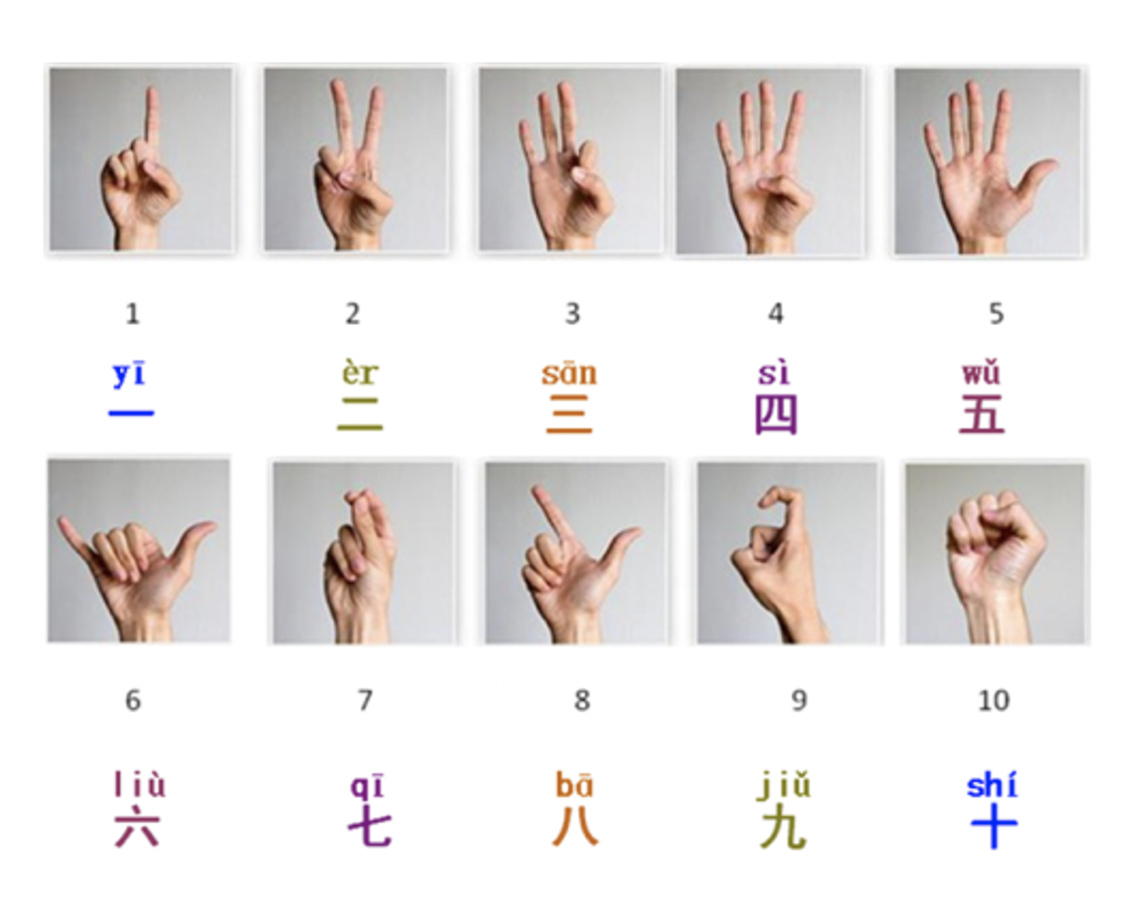
Activity 2 – Counting from 1-20 in Chinese

You try to read out the Chinese numbers
一 | 二 | 三 | 四 | 五 | 六 | 七 | 八 | 九 | 十
yi | èr | san | sì | wŭ | lìu | qi | ba | jĭu | shí
十  一 | 十  二 | 十  三 | 十  四 | 十  五 | 十  六 | 十  七 | 十  八 | 十  九 | 二  十
shí  yi | shí  èr | shí  san | shí  sì | shí  wŭ | shí  lìu | shí  qi | shí  ba | shí  jĭu | èr  shí

If you have access to internet, click on the links below.
Listen to the counting in the video and try to say the numbers out loud while you are following along.
When you have finished watching the video, try to count the Chinese numbers 1—20 by yourself.

Learn Chinese numbers 1—20
https://www.youtube.com/watch?v=1pd64abZZM8

Activity 3— Numbers worksheet (Write Chinese numbers 11—20. Then use Pinyin to write next to the English number.
Example: one yi ; Five wŭ ; nine jĭu

(If you can’t finish the worksheets, you will continue to finish it next week)
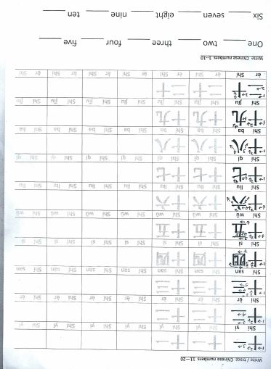

SEE YOU NEXT WEEK!

