HOLY EUCHARIST CATHOLIC PRIMARY SCHOOL
1a Oleander Drive, St Albans South VIC 3021
www.hestalbanssth.catholic.edu.au

Mandarin Term 2
Grade 2
Feel free to ask me any question relating to your Mandarin lessons!
Please stay safe!
Mrs. Huynh

Mrs. Huynh’s email is:
linda. huynh@hestalbanssth.catholic.edu.au

Week 1&2
Mandarin lessons start in week 2
【To Do List】
1. Look at the numbers chart below try to read the Chinese numbers 1-10.
2. Start counting Chinese numbers with your hand.
3. Look at the numbers chart below; try to count the Chinese numbers 1—30.
4. Complete the activities (If you can’t finish the worksheets, you will continue to finish
it next week).

Activity 1 – Use one hand to count the Chinese numbers 1—10
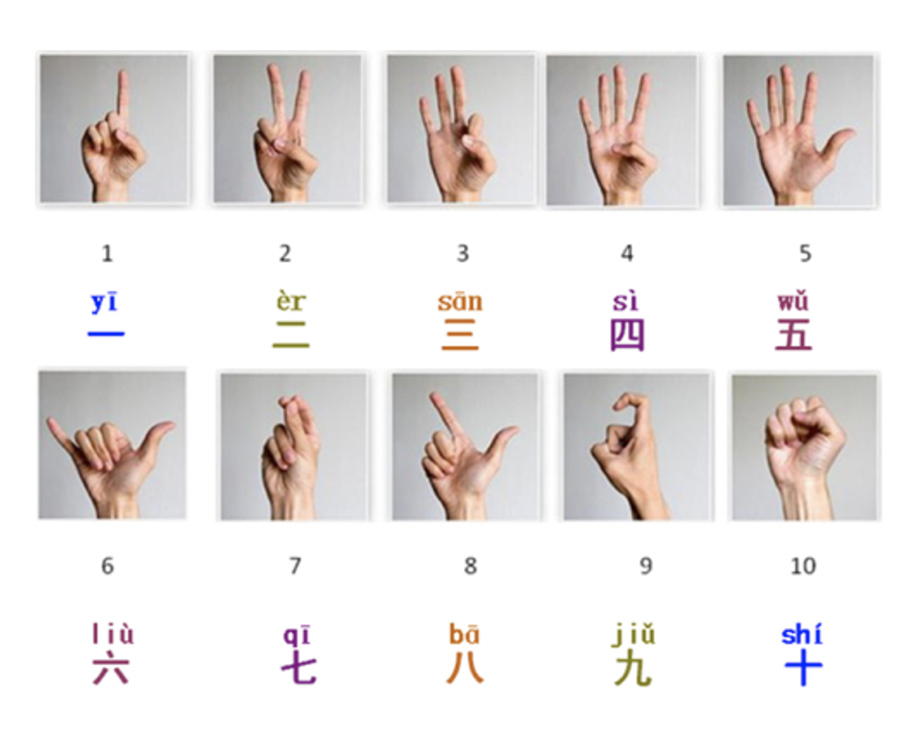
Chinese numbers chart

一 | 二 |  | 三 | 四 | 五 | 六 | 七 |  | 八 | 九 | 十
yi | èr |  | san | sì | wŭ | lìu | qi |  | ba | jĭu | shí
十  一 |  | 十  二 | 十  三 | 十  四 | 十  五 | 十  六 |  | 十  七 | 十  八 | 十  九 | 二  十
shí  yi |  | shí  èr | shí  san | shí  sì | shí  wŭ | shí  lìu |  | shí  qi | shí  ba | shí  jĭu | èr  shí
二  十  一 |  | 二  十  二 | 二  十  三 | 二  十  四 | 二  十  五 | 二  十  六 |  | 二  十  七 | 二  十  八 | 二  十  九 | 三  十
èr  shí  yi |  | èr  shí  èr | èr  shí  san | èr  shí  sì | èr  shí  wŭ | èr  shí  lìu |  | èr  shí  qi | èr  shí  ba | èr  shí  jĭu | san  shí

Activity 2--- Number worksheet Use Pinyin to write the numbers.

Example: 11 shí yi ; 15 shí wŭ ; 23 èr shí san ; 29 èr shí jĭu

2 ________ 5 ________ 8 ________ 3 ________

10 ________ 16 ___________ 19 ___________ 14 ___________

20 ___________ 27 ___________ 25 ___________ 30 ___________

Activity 3 -- Revision Chinese Zodiac

Chinese Zodiac

1. (老) 鼠 | (Lăo) shŭ | 2020 2008 | rat, mouse
2. 牛 | Níu | 2021 2009 | Cow ox
3. (老) 虎 | (Lăo) hŭ | 2022 2010 | tiger
4. 兔 子 | Tù zi | 2023 2011 | rabbit
5. 龙 | lóng | 2024 2012 | dragon
6. 蛇 | Shé | 2025 2013 | snake
7. 马 | mă | 2026 2014 | horse
8. 羊 | yáng | 2027 2015 | goat
9. 猴 (子) | Hóu (zi) | 2028 2016 | monkey
10. 鸡 | ji | 2029 2017 | rooster
11. 狗 | gŏu | 2030 2018 | dog
12. 猪 | zhu | 2031 2019 | pig

Match the Chinese characters with Pinyin; then you use Pinyin to write the number in order under the Chinese characters.

狗 | (老)虎 | 鸡 | 蛇 | 马 | 猴(子)

mă | Shé | Hóu zi | Lăo shŭ | gŏu | ji

龙 | (老)鼠 | 猪 | 羊 | 牛 | 兔 子

mă | Shé | Hóu zi | Lăo shŭ | gŏu | ji

Click on the links below. ( If you have access to internet)
Listen to the counting in the video and try to say the numbers out loud while you are following along.
When you have finished watching the video, try to count the Chinese numbers 1—30 by yourself.
https://www.youtube.com/watch?v=LpPs5RppA5A

See you next week!

