HOLY EUCHARIST CATHOLIC PRIMARY SCHOOL
1a Oleander Drive, St Albans South VIC 3021
www.hestalbanssth.catholic.edu.au

Mandarin Term 2
Grade Prep
Feel free to ask me any question relating to your Mandarin lessons!
Please stay safe!
Mrs. Huynh

Mrs. Huynh’s email is:
linda. huynh@hestalbanssth.catholic.edu.au

Week 1&2
Mandarin lessons start in week 2.
【To Do List】
1. Look at the numbers chart below try to read the Chinese numbers 1-10
2. If you can access to internet, click on the links below.
Listen to the counting in the videos and try to say the numbers out loud while you are following along.

Learn Chinese numbers 1--10
https://www.youtube.com/watch?v=Hh6_bsvYgkc
https://www.youtube.com/watch?v=2eLP3FuuEVs

Numbers chart
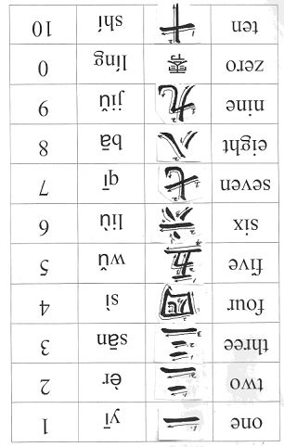
3. Complete the activities
Activity 1-- Tracing the Chinese number on the Number book (5--10)
If you have the Chinese number book from your teacher, use it to trace the number characters. If you do not have the book, you can collect it next week.

Activity 2 -- Trace the Chinese numbers then draw a line to match with the pictures.

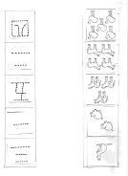
SEE YOU NEXT WEEK!

