HOLY EUCHARIST CATHOLIC PRIMARY SCHOOL
1a Oleander Drive, St Albans South VIC 3021
www.hestalbanssth.catholic.edu.au

Mandarin Term 2
Grade 5 & 6
Feel free to ask me any question relating to your Mandarin lessons!
Please stay safe!
Miss. Sun

Miss. Sun’s email is:
miyi.sun@hestalbanssth.catholic.edu.au

Week 1&2
Mandarin lessons start in week 2.
【To Do List】
1. Go through the PowerPoint slides (on Google Classroom Classwork)
2. Click on the little speaker signs to hear the pronunciation of the words
3. Complete the activities in the slides
【Assignment】
Once you’ve finished the activities, take a picture of the written works and upload it to show that you have completed the tasks.
I will give out reward stickers according to the number of tasks completed, so make sure you submit those assignments!

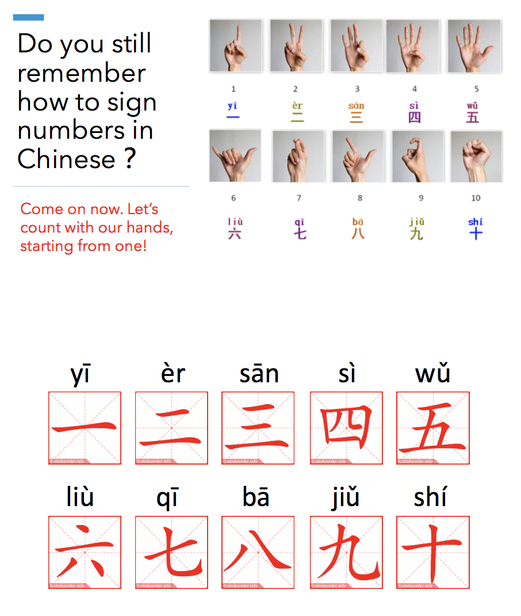
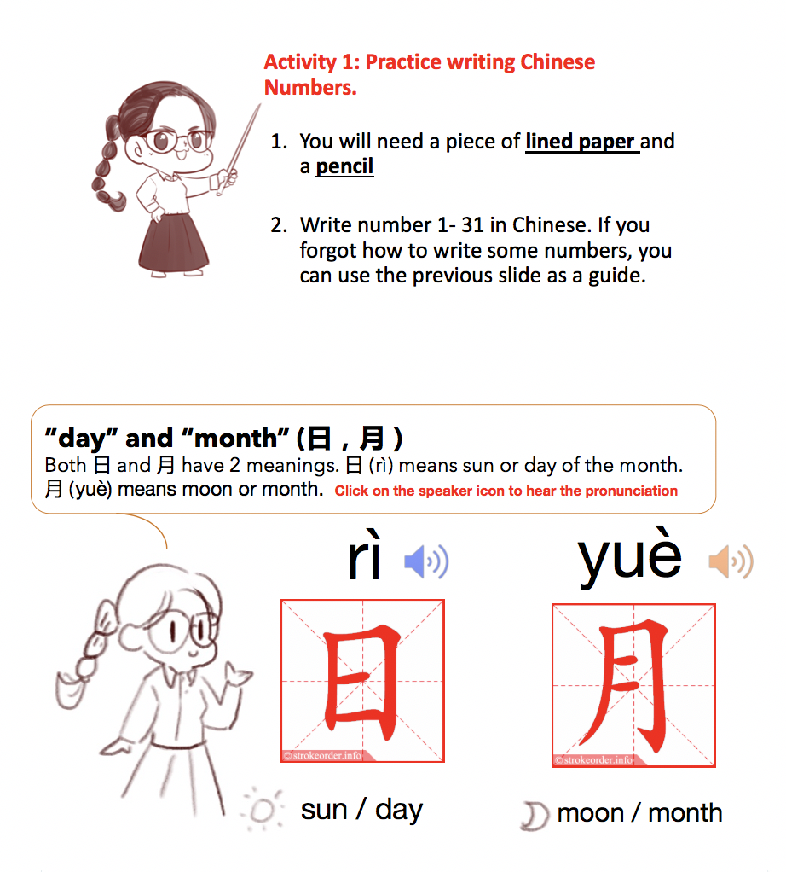
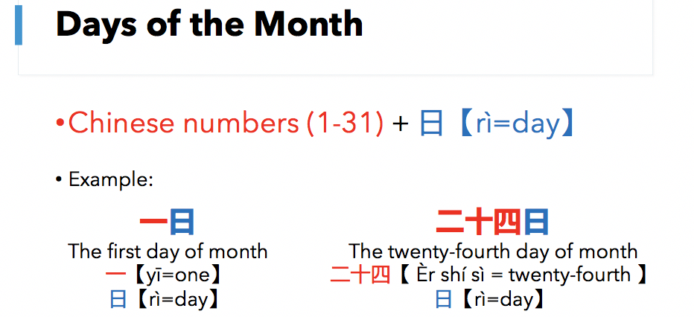
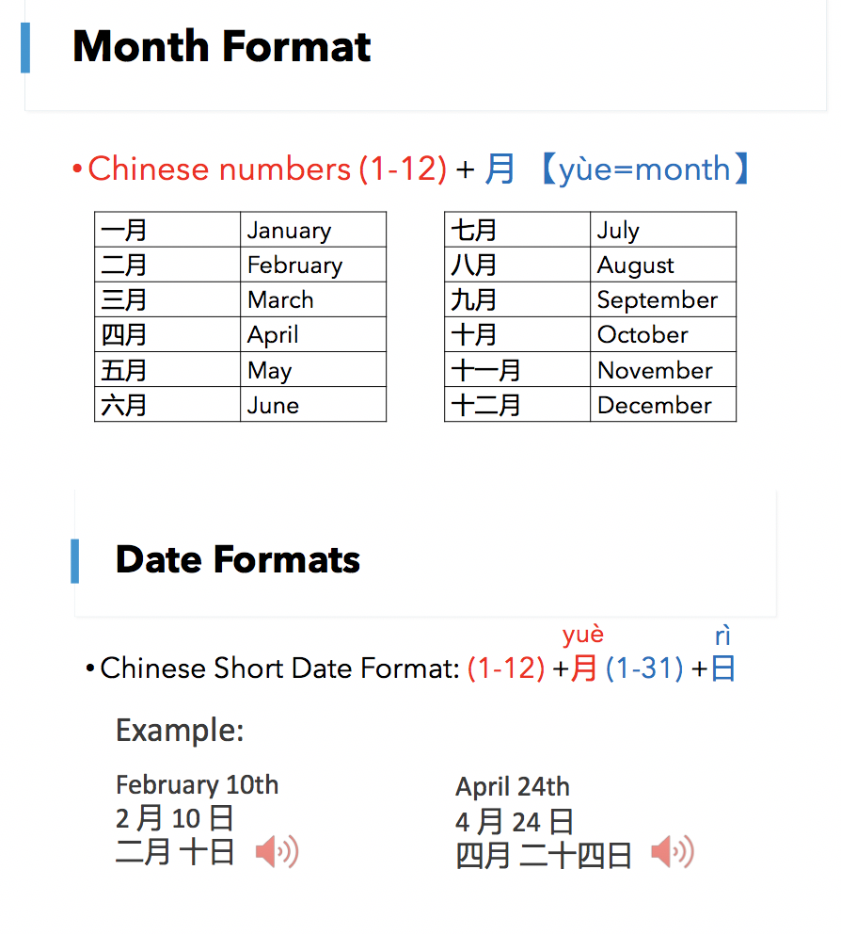
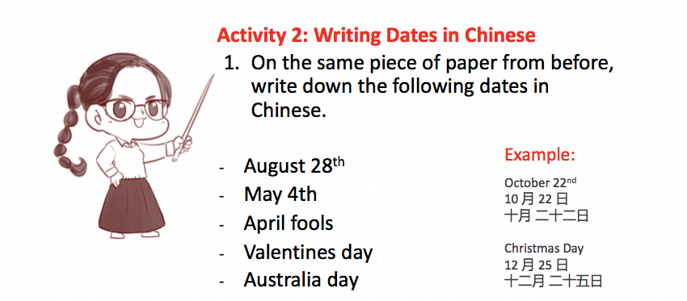
SEE YOU NEXT WEEK!

