HOLY EUCHARIST CATHOLIC PRIMARY SCHOOL
1a Oleander Drive, St Albans South VIC 3021
www.hestalbanssth.catholic.edu.au

Mandarin Term 2
Grade 3 & 4
Feel free to ask me any question relating to your Mandarin lessons!
Please stay safe!
Miss. Sun

Miss. Sun’s email is:
miyi.sun@hestalbanssth.catholic.edu.au

Week 3

【To Do List】
- Watch the video and then go through the PowerPoint slides
- Complete the activities in the slides

【Assignment】
Once you finished the activities, take a picture of the written works and upload it to show that you have completed the tasks. I will give out reward stickers according to the number of tasks completed, so make sure you submit those assignments!
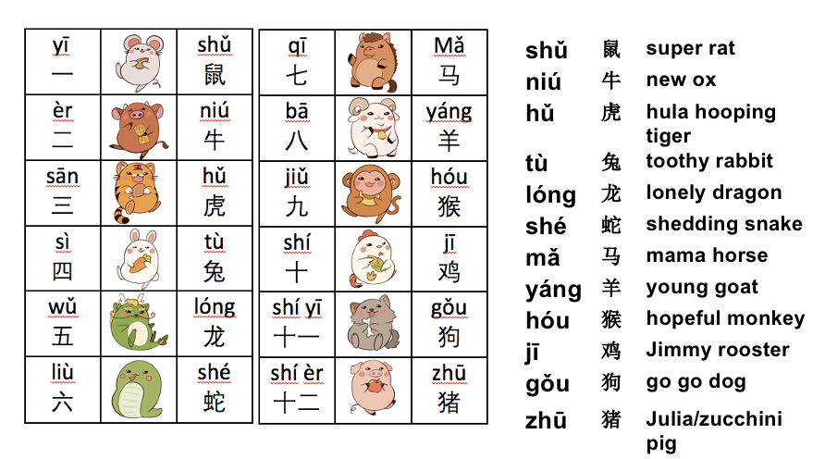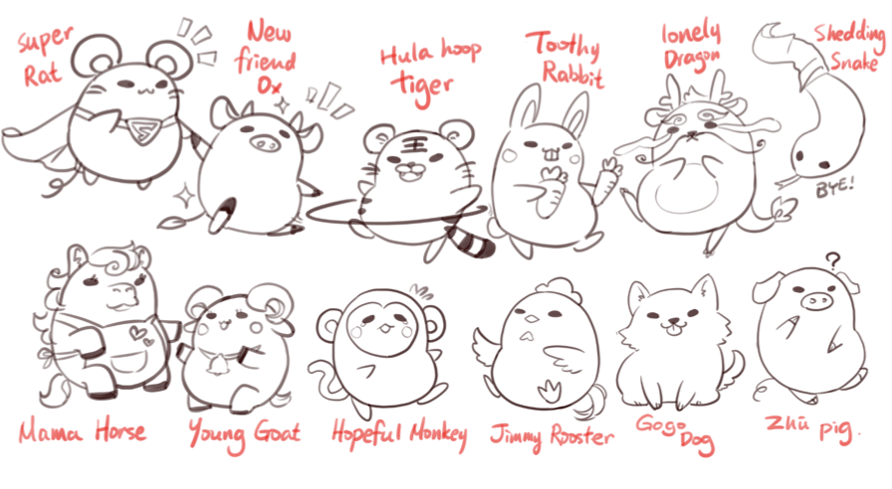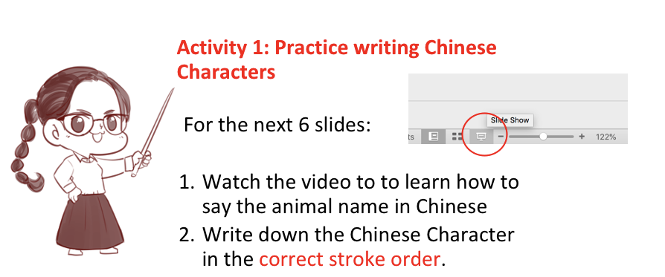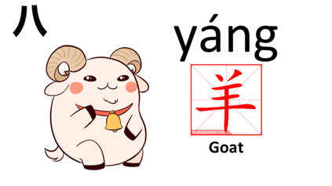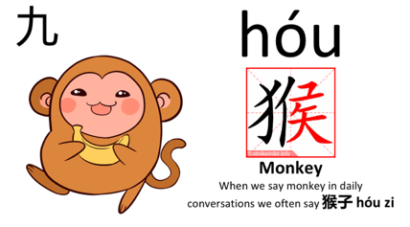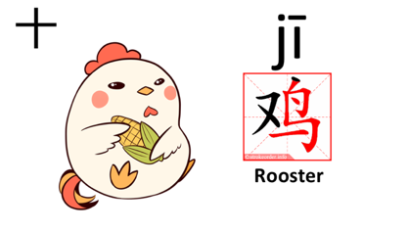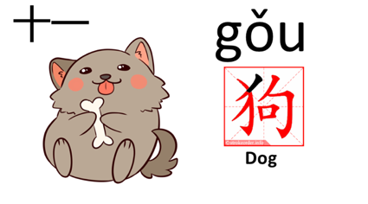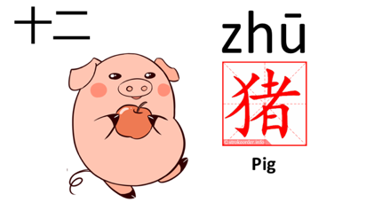
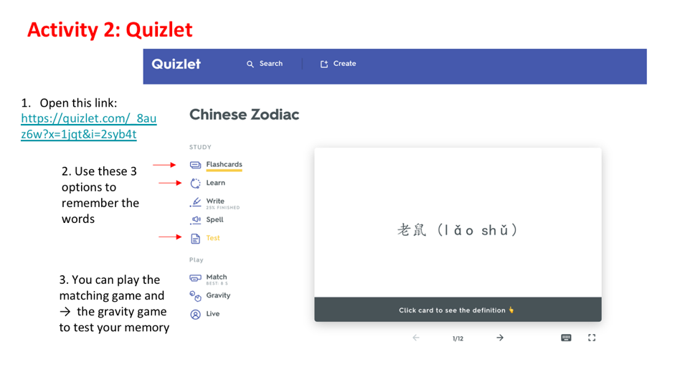
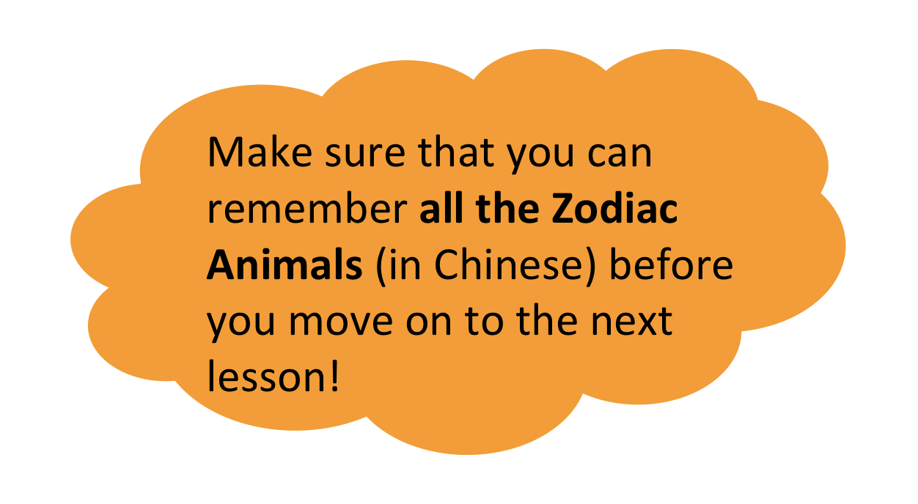

SEE YOU NEXT WEEK!

