GRADE 5 TIMETABLE
Grade 5 Home Learning Schedule
Tuesday 28th of April, 2020
IMPORTANT INFORMATION ABOUT YOUR HOMEWORK PACKS:
If you still haven’t picked up your new Homework pack from school last Friday- you are required to pick it up as you will need the resources for your Remote Learning during Week 3 & 4.
GOOGLE MEET @ 9am - Check Google classroom home page banner for login link
GOOGLE MEET RULES:
- Please keep your microphone off unless you wish to speak or ask a question.
- Wait patiently until it is your turn to speak.
- If you wish to speak to friends, log in early or do this at the end of our meeting.
THANK YOU.
GOOGLE CLASSROOM COMMENTS: Please DO NOT make unnecessary comments on our posts. Only use the comments for questions you have about your learning. Thank you.
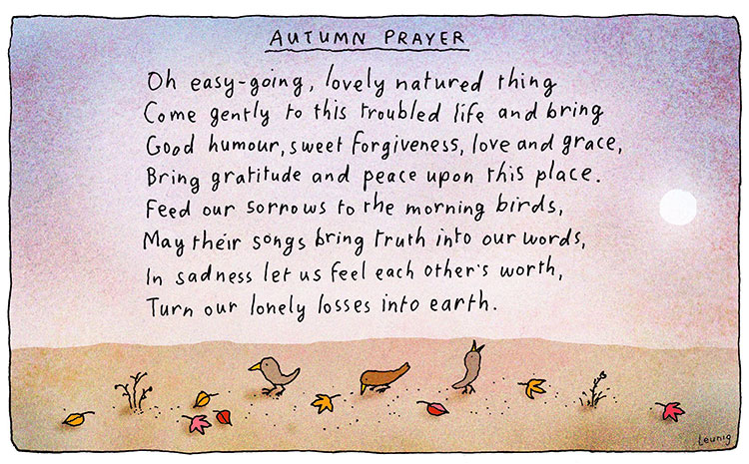
Grade 5 Morning Prayer...

Our focus for today’s prayer is on the season of Autumn. What changes in nature have you noticed recently?

The daylight hours are shorter, the leaves on the trees have changed colour and now they are starting to fall to the ground.

These changes in nature also encourage us to reflect and think about What we ourselves can let go of? (worries, fears, failures, disappointments, habits etc.)
Remember that when we let go of these things that are holding us back that encourages growth in our own lives.
9:30-10:15am | 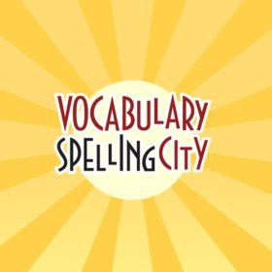  LITERACY- SPELLING FOCUS: -ee words  -Log onto www.spellingcity.com and complete the latest unit of work assigned to you by your teacher with ‘ee’ words.  -After completing the activities on spelling city complete the spelling matters Unit 5 “ee sheet” that you would’ve received in your OLD homework pack.  -The worksheet has been posted in ‘Classwork’ if you do not have your own paper copy. You will just have to write your answers in an exercise book or on some paper.
10:15-11am? | WRITING- Sizzling Starters (Action)  -Watch the start of the Angry Birds Movie  https://www.youtube.com/watch?v=8LA4MUBiqR0&feature=youtu.be&t=72  -Write an exciting introduction about the Angry birds movie clip using a sizzling starter.  -Your paragraph should be at least 5-6 sentences long. Be as descriptive as possible- really think about what the Angry bird can see, hear, feel, touch, smell etc.
11am-12pm | LUNCH BREAK
GOOGLE MEET TODAY @ 12pm - See Google Classroom banner for login link
12:30-1:15pm | Digital Technologies w/ Miss Borg  -Today you have another Digital Technology lesson as this is your usual time allocated to this subject at school.  -Miss Borg will post on the stream with what activities she would like you to complete during this time. Please see Miss Borg’s post for instructions.
1:15pm-2pm | RELIGION- GENEROSITY IN THE CHURCH- Organisation Project  -Continue working on your Google Slides Presentation individually or with a partner.  YOUR TASK:  -Design a Google Slides presentation on one organisation that shows generosity.  -Use suitable pictures to support your presentation. Be creative.  -Once complete- please revise your work for spelling, grammar or formatting errors.  -Your final task is to complete your ‘Organisation Project- Self assessment’ found in classwork and then submit for your teacher to assess. Also share your Google Slide with your classroom teacher.
2pm-2:30pm | SNACK BREAK
2:30-3:15pm | 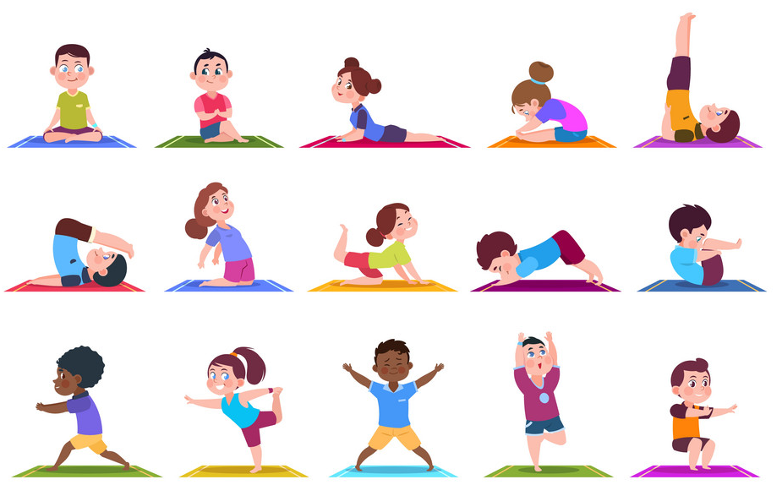  Sport - Daily Physical Activity  -Mr Herrera has set Physical Activities for you to complete each day to keep your body and mind healthy whilst undertaking Remote Learning.  -Please see his task set in Classwork under Physical Education. Open the planner and find Week 2- Tuesday’s (Meditation & Yoga) task. Relax & Enjoy!

Keep up the great work with your Remote Learning- We are cheering you on from afar! :)

Your Grade 5 teachers (Mr P, Mr Nicholl & Miss Christie)

