GRADE 5 TIMETABLE
Grade 5 Home Learning Schedule
Week 7 Day 3,
Wednesday 27th of May, 2020
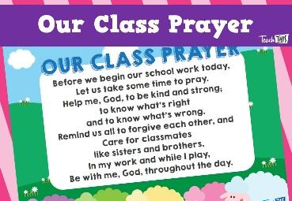
Prayer for the day...

ANNOUNCEMENTS:
Please read and follow all announcements and lesson instructions carefully before beginning your learning.

GOOGLE MEET @ 9am - Check Google classroom home page banner for login link.

MARK THE ATTENDANCE ROLL.

GOOGLE MEET RULES: Please remember these when meeting together.

COMMENTS: Please DO NOT make unnecessary comments on our posts. Only use the comments for questions you have about your learning.
Thank you.

WORK PACKS.
No work packs unless you did not pick yours up last Friday. You will need the activities to compete Daily Scheduled activities this week.

9:30-10:15am | Reading  SPELLING – Unit 8 - ‘ou’ as in round  WILT: I am learning the meaning of new words and how to use these in context.  Log into your Spelling City account and complete the assigned activities.  Complete the Spelling Matters Unit 8 from your home pack.  Use a dictionary and internet sites to help you complete all activities successfully.  EARLY FINISHERS OR NO HOME PACK:  Write 5 words you didn't know into sentences.  Make a find a word using 10 of your spelling words.  Write the 10 words in alphabetical order.
10:15-11am | WRITING- Letter to Australia (Final Copy)  Continuation from Yesterday’s Lesson  Use your Draft of a written ‘Letter to Australia’ about your experience of the COVID-19 pandemic.  Today you will use the provided A4 lined paper in your work pack to neatly and clearly write your letter.  - Please set out your letter correctly using the provided format.  Dear Australia,  From  - Make sure you use your very best handwriting to write your letter.  - Fix up any mistakes in your draft letter using the teacher’s suggestions.  Have you provided enough detail in your letter?
11am-12pm | LUNCH BREAK
NO GOOGLE MEET @ 12pm- PLEASE SEE MISS SUN’S WORD OF THE WEEK & ASSIGNMENT
12pm-1pm | LOTE with Miss Sun  Please go to Google Classroom- ‘Classwork’ and look for ‘Miss Sun LOTE for Term 2 Week 7’ folder and you will find her assignment set for this week.  IF YOU HAVE ANY ISSUES WITH THIS TASK PLEASE EMAIL MISS SUN ON HER EMAIL ADDRESS: miyi.sun@hestalbanssth.catholic.edu.au
1pm-2pm | 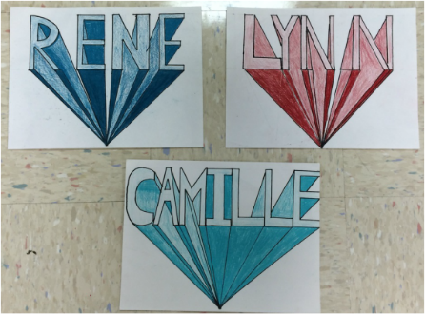  ART with Ms Hickey  Please go to Google Classroom- ‘Classwork’ and look for ‘ART: Mrs Hickey’ and you will find her assignment set for Classwork for Week 7 – Technical Art / Using Block Letters.  Please also refer to Mrs Hickey’s post and video.  IF YOU HAVE ANY ISSUES WITH THIS TASK PLEASE EMAIL MRS HICKEY ON HER EMAIL ADDRESS: shobha.hickey@hestalbanssth.catholic.edu.au
2pm-2:30pm | SNACK BREAK
2:30-3:15pm | PHYSICAL EDUCATION with Mr Herrera  Google Meet at 2.30  Please go to Google Classroom- ‘Classwork’ and look for ‘PHYSICAL EDUCATION’ Week 7 Term 2 and you will find your YOGA assignment set by Mr Herrera for PE. Please also refer to Mr Herrera’s post on the stream.  IF YOU HAVE ANY ISSUES WITH THIS TASK PLEASE EMAIL MR HERRERA ON HIS EMAIL ADDRESS:  heribert.herrera@hestalbanssth.catholic.edu.au

