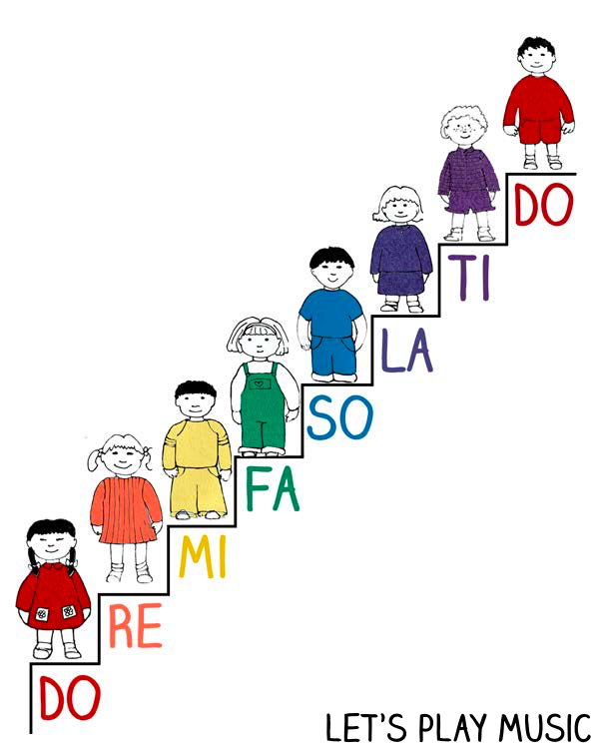
________________________________________________________

________________________________________________________
Do
___________________________________________Ti___________
La
_____________________________So_________________________
Fa
_________________Mi_____________________________________
Re
---Do---

