HOLY EUCHARIST CATHOLIC PRIMARY SCHOOL
1a Oleander Drive, St Albans South VIC 3021
www.hestalbanssth.catholic.edu.au

Music Term 2
Grade 1 & 2
Any questions or problems, just email me and I’ll answer back!
Stay safe and healthy!
Mr. O’Bree
Mr. O’Bree’s email is:
Damian.OBree@hestalbanssth.catholic.edu.au
You will need a piano or keyboard OR if you don't have one, get a piano app for your ipad.
You can download it on Mum or Dad’s phone or an ipad or tablet.

Week 4
Game:
This week, I want you to make the weirdest sound you can make using things around your house. How weird can your sound be?
- Let’s look a little closer at Part B for Chopsticks. You can print it out if you find it hard to read.
- Remember our ta-a from last week? Part B of Chopsticks has more ta-a’s than Part A.
- Can you count how many there are?
https://drive.google.com/open?id=1_LFbDOh3S65PRjofI2tEIXct-MNgZcP3
This is Part B. Have a listen and follow your music. Remember to count in 3’s: 1,2,3 1,2,3
https://drive.google.com/open?id=1N674acCbeGEkTHPu2AFEOcG7p1PJ7i38

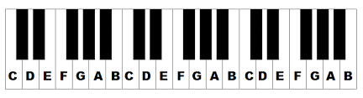
- Remember, you can go as slow as you like. :)
- If you want to, you can try Part A and B together, but you don’t have to.
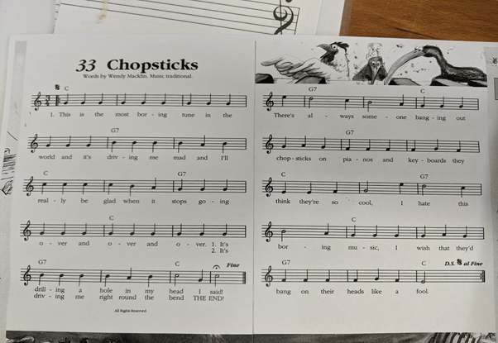
Let’s have some fun to finish our Music lesson. Watch this funny video. The music is called ‘The Typewriter’. It was written by a man called Leroy Anderson. Ask your family member what a typewriter is.
Is it an instrument?
https://www.youtube.com/watch?v=XAHlM8LNeDE

SEE YOU NEXT WEEK!

