HOLY EUCHARIST CATHOLIC PRIMARY SCHOOL
1a Oleander Drive, St Albans South VIC 3021
www.hestalbanssth.catholic.edu.au

Music Term 2
Grade 3 & 4
Any questions or problems, just email me and I’ll answer back!
Stay safe and healthy!
Mr. O’Bree

Mr. O’Bree’s email is:
Damian.OBree@hestalbanssth.catholic.edu.au

For our lessons this term, you will need a piano or keyboard OR if you don’t have one, download a piano app from the Apple Store or Google Play. I use Perfect Piano, but any piano app will do.
You can download it on Mum or Dad’s phone or an ipad or tablet.

Week 4

Game: Make a pitched note, from something around your house, That means, a note that you can hum. See if you can find out what not it is on your piano, keyboard or app.
(Example: If you fill a glass with water and tap the glass, it makes a note. The more water the lower the note. The less water the higher the note.)
- Let’s look at another song. This is called Haida, a Hebrew folk song. Like Chopsticks, it also has a Part A and a Part B. But unlike Chopsticks, you can sing Part A and Part B together.
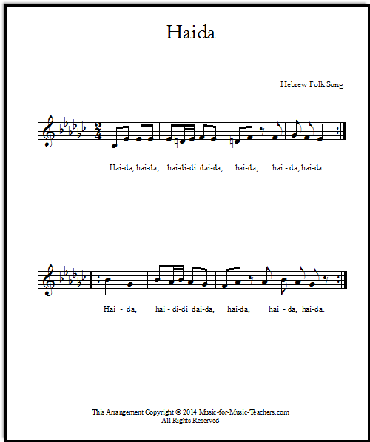
Listen to the YouTube clip of a choir singing it and see if you can sing along with either Part A or B:
https://www.youtube.com/watch?v=UXvtL53plc4
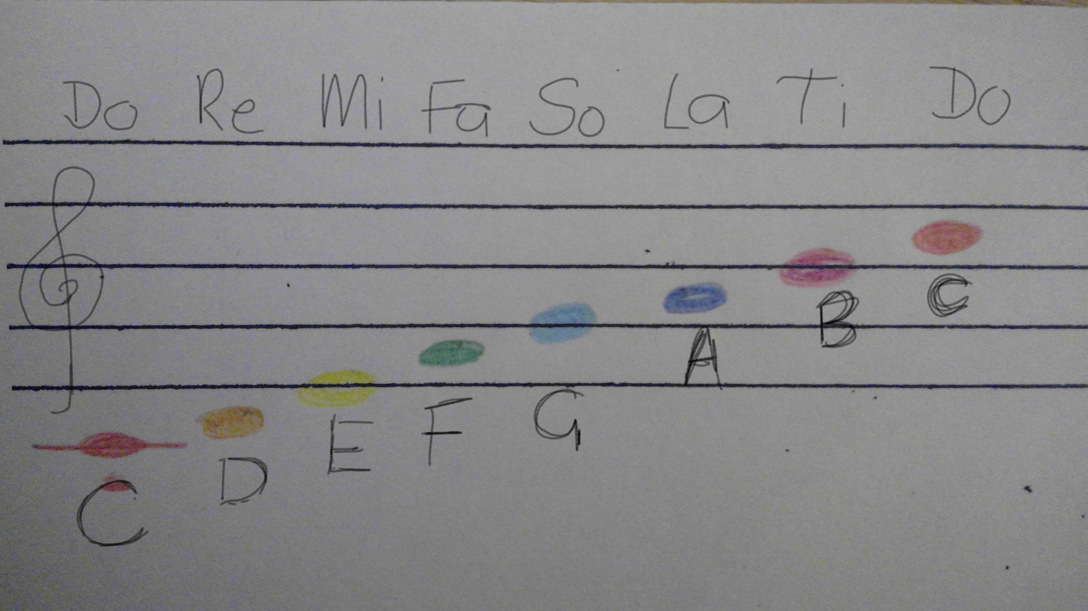

- Keep practising your Solfa hand signs. Start on the red DO at your waist and go to the high DO at your forehead.
https://drive.google.com/open?id=1TgXcL8zkCQsk2KYPKHizcviRFQuvMAAs
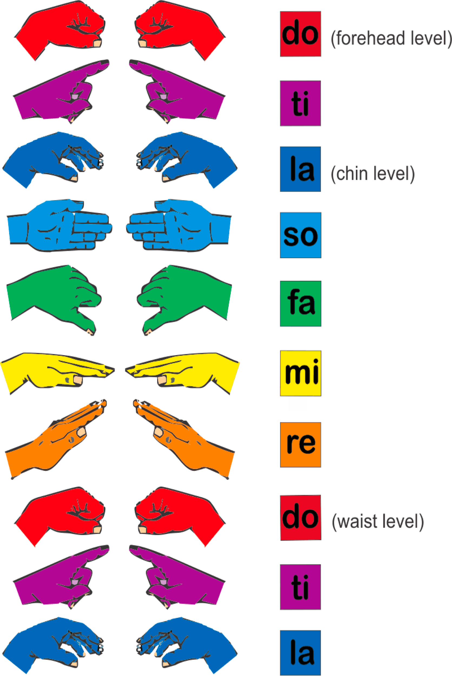
These are those notes on a keyboard. Do is C.
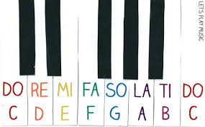

- 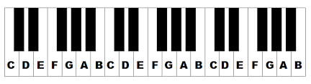
https://drive.google.com/open?id=1wVxRfCTtVGRAou4rOizQZeNPrOMmIyzW
- Let’s look a little closer at Part B for Chopsticks.
https://drive.google.com/open?id=1N674acCbeGEkTHPu2AFEOcG7p1PJ7i38
Remember, Part B has more ta-a’s. They are held for 2 beats.If you’ve forgotten how to count a ta-a, here’s a video I did for Gr. 1 and 2 to refresh your memory.
Concentrate on practising just Part B this week...and having a sing along with Haida
- Let’s keep singing our song for Mass.
https://www.youtube.com/watch?v=9clU0ONvWJE
May God Be In Your Heart

May God be in your mind
May God be in your heart
May God be always looking over your shoulders

May God be in my mind
May God be in my heart
May God be always looking over my shoulders

God is in my mind,
in my thoughts all the time
God in my words,
God is my life

God is in my heart,
in the love that I share
God in all I do,
God is my prayer

God looks over me,
God looks after you
God is in me,

SEE YOU NEXT WEEK!

