HOLY EUCHARIST CATHOLIC PRIMARY SCHOOL
1a Oleander Drive, St Albans South VIC 3021
www.hestalbanssth.catholic.edu.au

Music Term 2
Grade 5 & 6
Any questions or problems, just email me and I’ll answer back!
Stay safe and healthy!
Mr. O’Bree

Mr. O’Bree’s email is:
Damian.OBree@hestalbanssth.catholic.edu.au

For our lessons this term, you will need a piano or keyboard OR if you don’t have one, download a piano app from the Apple Store or Google Play. I use Perfect Piano, but any piano app will do.
You can download it on Mum or Dad’s phone or an ipad or tablet.

Week 4

- Take a closer look again at Part B of Chopsticks.

- We have crotchets (ta’s) and minims (ta-a’s) . If you’ve forgotten how to clap out a ta-a, watch the video I did for the Gr 1 & 2’s.
https://drive.google.com/open?id=1_LFbDOh3S65PRjofI2tEIXct-MNgZcP3
- Now clap out Part B very slowly remembering that each bar (section) has 3 beats. A ta-a and a ta = 3 beats. Get a little faster each time you do it. Say the words in the rhythm of the song. The first beat in Part B is actually the 3rd beat continuing on from the last bar of PART A.
Keep practising your hand signs. Remember, DO is C. We go from C to C, which is an OCTAVE (8 notes).

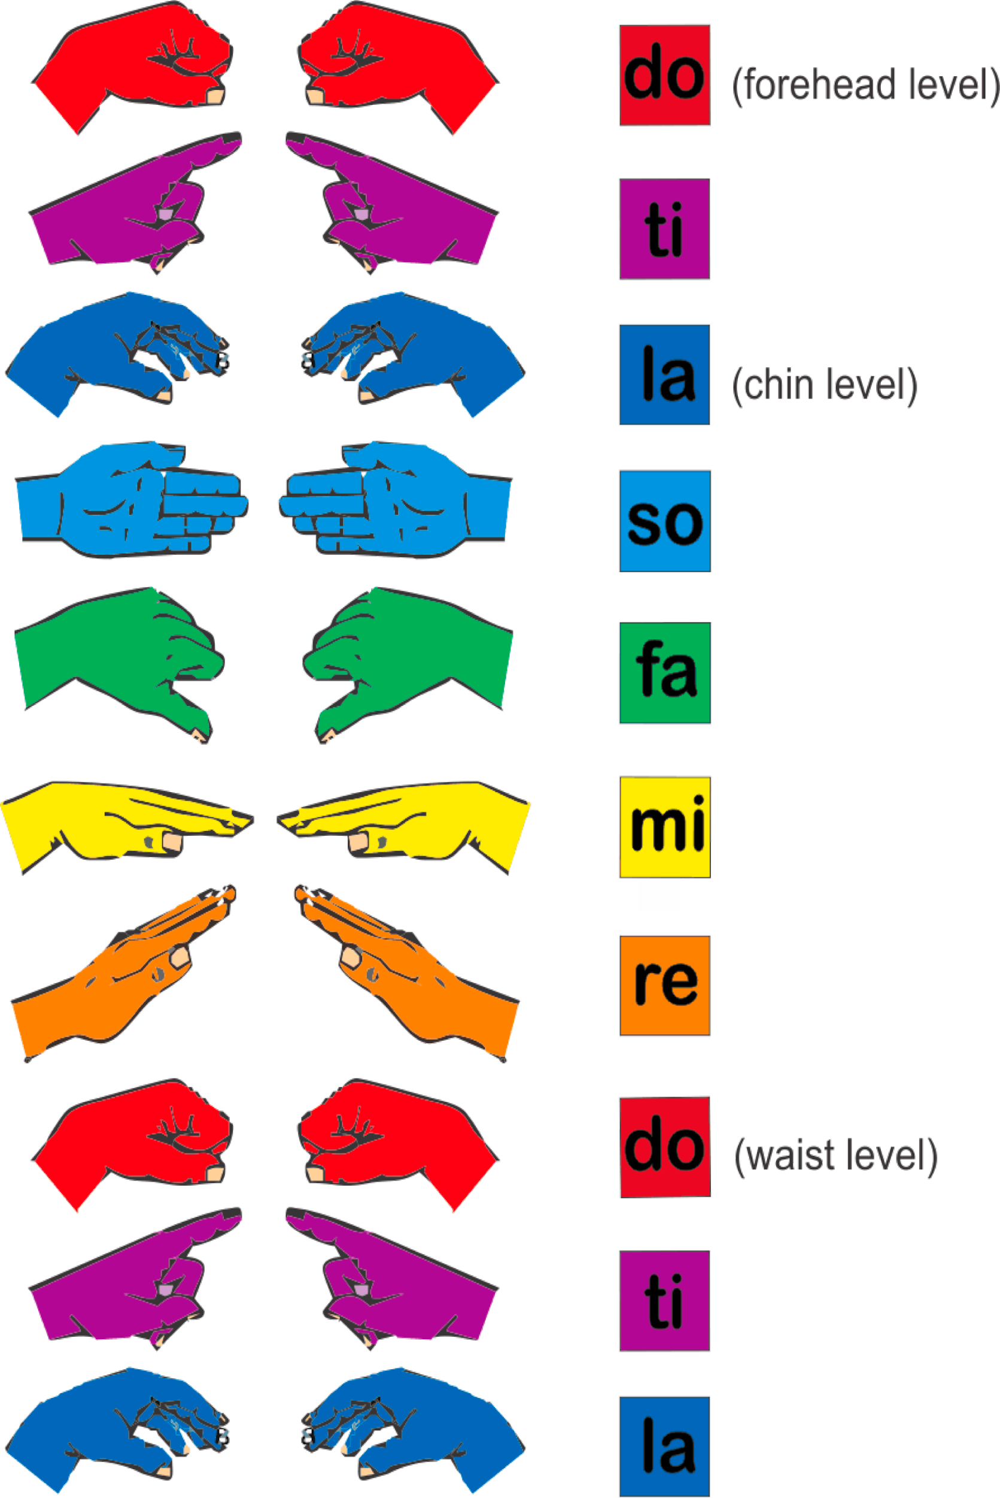

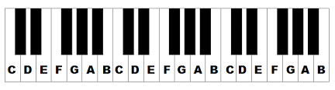
Now try to play Part B while singing the solfa words (Do Re Mi) at the same time. Watch my video. Remember, you can go as slow as you like!
https://drive.google.com/open?id=1N674acCbeGEkTHPu2AFEOcG7p1PJ7i38

- Keep practising singing, playing and using Solfa language (Do Re Mi) for both Part A and B for this week.

- Let’s finish with a bit of fun. Below is a link to a piece of music called ‘Plink, Plank,Plunk’ by Leroy Anderson. Listen to the piece of music and answer the questions.
https://www.youtube.com/watch?v=eFsx8EPZ4pk
Answer these questions:
- How many different melodies (tunes) do you hear? Is it just Part A and Part B or is there a Part C?
- What is unusual about how the orchestra is playing their stringed instruments?
- What other sounds do hear being played? How are they making those sounds?
- Near the end, the music gets very soft (pianissimo) and then gets louder (crescendo). Can you hear it?

SEE YOU NEXT WEEK!

