HOLY EUCHARIST CATHOLIC PRIMARY SCHOOL
1a Oleander Drive, St Albans South VIC 3021
www.hestalbanssth.catholic.edu.au

Music Term 2
Grade 1 & 2
Mr. O’Bree’s email is:
Damian.OBree@hestalbanssth.catholic.edu.au
You will need a piano or keyboard OR if you don't have one, get a piano app for your ipad.
You can download it on Mum or Dad’s phone or an ipad or tablet.

Week 5

Game:
This week, I want you to make the lowest or deepest sound you can make using things around your house.

- You are going to learn some hand signs to help you learn different notes.You might remember them from last year. Start on the red DO at your waist and go to the high DO at your forehead.
- Click on the link to see Mr. O’Bree showing you how to make the hand signs. The notes start low and go higher.
https://drive.google.com/open?id=1TgXcL8zkCQsk2KYPKHizcviRFQuvMAAs
Can you practise? Start on the Do which is C on the keyboard or piano.

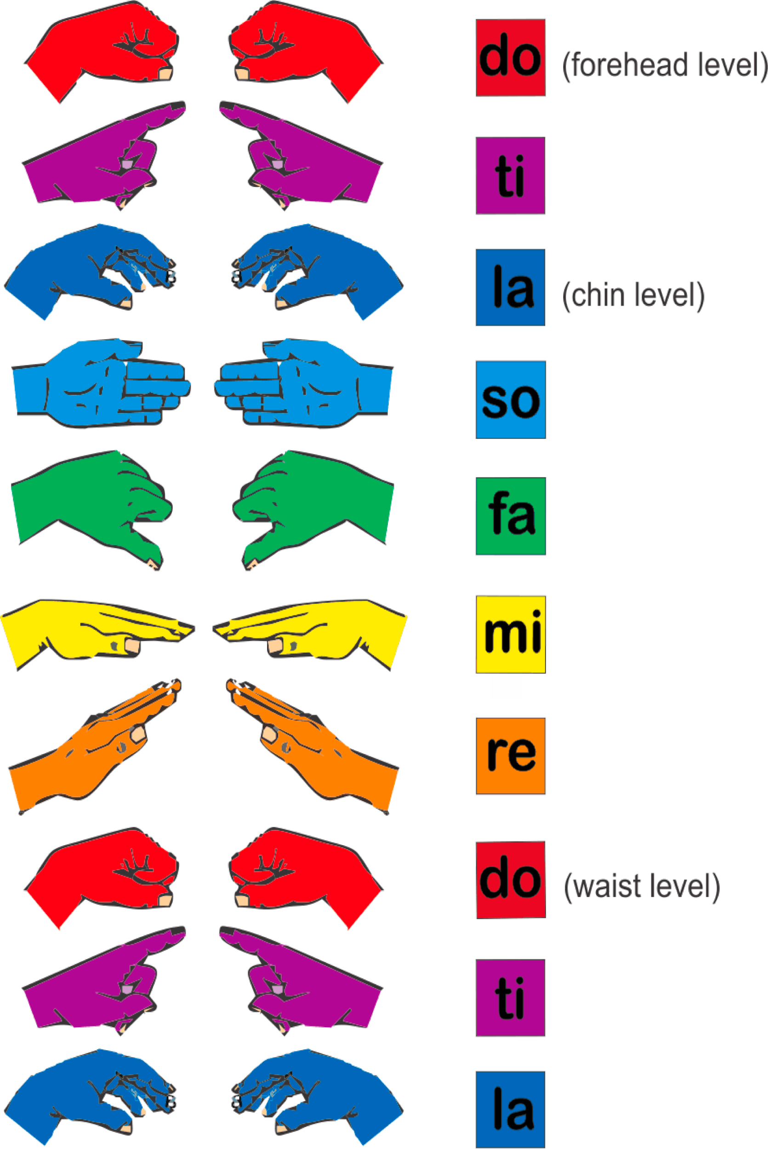
- These are those notes on a keyboard. Do is C.
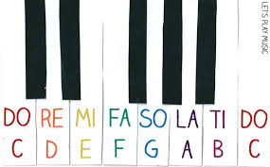
- Can you find these notes on your piano, keyboard or piano app on your phone or iPad?
- See if you can learn these patterns. Make sure you are doing the hand signs as well.

- DO RE MI RE DO
- DO DO RE RE MI MI DO
- DO MI DO MI DO MI DO
Can you make any more patterns using Do Re Mi?

- Have a listen to this fun song. This is a singer called Peter Coombe having some fun with the song Chopsticks. See if you can hear some of the tune of Part A of Chopsticks.
https://www.youtube.com/watch?v=q8HYm_f18Tk
Chopsticks - Peter Coombe
I play the violin every morning
And every evening of every day
Suzuki Bach Vivaldi Schumann
But really all that I want to play is –

I play the grand piano practice
My chords and scales and arpeggios
So boring and it drives my family
Up the wall Dad says 'Why don't you play' –

I play the flute the silver flute
But it doesn't sound much like James Galway
I wonder if when he was ten whether
Sometimes he was allowed to play –
I'd really love to sing a classical
Song or two at the Opera House
And sound like Pavarotti
La la la la la la la la la la la.

SEE YOU NEXT WEEK!

