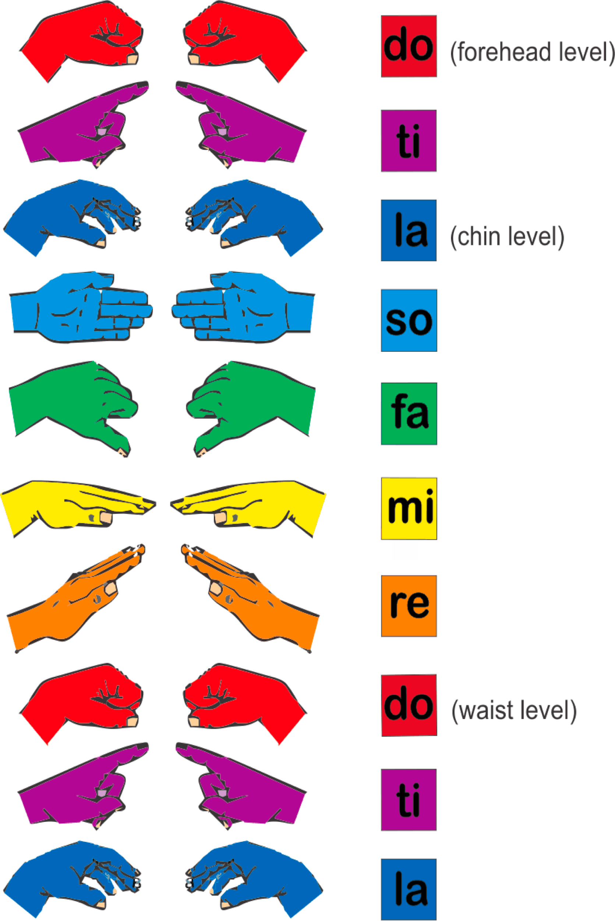
- DO RE MI RE DO
- DO DO RE RE MI MI DO
- DO MI DO MI DO MI DO

- How many other patterns can you make using DO RE MI? Write them below:
1.
2.
3.

