HOLY EUCHARIST CATHOLIC PRIMARY SCHOOL
1a Oleander Drive, St Albans South VIC 3021
www.hestalbanssth.catholic.edu.au

Music Term 2
Grade 5 & 6

Mr. O’Bree’s email is:
Damian.OBree@hestalbanssth.catholic.edu.au

For our lessons this term, you will need a piano or keyboard OR if you don’t have one, download a piano app from the Apple Store or Google Play. I use Perfect Piano, but any piano app will do.

Week 5

Find the heaviest, deepest sound from things around the house. Record and send them to me.

Here are the notes on the stave again. We call the notes from C to C (or DO to DO) the C MAJOR SCALE.
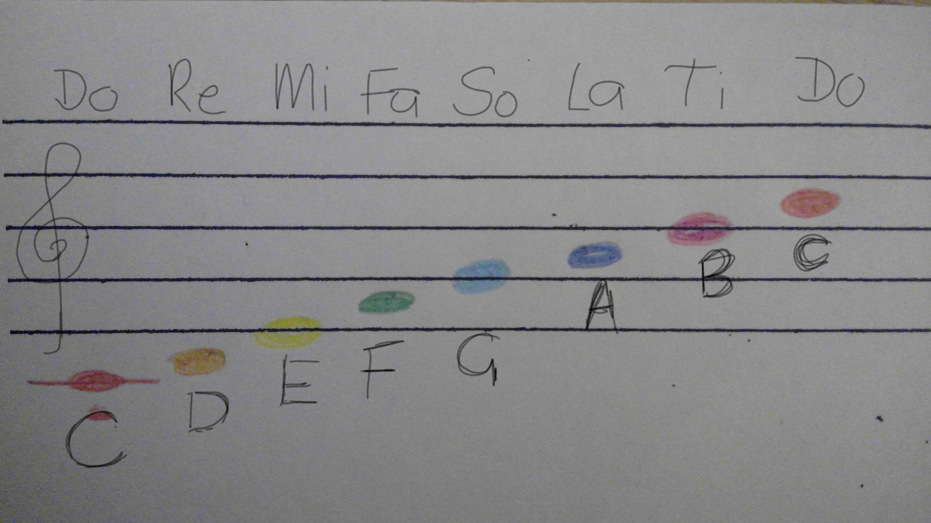

Here is a blank stave.
I want you to draw your own stave or you can print out this on. It must have 5 lines evenly separated.
At the start of the stave I want you to draw a treble clef.
I want you to split it into 3 parts. These parts are called bars.
I want you to only use DO(C) RE(D) MI (E) FA (F) and SO (G) to make a simple tune across the 3 bars.
***REMEMBER, THE LOW DO AND RE ARE BELOW THE STAVE!***

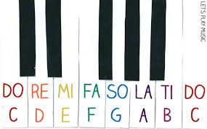

These are those notes on a keyboard. Do is C. This will help you know what your DO RE MI tune sounds like.
(If you want to use more than just DO RE MI FA and SO, go for it!)

If your music is in 3’s, write 3 next to the treble clef.
4
If your music is in 4’s, write 4 next to the treble clef.
4
Create your tune using the correct colour coding. Just use ta’s and ti-tis if ta-as are too hard, but I think you can compose using ta-as.
https://drive.google.com/open?id=1TgXcL8zkCQsk2KYPKHizcviRFQuvMAAs
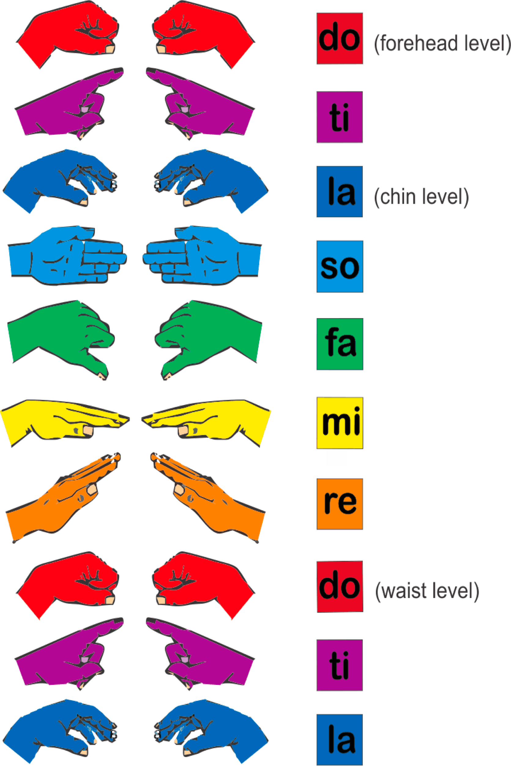
https://drive.google.com/open?id=1wVxRfCTtVGRAou4rOizQZeNPrOMmIyzW
Keep practising just Part A and B of Chopsticks this week. Try and increase the tempo!
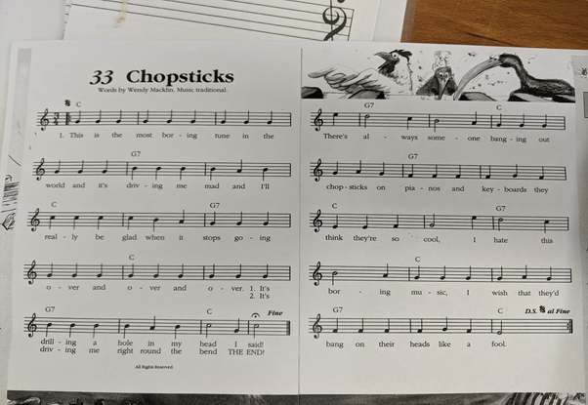
SEE YOU NEXT WEEK!

