HOLY EUCHARIST CATHOLIC PRIMARY SCHOOL
1a Oleander Drive, St Albans South VIC 3021
www.hestalbanssth.catholic.edu.au

Music Term 2
Grade 1 & 2
Mr. O’Bree’s email is:
Damian.OBree@hestalbanssth.catholic.edu.au
You will need a piano or keyboard OR if you don't have one, get a piano app for your ipad.
You can download it on Mum or Dad’s phone or an ipad or tablet.

Week 6
Game:
This week, I want you to make a BIG sound using things around your house. That doesn’t mean loud, just a big sound.
- Last week, we listened to Peter Coombe sing a silly song he called Chopsticks and he used the first part of Part A. Can you hear ‘this is the most boring tune in the world and it’s driving me mad and I’ll really be glad’ after the first 2 verses?
- Listen again and only play Part A after the first 2 verses, then sing along to the rest, because the music changes.
https://www.youtube.com/watch?v=q8HYm_f18Tk
Chopsticks - Peter Coombe
I play the violin every morning
And every evening of every day
Suzuki Bach Vivaldi Schumann
But really all that I want to play is –

PLAY PART A HERE!

I play the grand piano practice
My chords and scales and arpeggios
So boring and it drives my family
Up the wall Dad says 'Why don't you play' –

PLAY PART A HERE!

I play the flute the silver flute
But it doesn't sound much like James Galway
I wonder if when he was ten whether
Sometimes he was allowed to play –
I'd really love to sing a classical
Song or two at the Opera House
And sound like Pavarotti
La la la la la la la la la la la.

- Let’s keep practising our Do Re Mi hand signs.

https://drive.google.com/open?id=1TgXcL8zkCQsk2KYPKHizcviRFQuvMAAs
Can you practise? Start on the Do which is C on the keyboard or piano.

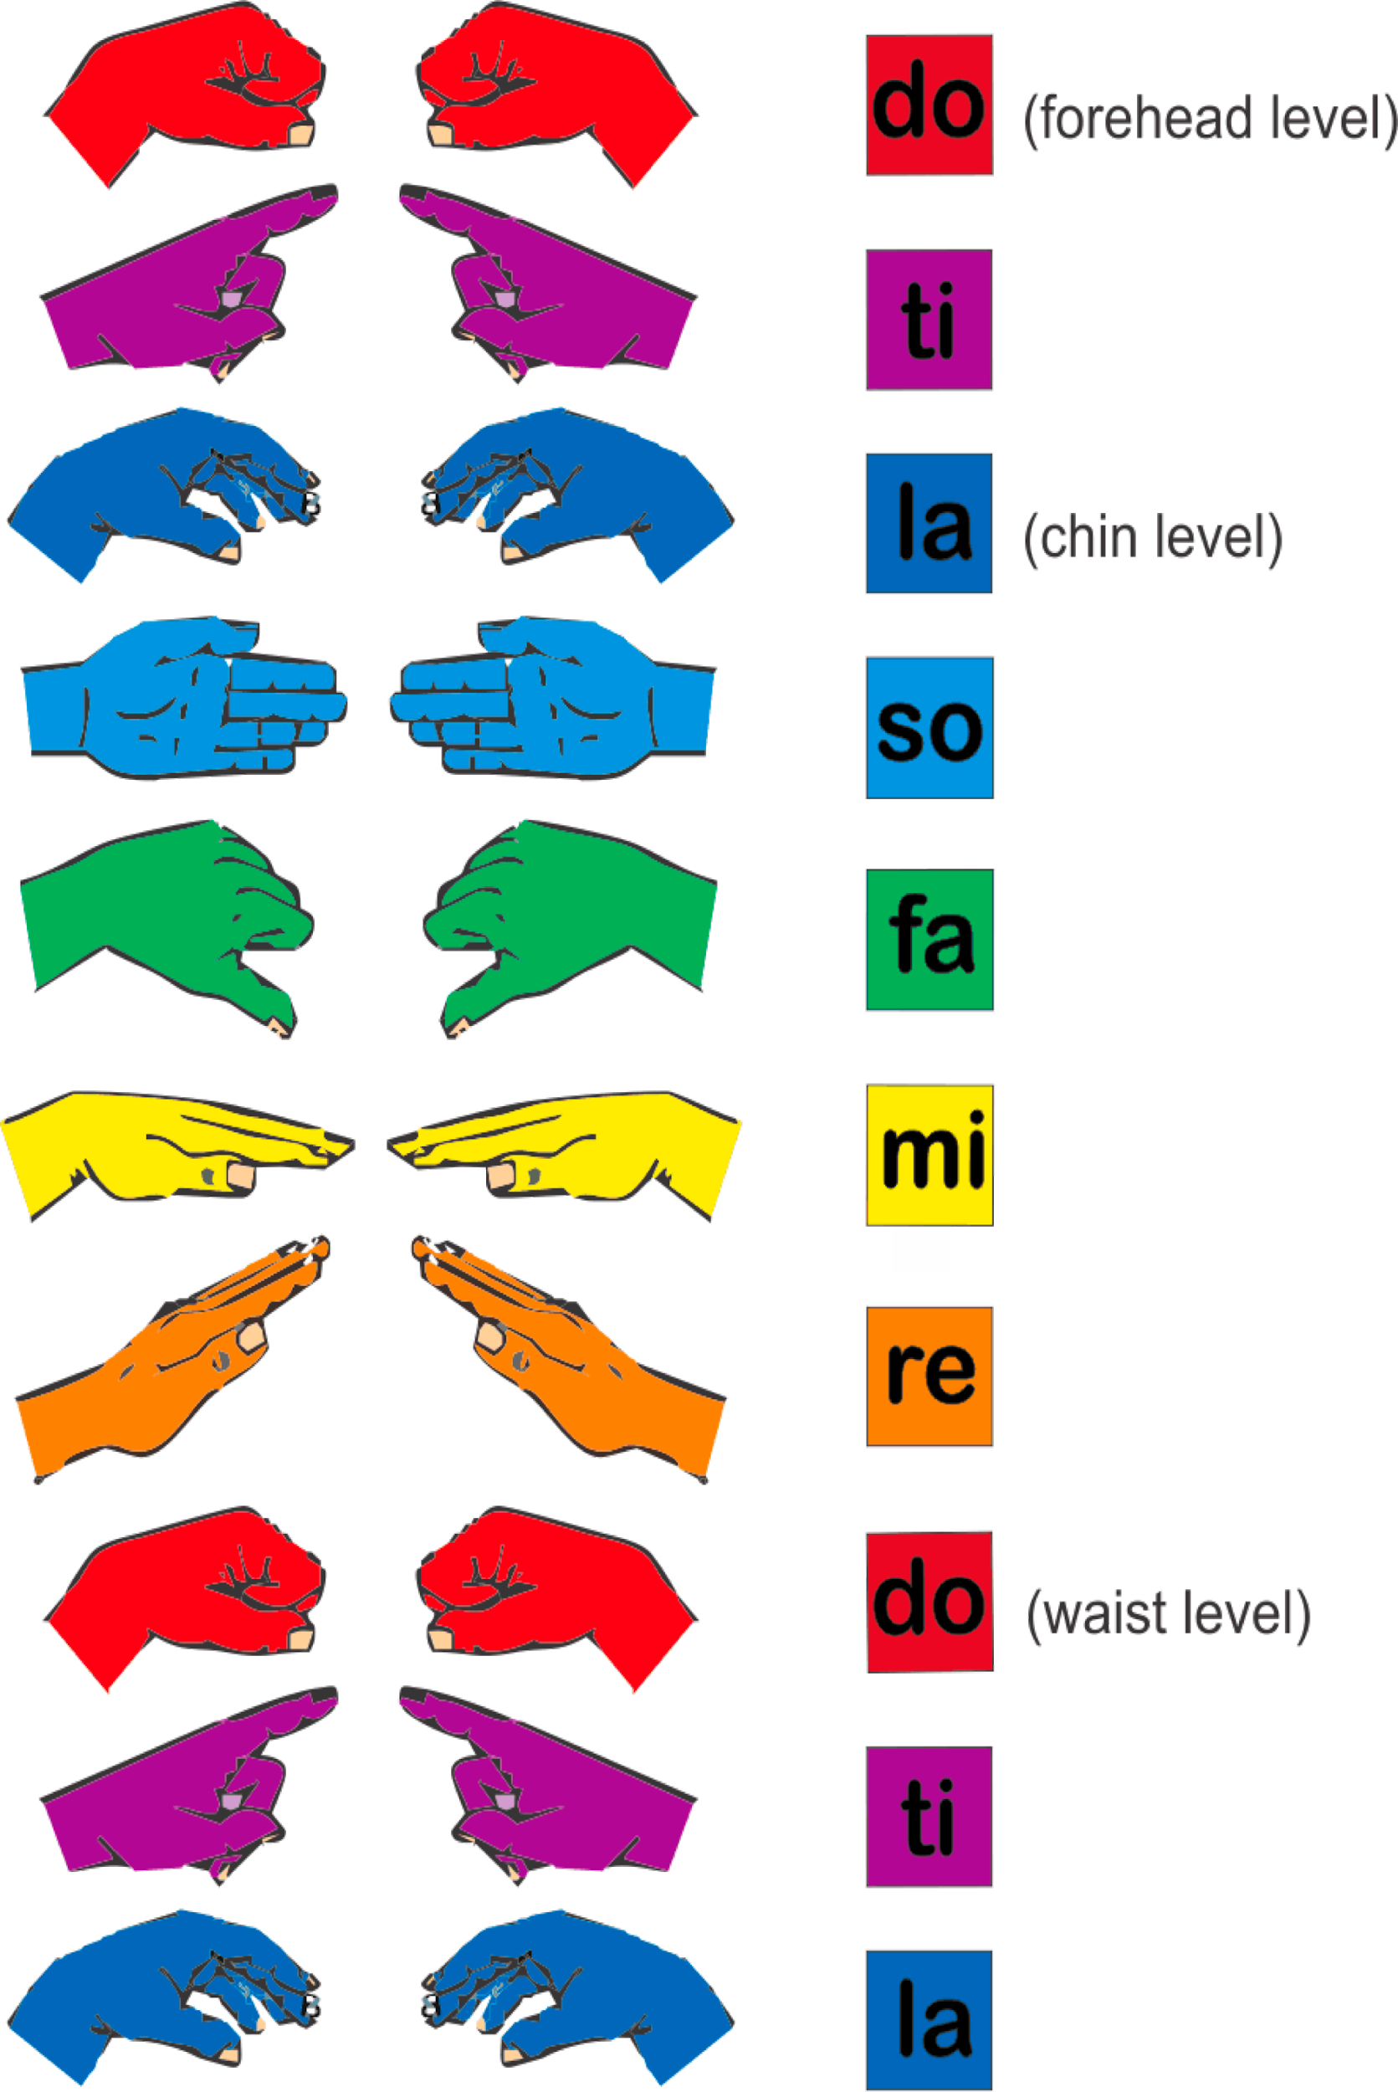
- These are those notes on a keyboard. Do is C.
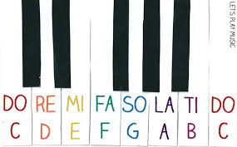
- Can you find these notes on your piano, keyboard or piano app on your phone or iPad?
- See if you can learn these new patterns. Make sure you are doing the hand signs as well.

- DO RE MI FA SO
- DO DO(LOW) RE RE MI MI FA FA DO (HIGH)
- DO RE MI FA SO FA MI RE DO

Can you make any more patterns using Do Re Mi Fa and So?

SEE YOU NEXT WEEK!

