HOLY EUCHARIST CATHOLIC PRIMARY SCHOOL
1a Oleander Drive, St Albans South VIC 3021
www.hestalbanssth.catholic.edu.au

Music Term 2
Grade 5 & 6

Mr. O’Bree’s email is:
Damian.OBree@hestalbanssth.catholic.edu.au

Week 6
**There is work to submit this week**
Game:
Find the best sound using something from nature (you’ll have to go outside to find this) Record it and send it to me or submit it through your Google Classroom page.
Here are the notes on the stave again. We call the notes from C to C (or DO to DO) the C MAJOR SCALE.
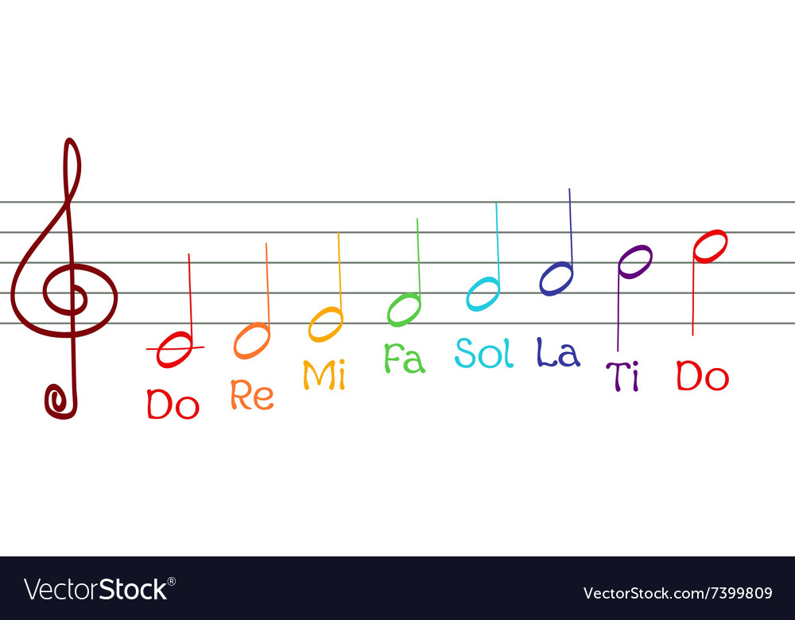

Here is a blank stave again.
Like last week, I want you to draw your own stave or you can print out this on. At the start of the stave I want you to draw the treble clef as normal.
Like last week, I want you to split it into 3 bars.
This week I want you to be brave and try to use DO (C) RE (D) MI (E) FA (F) SO (G) LA TI and DO(C) to make a simple tune across the 3 bars. Can you do it? Make sure you are using ta and ti-ti and not writing words.

If your music is in 3’s, write 3 next to the treble clef.
4
If your music is in 4’s, write 4 next to the treble clef.
4

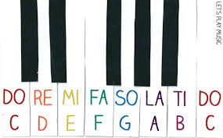
https://drive.google.com/open?id=1TgXcL8zkCQsk2KYPKHizcviRFQuvMAAs
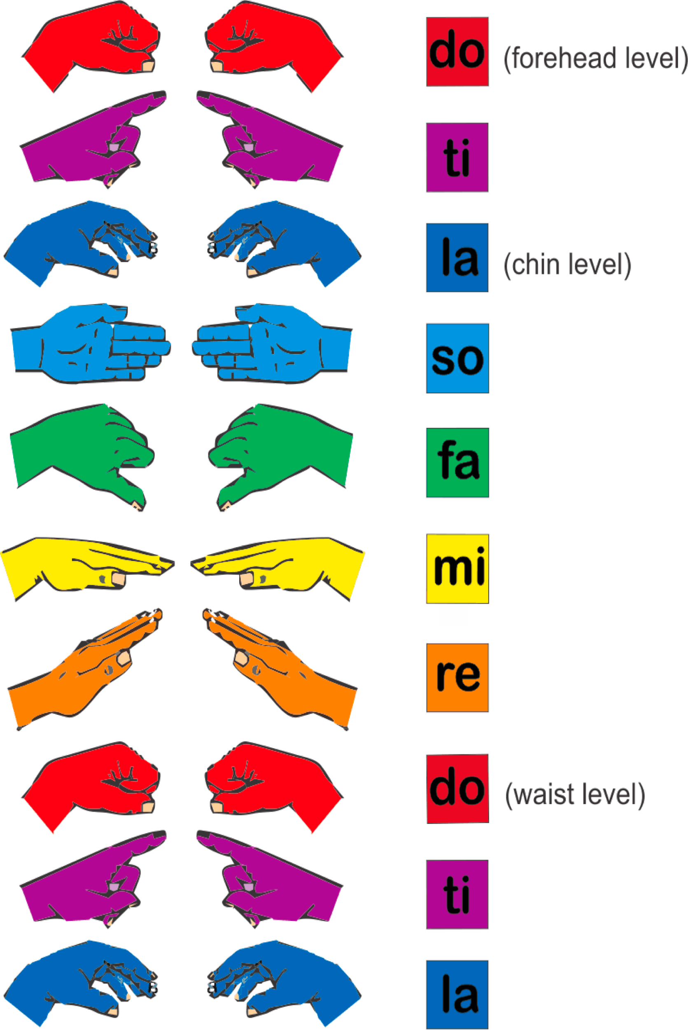
**WORK TO SUBMIT**
This week I want you to record Part A, Part B, or the complete Chopsticks and send it to me through Google Classroom or email it. If you can’t play a complete section, play what you do know.
