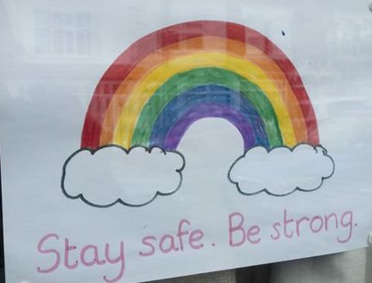
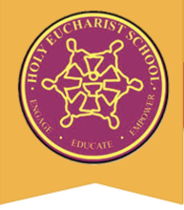
Term 2 2020
Remote Learning Wellbeing

Dear Families,

Hope you are all healthy and safe during these uncertain and unprecedented times.
During this difficult time, it is completely normal to feel upset, anxious, overwhelmed or afraid, but the things we need to do is to remain calm, safe and positive. During this time that we are all experiencing, it's important that we remember that we are all in this together and are here for each other.

At Holy Eucharist, we recognise the need for students and families to be able to have access to support within the school and outside the school. This page will provide information about support pathways available to students and families.

Support at school

To support families and student’s mental health and emotional well-being during these times, the school is available to receive calls from 9:00 am –3.30 pm Monday–Friday if parents have any questions in regard to Home Learning Packs, Technology devices (laptops), login in details for your child/children..etc). During this time, there is small amount of staff available to assist you as well as Jeffrey Parker (Principal) and Michael Bonnici (Deputy Principal).

Support outside school

Online Counselling

To support student’s mental health and emotional well-being during these times, Edward Faraci the school counsellor is available to assist and support students.

Edward has made himself available for online counselling sessions with students. This can be done online via a voice or a video call.

If you feel your child would benefit from an online counselling session, you can contact Edward through email and together you can negotiate a suitable date and time for this to occur.
He can be contacted at: Edward.Faraci@hestalbanssth.catholic.edu.au . You also will be required to complete a permission form. You can call the office and the form will be placed in your child’s Home Learning Pack.

Alternatively you can download the form from our school website by visiting www.hestalbanssth.catholic.edu.au and clicking onto the ‘Parent Information’ drop down box and clicking onto ‘Forms’. Please complete the form and return to the school. If you have already completed the Permission Form you are not required to fill in another one.

He is also more than happy to speak with parents in order to bounce around some ideas on how best to support your child during this time.

Feel free to contact the school counsellor if you are unsure or if you have any questions.

There are community organisations that provide great support for students as well as parents, carers and guardians listed below:

Wellbeing Hub

The Wellbeing Hub is based on the Australian Student Wellbeing Framework and purpose is to support students (along with parents and educators) by providing information and resources related to a variety of topics. https://studentwellbeinghub.edu.au/

Kids helpline is Australia's only free, personal and confidential 24/7, 365 days a year phone and online counselling service for young people aged 5 to 25. There is a lot of information and misunderstanding (confusion) out there about COVID-19 and things feel a bit unsure. If your child is feeling worried, stressed or anxious, Kids helpline is here for you. https://kidshelpline.com.au/ Kids helpline can also help you anytime and for any reason.

Watch this Youtube clip https://www.youtube.com/watch?v=EyUQp5bjcnc on ’How Kids Helpline Can Help You’.
There is also a Parent Helpline available for parents:
https://kidshelpline.com.au/parents/issues/how-parentline-can-help-you
https://kidshelpline.com.au/search?key=covid-19

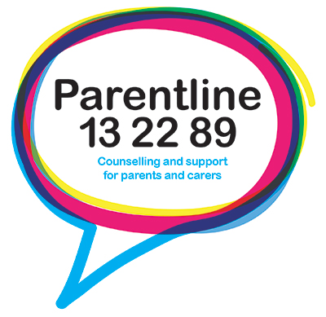 Parentline is a phone service available from 8 am-midnight 7 days a week including public holidays for parents and carers of children from birth to 18 years old. We offer confidential and anonymous counselling and support on parenting issues.
https://www.education.vic.gov.au/parents/services-for-parents/Pages/parentline.aspx

Coronavirus (COVID-19) advice for parents, carers and guardians https://www.education.vic.gov.au/parents/Pages/coronavirus-advice-parents.aspx

headspace – A National Youth Mental Health Foundation. They are here for you during coronavirus (COVID-19) click on link https://headspace.org.au/covid-19/ where you can seek support and get access to tools, resources and useful information to help you during this time.
Also if you need support, resources, tools anytime visit their website. https://headspace.org.au/

National Coronavirus Helpline. Call for information and advice about COVID-19 or
visit their website. Find out how they are monitoring and responding to the outbreak, how you can help slow the spread of COVID-19 in Australia, and what to do if you have symptoms. They also report the latest official medical advice and case numbers.

https://www.health.gov.au/news/health-alerts/novel-coronavirus-2019-ncov-health-alert

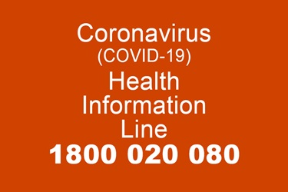

National Coronavirus Helpline. Call this line if you are seeking information on coronavirus. The line operates 24 hours a day, seven days a week.

During this period, try to reduce media exposure and encourage students to take time to enjoy some of the things they love at home, practice mindfulness and stay connected to friends and family via the technologies available to us. Remember to try to continue a routine and provide a balance of activities – including physical, creative and relaxing activities.

During this time, please remember to access the above support services, if necessary. Please take care of yourselves, your families and of others. Remember we are all in this together.

Kind Regards,
Julie Semcesen - Wellbeing / Learning Diversity Leader. Jeffrey Parker
Jo Dragovic - Wellbeing Support, Family School Partnership (FSP) Leader. Principal
Edward Faraci – Student Counsellor.

