HOLY EUCHARIST CATHOLIC PRIMARY SCHOOL
1a Oleander Drive, St Albans South VIC 3021
www.hestalbanssth.catholic.edu.au

Mandarin Term 2
Grade 2
Feel free to ask me any question relating to your Mandarin lessons!
Please stay safe!
Mrs. Huynh

Mrs. Huynh’s email is:
linda. huynh@hestalbanssth.catholic.edu.au

Week 6
【To Do List】
Activity 1: Continue to learn the name of the body parts
* Click on the video link that was posted on 9th May on Class Dojo called ‘Family members’
Activity 2: Continue to trace the Chinese characters: 舌 头 ( shé tóu), 牙(yá ) by following the stroke order. ( Only if you have access to the internet)
Revision :
Activity 1 – Counting from 1-30 in Chinese
Activity 2: Read and use Pinyin to fill in the ‘Introduce yourself’ worksheet

Activity 1: Continue to learn the name of the body parts
Click on the links below to learn the name of the body parts (Only if you have access to the internet).
Learn the names of body parts in Mandarin
https://www.youtube.com/watch?v=3lqVe-_tKlQ

* Click on the video link that was posted on 9th May on Class Dojo called ‘Family members’
* Listen and try to repeat after the teacher.

Body parts

 | Chinese  Character / Pinyin | English |  | Chinese  Character / Pinyin | English
1 | 头 / tóu | head | 2 | 口/嘴 Kŏu /Zŭi | mouth
3 | 牙 齿 / yá chĭ | teeth | 4 | 舌 头 / shé tóu | tongue
5 | 唇 / chún | lip | 6 | 鼻 子/ Bí zi | nose
7 | 眼 睛 / yăng jing | eye | 8 | 耳 朵 / ĕr duo | ear
9 | 脸 / liăn | face | 10 | 眉 毛/ méi mao | Eyebrow
11 | 头 发 / Tóu fà | hair | 12 | 手 / Shŏu | hand
13 | 脚 / jiăo | feet | 14 | 手 指 /Shŏu zhĭ | finger
15 | 脚趾 / Jiăo zhĭ | toe | 16 | 颈 / jing | neck
17 | 腿 / Tuĭ | leg | 18 | 胳 膊 / Ge bo | arm
19 | 肩 膀 / jian băng | shoulder | 20 | 身 体 / shen tĭ | Body

Activity 2: Continue to trace the Chinese characters: 舌 头 ( shé tóu), 牙(yá ) by following the stroke order.
Click on the links below ( Only if you have access to the internet)
* How to write Chinese character (she)
http://bishun.strokeorder.info/mandarin.php?q=%E8%88%8C
* How to write Chinese character (tou) head
http://bishun.strokeorder.info/mandarin.php?q=%E5%A4%B4
* How to write Chinese character (ya)
http://bishun.strokeorder.info/mandarin.php?q=%E7%89%99

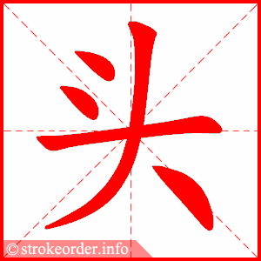

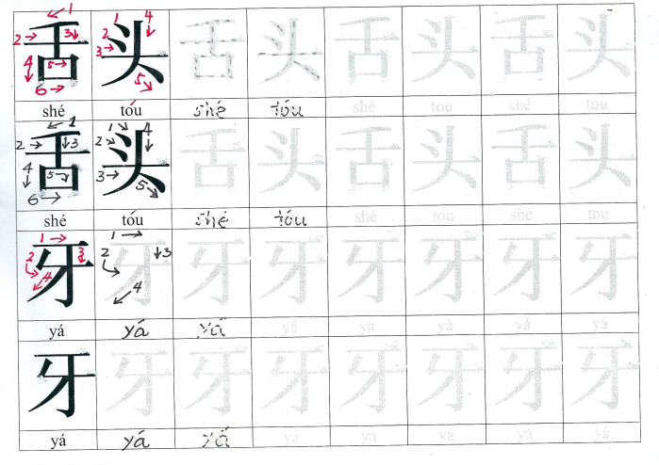
REVISION WORK

Revision : Counting from 1-30 in Chinese

Chinese numbers

一 | 二 |  | 三 | 四 | 五 | 六 | 七 |  | 八 | 九 | 十
yi | èr |  | san | sì | wŭ | lìu | qi |  | ba | jĭu | shí
十  一 |  | 十  二 | 十  三 | 十  四 | 十  五 | 十  六 |  | 十  七 | 十  八 | 十  九 | 二  十
shí  yi |  | shí  èr | shí  san | shí  sì | shí  wŭ | shí  lìu |  | shí  qi | shí  ba | shí  jĭu | èr  shí
二  十  一 |  | 二  十  二 | 二  十  三 | 二  十  四 | 二  十  五 | 二  十  六 |  | 二  十  七 | 二  十  八 | 二  十  九 | 三  十
èr  shí  yi |  | èr  shí  èr | èr  shí  san | èr  shí  sì | èr  shí  wŭ | èr  shí  lìu |  | èr  shí  qi | èr  shí  ba | èr  shí  jĭu | san  shí

Revision : -- Chinese Zodiac

Chinese Zodiac

1. (老) 鼠 | (Lăo) shŭ | 2020 2008 | rat, mouse
2. 牛 | Níu | 2021 2009 | Cow ox
3. (老) 虎 | (Lăo) hŭ | 2022 2010 | tiger
4. 兔 子 | Tù zi | 2023 2011 | rabbit
5. 龙 | lóng | 2024 2012 | dragon
6. 蛇 | Shé | 2025 2013 | snake
7. 马 | mă | 2026 2014 | horse
8. 羊 | yáng | 2027 2015 | goat
9. 猴 (子) | Hóu (zi) | 2028 2016 | monkey
10. 鸡 | ji | 2029 2017 | rooster
11. 狗 | gŏu | 2030 2018 | dog
12. 猪 | zhu | 2031 2019 | pig

Revision : Activity 2 : Read and use Pinyin to fill in the ‘Introduce yourself’ worksheet.

Please submit your completed Chinese activities (worksheets) on Class Dojo

介 绍 自 己 jìe shào zì jĭ ( Introduce yourself)

S: 老 师 你 好 ! Hello! Teacher
Lăo shi Nĭ hăo!

我 叫 (是)_______ (your name) [ I am _____ (your name) ]
wŏ jìao (shì)

我 (是) ___ 岁 [I am _ __ years old ]
wŏ (shì) sùi

[ Born-- 2013— 7 - qi ( Shé - snake)]; [Born --2012— 8 – ba (lóng - dragon)];
[Born 2011— 9 - jĭu (Tù- rabbit ] [Born --2010— 10 – shí ((Lăo) hŭ – tiger )

我 属 ____ [My animal sign is ____ ]
wŏ shŭ

谢 谢 [ Thank you ]
xìe xie

再 见 [ Good-bye ]
zài jiàn

