GRADE 5 TIMETABLE
Grade 5 Home Learning Schedule
Week 3 Day 3,
Wednesday 29th of April, 2020
Thought for the day...

ANNOUNCEMENTS:
Please read and follow all announcements and lesson instructions carefully before beginning your learning.

GOOGLE MEET @ 9am - Check Google classroom home page banner for login link.

MARK THE ATTENDANCE ROLL.

GOOGLE MEET RULES: Please remember these when meeting together.

COMMENTS: Please DO NOT make unnecessary comments on our posts. Only use the comments for questions you have about your learning.
Thank you.

WORK PACKS.
These should be picked up from school.
All worksheets can be found on the HOLY EUCHARIST SCHOOL WEBSITE.
https://www.hestalbanssth.catholic.edu.au/

IMPORTANT:
MAKE SURE I TAKE A BREAK!
Some students are working so hard and are forgetting to take breaks.
Please remember that from 11-12pm and 2pm- 2:30pm are your times to recharge!
9:30-10:15am | LITERACY - READING - Grammar (Proper Nouns)  Today’s grammar focus is on Proper Nouns (name of a place, person or thing)  - Work your way through the noun section on the Grammaropolis website - Click this link Noun to view the website.  - Read worksheet Unit 3 ‘It’s a Laugh’ in your old work pack then complete the Proper Nouns activities.  - Send a picture of your work to your classroom teacher or you can keep it safe in your homework pack ready to return at the end of Week 4 for collection.  - STUDENTS WHO HAVE FINISHED THE ABOVE:  Write these PROPER NOUNS in interesting sentences.  Amazon River, Donald Trump, Mr. Parker, Saturn, The Titanic,
10:15-11am | 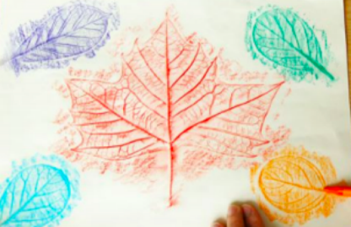  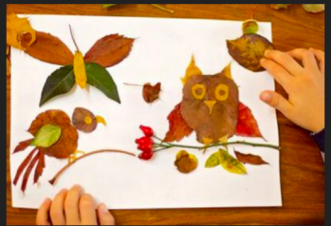  WELLBEING  Watch the Videos to get some ideas.  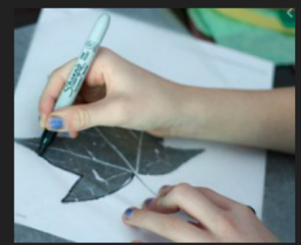  https://www.youtube.com/watch?v=W66TAqCT4hc  https://www.youtube.com/watch?v=T7ywigOR23E  Get some exercise and fresh air outside. Look for some interesting shaped leaves to help you create your art piece.  Use textas, crayons, chalk or colour pencils for your design.  Take a photo of your art and email or share it with your teacher.
11am-12pm | LUNCH BREAK
NO GOOGLE MEET @ 12pm- PLEASE SEE MISS SUN’S WORD OF THE WEEK & ASSIGNMENT
12pm-1pm | LOTE with Miss Sun  Please go to Google Classroom- ‘Classwork’ and look for ‘Miss Sun LOTE for Term 2’ folder and you will find her assignment set for this week.  IF YOU HAVE ANY ISSUES WITH THIS TASK PLEASE EMAIL MISS SUN ON HER EMAIL ADDRESS: miyi.sun@hestalbanssth.catholic.edu.au
1pm-2pm | ART with Ms Hickey  Please go to Google Classroom- ‘Classwork’ and look for ‘ART: Mrs Hickey’ and you will find her assignment set for Week 3 OPTICAL ILLUSION. Please also refer to Mrs Hickey’s post with a video on the stream.  IF YOU HAVE ANY ISSUES WITH THIS TASK PLEASE EMAIL MRS HICKEY ON HER EMAIL ADDRESS: shobha.hickey@hestalbanssth.catholic.edu.au
2pm-2:30pm | SNACK BREAK
2:30-3:15pm | PHYSICAL EDUCATION with Mr Herrera  Please go to Google Classroom- ‘Classwork’ and look for ‘PHYSICAL EDUCATION’ Week 3 Term 2 and you will find your Dance assignment set by Mr Herrera for PE. Please also refer to Mr Herrera’s post on the stream.  IF YOU HAVE ANY ISSUES WITH THIS TASK PLEASE EMAIL MR HERRERA ON HIS EMAIL ADDRESS:  heribert.herrera@hestalbanssth.catholic.edu.au

