GRADE 5 TIMETABLE
Grade 5 Home Learning Schedule
Week 4 Day 3,
Wednesday 6th of May, 2020
Thought for the day...

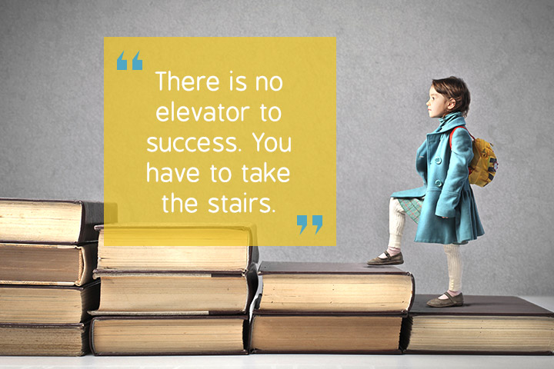
ANNOUNCEMENTS:
Please read and follow all announcements and lesson instructions carefully before beginning your learning.

GOOGLE MEET @ 9am - Check Google classroom home page banner for login link.

MARK THE ATTENDANCE ROLL.

GOOGLE MEET RULES: Please remember these when meeting together.

COMMENTS: Please DO NOT make unnecessary comments on our posts. Only use the comments for questions you have about your learning.
Thank you.

WORK PACKS.
These should be picked up from school.
All worksheets can be found on the HOLY EUCHARIST SCHOOL WEBSITE.
https://www.hestalbanssth.catholic.edu.au/

IMPORTANT:
MAKE SURE I TAKE A BREAK!
Some students are working so hard and are forgetting to take breaks.
Please remember that from 11-12pm and 2pm- 2:30pm are your times to recharge!
9:30-10:15am | MOTHER'S DAY ACTIVITY -FLOWER BOOKMARK  In your home learning pack there is some coloured paper in there for you to create a flower bookmark for you Mum for mothers day. Be as creative as you can!  Here are some examples of possibles flowers you could make:
10:15-11am | LITERACY- COMIC STRIP STIMULUS  For this activity you need the A3 comic strip sheet that you received as part of your homework pack (as shown below)  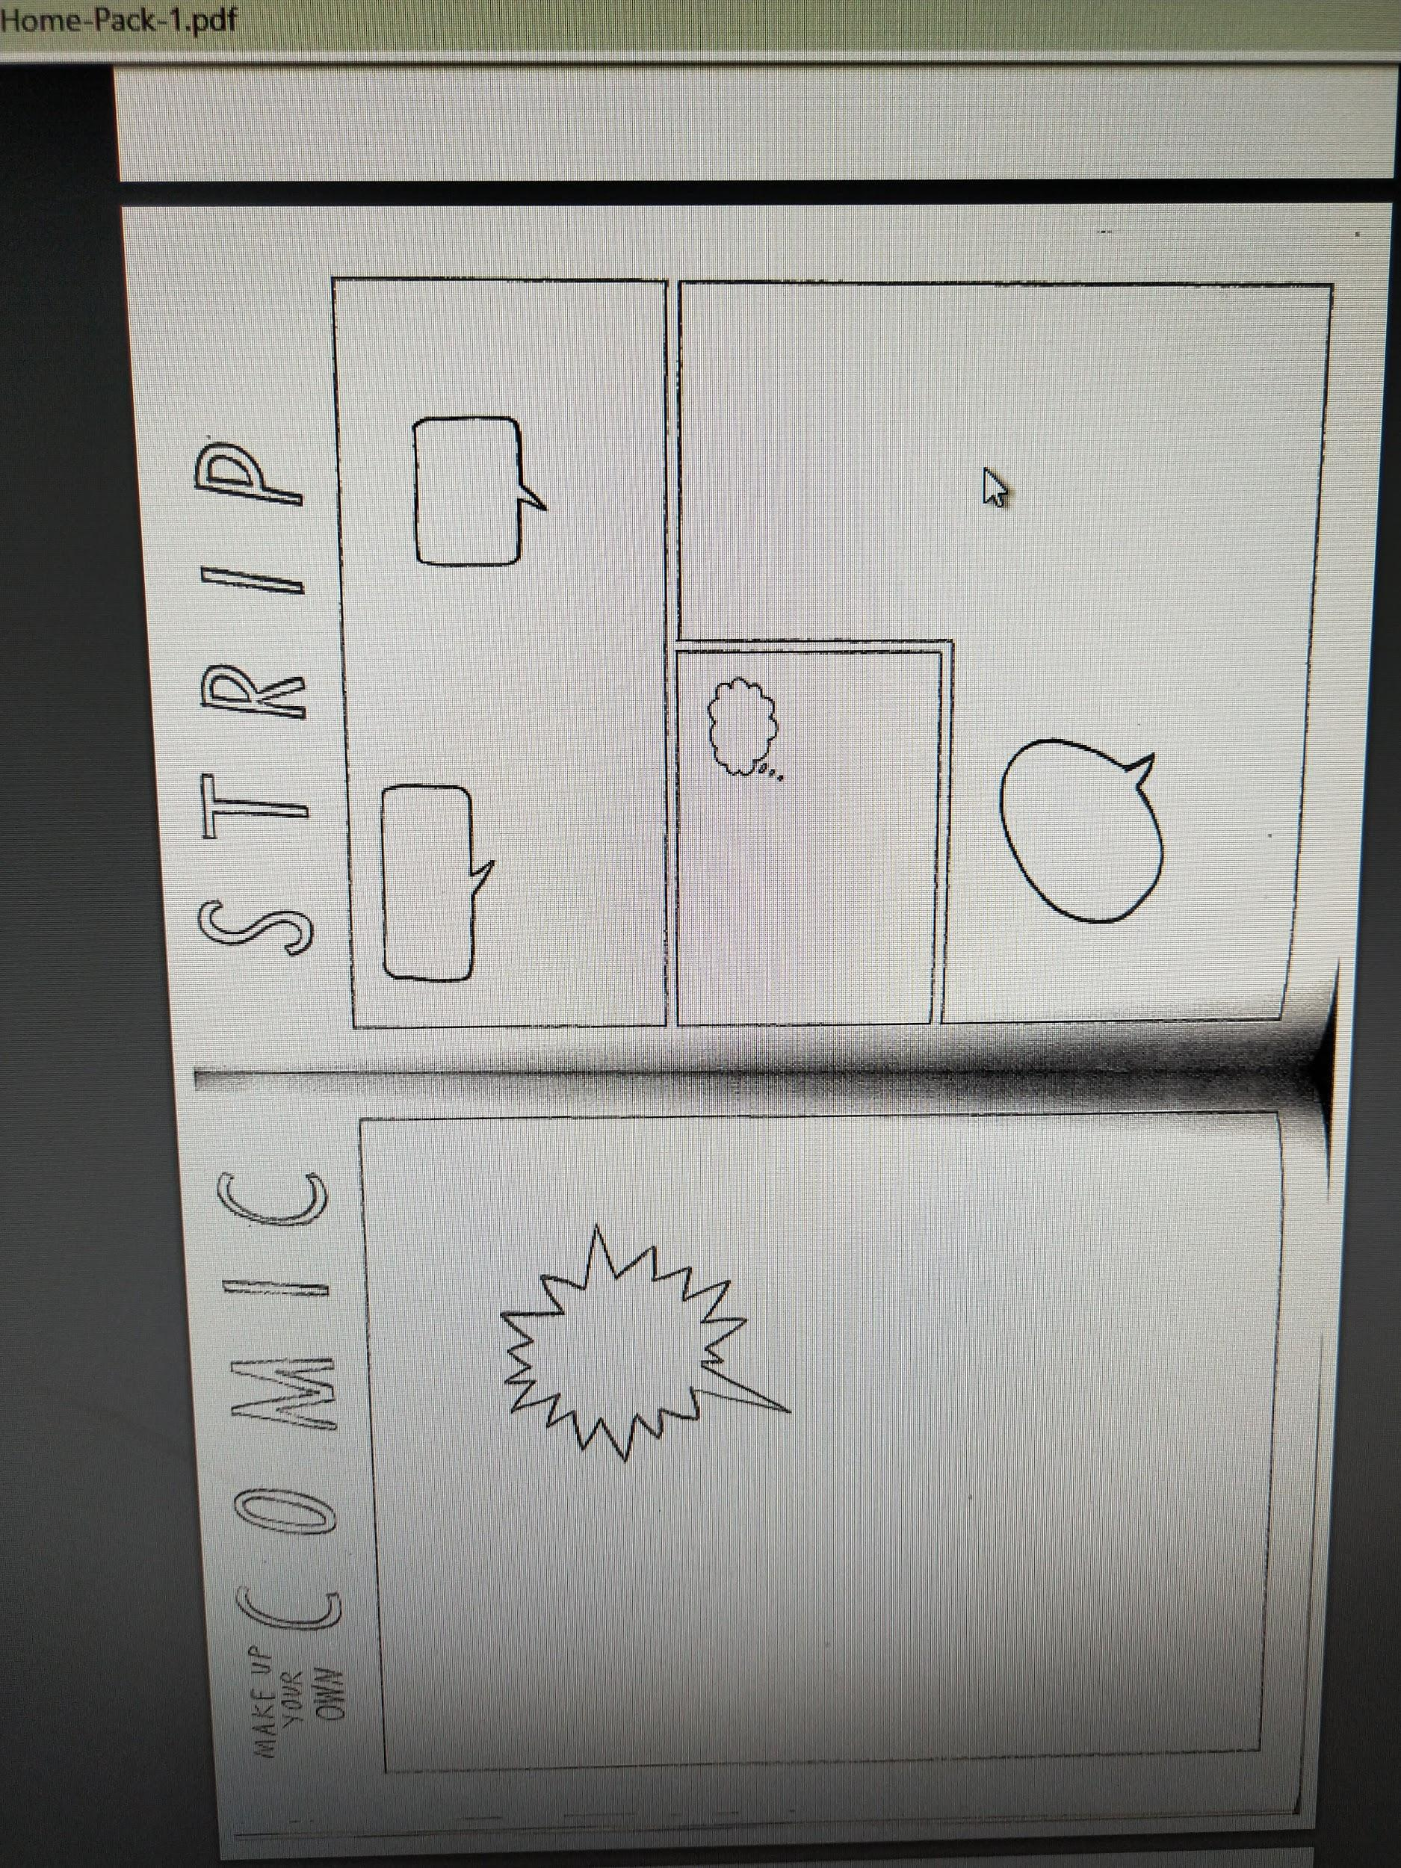  Your task is to create a short, colourful entertaining comic strip.Below are some possible ideas that you could use to create your comic strip:  A DAY AT SCHOOL  MAKE BELIEVE that you're in school. Your teacher is talking to the students in your class, and you have the power to read the hidden thoughts and daydreams of your fellow students as the teacher lectures. Choose a character to be the teacher who is speaking to students. What are his or her words? Now, what is going on in students’ heads? Place thought balloons over students’ heads and in them write their secret thoughts. If you wish, you can use talk balloons to have students respond to the teacher's words.  MAKING WISHES COME TRUE  MAKE BELIEVE you could have three wishes come true. What would they be? Select a character who makes a wish. In a talk balloon, have your main character explain to another why this wish was made and what it means to him or her. You can have this other character react to or comment on the main character’s wish selection or even express its own wish that it would like to see come true.  TRAVEL TO A MYSTERIOUS PLACE  MAKE BELIEVE you could travel to a mysterious land, planet or star. What is your character thinking or saying as it begins traveling on its trip – such as its hopes, expectations? What strange things or creatures does your character see or encounter in this mysterious land? Have your character comment on what it sees or encounters or engage in a conversation with a person, creature or animal it encounters. This can be in the form of greetings, dialogues, jokes, questions, or have the mysterious creature talk about its life. Have them react to one another – for example, they can comment on their appearance, they can talk about their favorite foods or customs. They can talk about real life concerns, too, such as living with bullies, loneliness, loss, problems on their minds.  You only have 4 slides so you need to make sure that your comic does not go for too long. You also do not have to use the ideas from above, if you have your own idea that you would like to do then feel more than free to go and do it!
11am-12pm | LUNCH BREAK
NO GOOGLE MEET @ 12pm- PLEASE SEE MISS SUN’S WORD OF THE WEEK & ASSIGNMENT
12pm-1pm | LOTE with Miss Sun  Please go to Google Classroom- ‘Classwork’ and look for ‘Miss Sun LOTE for Term 2 Week 4’ folder and you will find her assignment set for this week.  IF YOU HAVE ANY ISSUES WITH THIS TASK PLEASE EMAIL MISS SUN ON HER EMAIL ADDRESS: miyi.sun@hestalbanssth.catholic.edu.au
1pm-2pm | ART with Ms Hickey  Please go to Google Classroom- ‘Classwork’ and look for ‘ART: Mrs Hickey’ and you will find her assignment set for Classwork for Week 4. Please also refer to Mrs Hickey’s post with a video on the stream.  IF YOU HAVE ANY ISSUES WITH THIS TASK PLEASE EMAIL MRS HICKEY ON HER EMAIL ADDRESS: shobha.hickey@hestalbanssth.catholic.edu.au
2pm-2:30pm | SNACK BREAK
2:30-3:15pm | PHYSICAL EDUCATION with Mr Herrera  Please go to Google Classroom- ‘Classwork’ and look for ‘PHYSICAL EDUCATION’ Week 4 Term 2 and you will find your Dance assignment set by Mr Herrera for PE. Please also refer to Mr Herrera’s post on the stream.  IF YOU HAVE ANY ISSUES WITH THIS TASK PLEASE EMAIL MR HERRERA ON HIS EMAIL ADDRESS:  heribert.herrera@hestalbanssth.catholic.edu.au

