GRADE 5 TIMETABLE
Grade 5 Home Learning Schedule
Monday 4th of May, 2020
GOOGLE MEET @ 9am - Check Google classroom home page banner for login link
GOOGLE MEET RULES:
- Please keep your microphone off unless you wish to speak or ask a question.
- Wait patiently until it is your turn to speak.
- If you wish to speak to friends, log in early or do this at the end of our meeting.
THANK YOU.
GOOGLE CLASSROOM COMMENTS: Please DO NOT make unnecessary comments on our posts. Only use the comments for questions you have about your learning. Thank you.
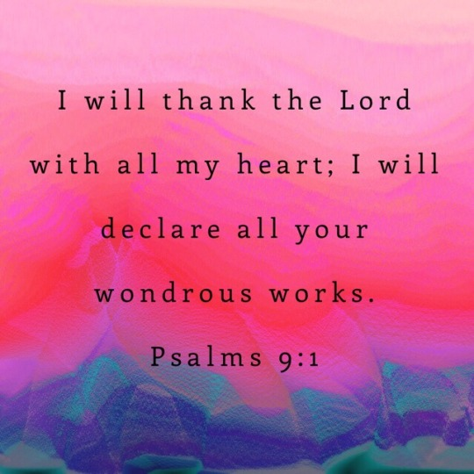
Grade 5 Morning Prayer...

Before we start another week of remote learning, let us be thankful for a new week filled with new opportunities to grow, to learn and to inspire others.

Let us reflect on this Psalm and express what we are thankful for this morning. Spend a quiet moment thanking God in your heart and then we will share some prayers of thanks with our Grade 5 community.

Dear God,
Thank you for….
Lord hear us
(All: Lord hear our prayer)
9:30-10:15am | 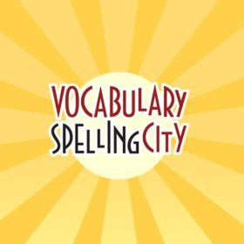  LITERACY- SPELLING FOCUS: -ee words as in geese  -Log onto www.spellingcity.com and complete the latest unit of work assigned to you by your teacher with ‘ee’ words.  -After completing the activities on Spelling City, complete the spelling matters Unit 6 “ee sheet” that you received in your OLD homework pack in a plastic pocket.  -The worksheet has been posted in ‘Classwork’ if you do not have your own paper copy. You will just have to write your answers in an exercise book or on some paper.
10:15-11am | WRITING- ‘Through the Keyhole’ Creative Writing Stimulus  -In your current Homework pack for weeks 3 & 4, you received a writing stimulus A3 sheet of paper with a keyhole image on one side and writing space on the other.  -Your first task is to imagine you are peering through the keyhole- What do you see? Draw what you see. Be as creative as possible!  -Once complete, now you are going to write a page of creative writing about what you see through the keyhole. Remember to use a sizzling starter and write about what you see, hear and feel as you peer through the keyhole. Use descriptive language and remember to keep your handwriting neat and legible.
11am-12pm | LUNCH BREAK
GOOGLE MEET TODAY @ 12pm - See Google Classroom banner for login link
12:30-1:15pm | MATHS- Factors and Multiples  -Watch the Maths Antics video about Factoring found at: Math Antics - Factoring  -Play the Factors and Multiples game found at: Factors and Multiples - 9-11 year olds  -In your current Homework pack for weeks 3 & 4, find the Targeting Maths worksheets on ‘Factors’ pg. 11 and ‘Multiples’ pg 12. Complete these two worksheets. If you cannot find these worksheets they can also be found in Classwork on Google Classroom.
1:15pm-2pm | 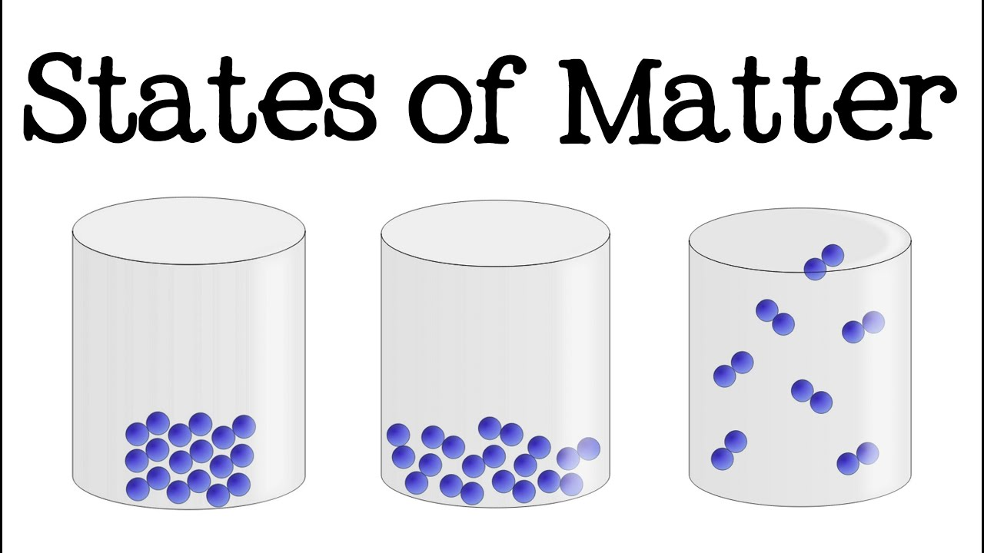  INQUIRY- States of Matter  -Watch the video 3 States of Matter for Kids (Solid, Liquid, Gas): Science for Children - FreeSchool  -Read the information found at Kids science: Solid, Liquid, Gas  -Complete the ‘States of Matter Quiz’ found in Classwork on Google Classroom.
2pm-2:30pm | SNACK BREAK
2:30-3:15pm | Sport - Daily Physical Activity  -Mr Herrera has set Physical Activities for you to complete each day to keep your body and mind healthy whilst undertaking Remote Learning.  -Please see his task set for today ‘Monday PE Week 4’ in Classwork under Physical Education.

Keep up the great work with your Remote Learning! We are sending so much encouragement your way!
Your Grade 5 teachers (Mr P, Mr Nicholl & Miss Christie)

