www.hestalbanssth.catholic.edu.au
Visual Arts Term 2
Please feel free to email me to ask any questions relating to your art
Mrs Hickey’s email is:
shobha.hickey@hestalbanssth.catholic.edu.au
PREP

Week 4

This week we will learn to draw and decorate the inside of the horse with fancy lines you have learnt in the last two weeks.

You can watch the video

https://www.youtube.com/watch?v=5t4BJn4FuxY

CAN YOU DRAW A HORSE?

IDEA - USING LINES
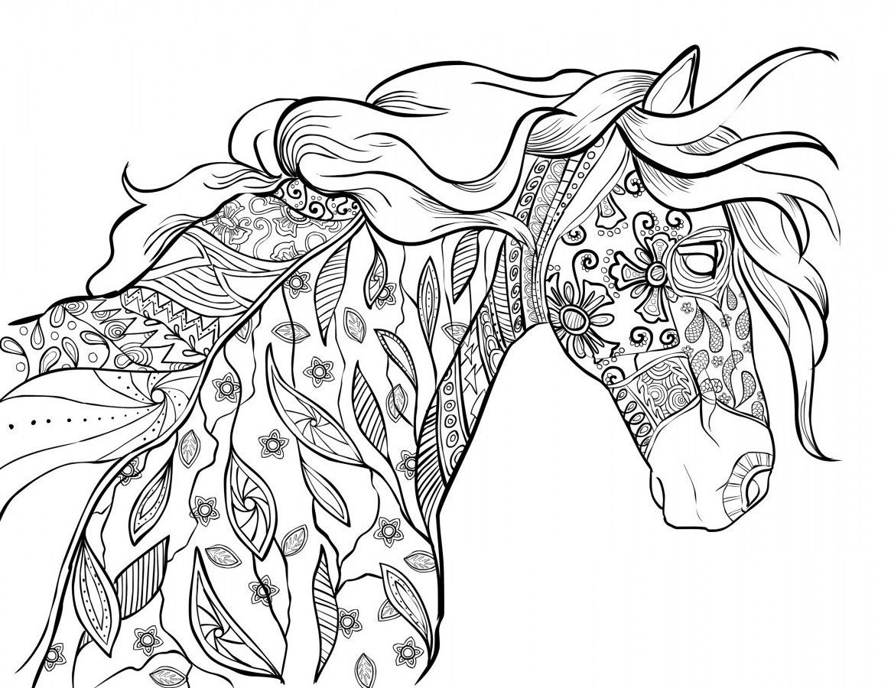

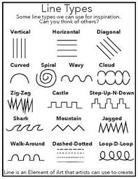

Use the lines to decorate the horse’s head. Put a mane or hair in the back of his neck.

