GRADE 5 TIMETABLE
Grade 5 Home Learning Schedule
Week 4 Day 4,
Thursday 7th of May, 2020
Thought for the day...

ANNOUNCEMENTS:

Please read and follow all announcements and lesson instructions carefully before beginning your learning.

GOOGLE MEET @ 9am - Check Google classroom home page banner for login link.

MARK THE ATTENDANCE ROLL.

GOOGLE MEET RULES: Please remember these when meeting together.

COMMENTS: Please DO NOT make unnecessary comments on our posts. Only use the comments for questions you have about your learning.
Thank you.

WORK PACKS.
These should be picked up from school.
All worksheets can be found on the HOLY EUCHARIST SCHOOL WEBSITE.
https://www.hestalbanssth.catholic.edu.au/

IMPORTANT:
MAKE SURE YOU TAKE A BREAK!
Some students are working so hard and are forgetting to take breaks.
Please remember that from 11-12pm and 2pm- 2:30pm are your times to recharge!
9:30am-10:15am | RE- PRAYER REFLECTION  Read the reflection assigned to you in google docs “Gospel reflection 7/5/2020”  After reading the Gospel answer the questions below in the document provided
10:15am-11am | LITERACY – WRITING RESPONSE  Answer the following questions in the document assigned to you ‘Writing response- stamps’  On this day the first stamp collection was started.  1)Do you collect anything?  2)If so, what do you collect and why did you decide to collect this item?  3)If not, is there an item you might like to collect?  4)Why do you think people collect things?
11am-12pm | LUNCH BREAK
GOOGLE MEET @ 12pm - Check Google classroom home page banner for login link
12pm-1pm | MUSIC with Mr O’Bree  Please go to Google Classroom- ‘Classwork’ and look for ‘Music Mr O’Bree’ folder and you will find his assignment set for this week.  IF YOU HAVE ANY ISSUES WITH THIS TASK PLEASE EMAIL MR O’BREE ON HIS EMAIL ADDRESS: Damian.OBree@hestalbanssth.catholic.edu.au
1pm-2pm | MATHS-MULTIPLES AND FACTORS-  First complete Unit 6 Wednesday Mental maths  Afterwards, play the following game about multiples:  Pumpkin Multiples: https://www.mathplayground.com/multiples.html  EXTENSION GAME:( ONLY PLAY THIS GAME IF YOU HAVE ENOUGH TIME!)  Jeopardy Multiples: https://www.math-play.com/Factors-and-Multiples-Jeopardy/factors-and-multiples-game_html5.html (You will need a pen and paper next to you when completing this game!)  After completing the pumpkin multiples game you need to complete page 12 targeting maths sheet as you can see below:  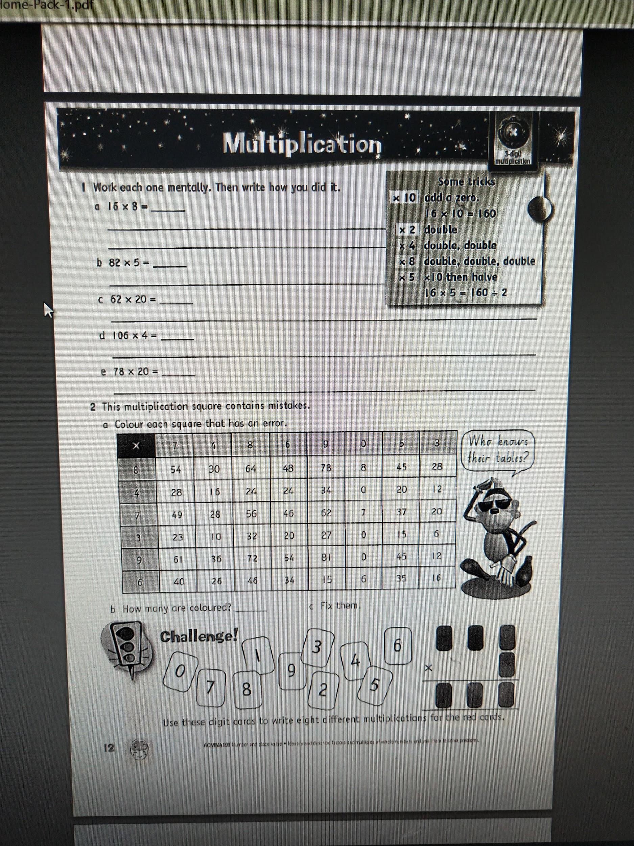
2pm-2:30pm | SNACK BREAK
2:30pm-3:15pm | PHYSICAL EDUCATION with JUST DANCE  Open the following link and complete the Just dance workout. https://www.youtube.com/watch?v=yQ4fTl4wbko  Do the actions to the song as you are shown  (NOTE: The video goes for 40 minutes so you do not have to do the entire thing in one sitting!You could say  do 20 minutes then rest and then do the other 20 minutes)

