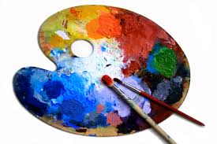
www.hestalbanssth.catholic.edu.au
Visual Arts Term 2
Mrs Hickey’s email is: shobha.hickey@hestalbanssth.catholic.edu.au
WEEK 5 GRADES 5 & 6
Learning Intention: This week we will learn how to use the tools on Sketchpad Online to create a picture of your choice.

Steps:
- Watch the video of me teaching you how to use Sketchpad Online.
- Open Sketchpad Online using the link: https://sketch.io/sketchpad/ or you can just Google Sketchpad Online.
- Create your picture.
- Use the to choose a background (plain or textured)
- Use the Clipart symbol to get your choice of pictures.
- Use the text symbol to add writing.

- Explore some of the other tools. Let’s see how creative you can get!

- Once finished, make sure you save your image by going to Export and save your image as a jpeg file. Save your download on your Desktop/Drive and submit this in the art assignment for Week 5.

DON’T HAVE A COMPUTER, DO THIS INSTEAD
If you don’t have access to a computer, use the template below to create your own picture. Remember to use colour, textures, patterns, line and tone to build up your picture. Be as creative as you can!

