www.hestalbanssth.catholic.edu.au
Visual Arts Term 2
Please feel free to email me to ask any questions relating to your art
Mrs Hickey’s email is:
shobha.hickey@hestalbanssth.catholic.edu.au
GRADE 1 & 2

Week 4

Today I am learning to draw a unicorn or a cartoon horse
I will learn to draw either a unicorn or a horse by following step by step drawings. You will also see the video on how to draw an easy peasy and fun cartoon horse. https://www.youtube.com/watch?v=laVebaRmKdA

I can use coloured pencils, or markers, glue stick and scissors, to cut up small pieces of paper, to decorate my unicorn or horse.

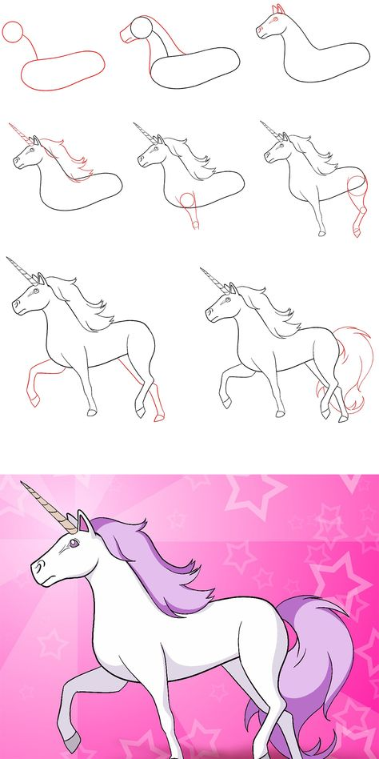
OR
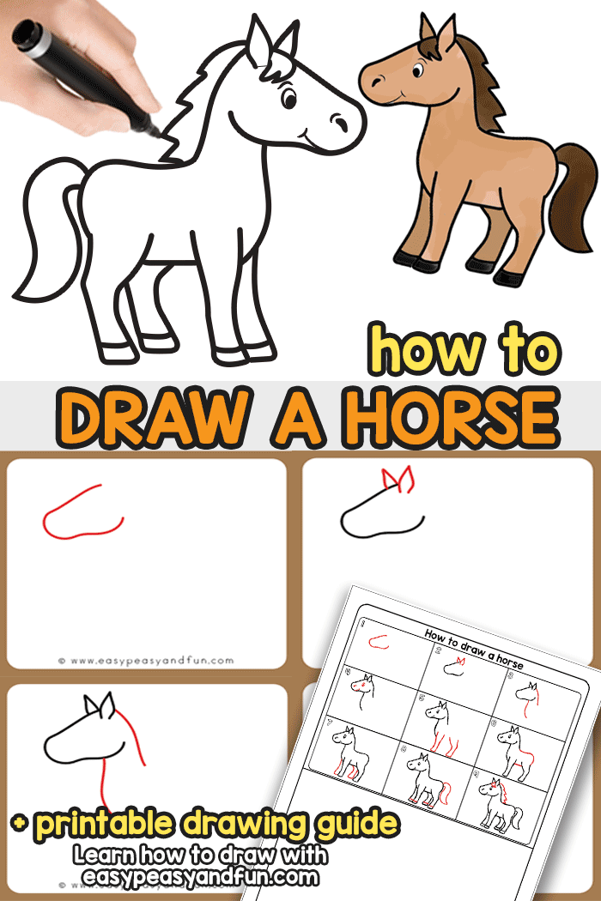

https://www.easypeasyandfun.com/how-to-draw-a-horse/

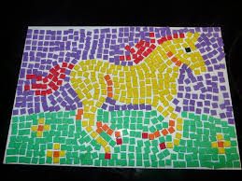
Hope you ENJOY drawing!

