www.hestalbanssth.catholic.edu.au
Visual Arts Term 2
Please feel free to email me to ask any questions relating to your art
Mrs Hickey’s email is:
shobha.hickey@hestalbanssth.catholic.edu.au
GRADE 3 & 4

Week 4

Drawing a horse is used as a symbolic image in

art, standing for strength, power and majestic

beauty.
This week you will follow a tutorial. and draw a horse or a cartoon horse.
You will decorate with fancy line work you have learnt in the last two weeks.
An example has been given for you:

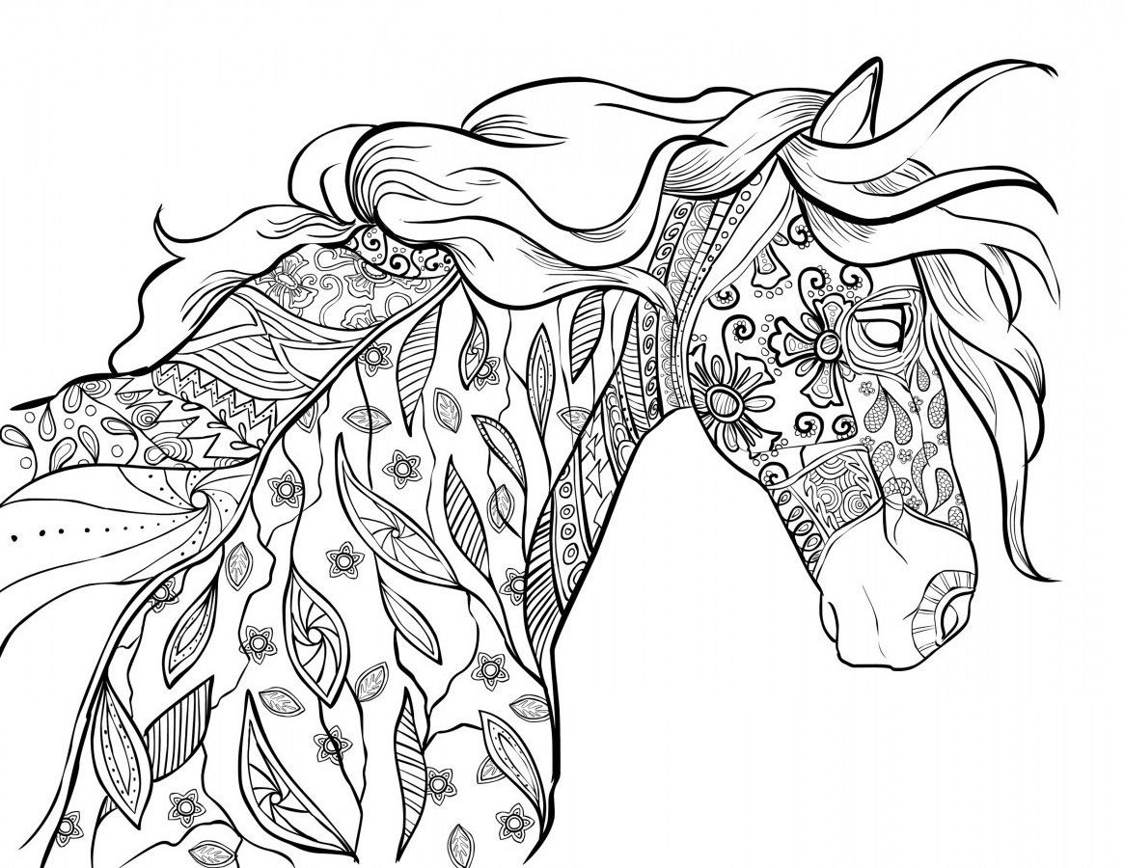

Step by step drawings
You can start and stop the video while you are drawing.

https://www.youtube.com/watch?v=5t4BJn4FuxY
How to draw a horse

https://www.youtube.com/watch?v=laVebaRmKdA&t=6s
How to draw a cartoon horse

- You will need white or any coloured paper
- Any dark marker

